Three Triangle Compressibility and Interestingness Atlas
Comparison position 1 of 120 Left and right upright Center visually inverted and maximized
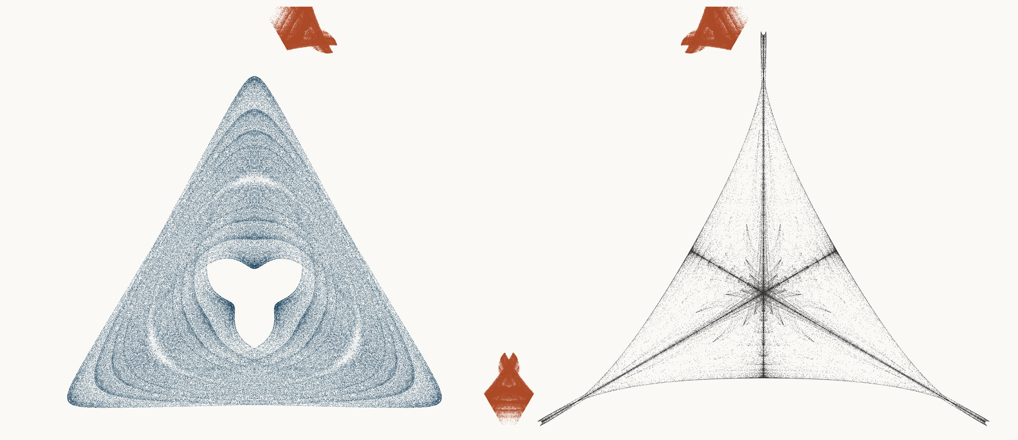
NEURAL INTERESTINGNESS 1 | RAW QUADTREE CODE BITS 1 | FORMER WUNDT GATE 1
X59379_M3  Definition X(59379); M3 pedal triangle  Neural score 65.547  Code bits 5,847 q/random 0.2523  Fitted taste 0.438 | X4271_M1  Definition X(4271); M1 cevian triangle  Code-bit rank 1 position 1  Quadtree code bits 583  q/random 0.06992 PNG/random 0.1817 | X31498_M1  Definition X(31498); M1 cevian triangle  Wundt position 1  Wundt gate 1.000000  q/random 0.5002 code bits 7,779
Each source plot uses 50,000 retained points after 4,000 discarded points and all six angle permutations. The center plot is visually oriented and enlarged only for presentation. Raw quadtree ranking is ascending by code bits.

Three Triangle Compressibility and Interestingness Atlas
Comparison position 2 of 120 Left and right upright Center visually inverted and maximized
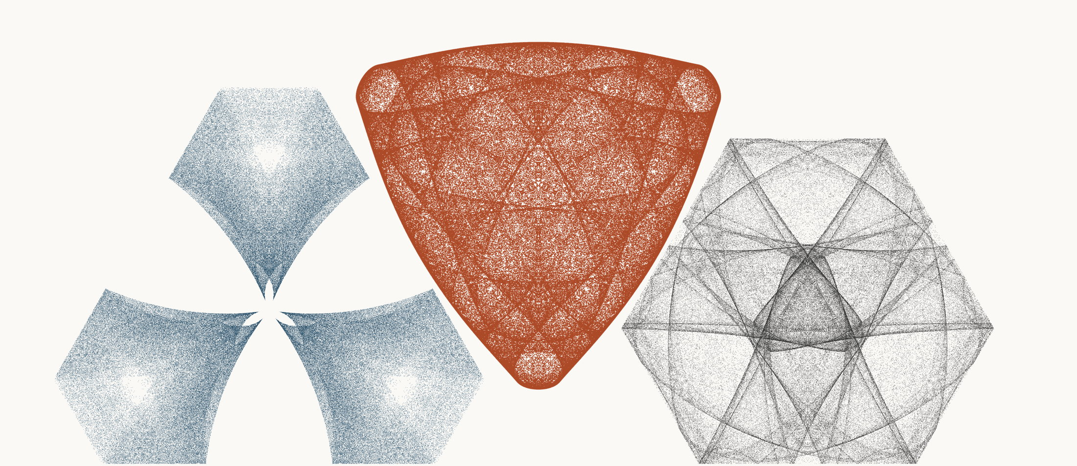
NEURAL INTERESTINGNESS 2 | RAW QUADTREE CODE BITS 2 | FORMER WUNDT GATE 2
X7327_M3  Definition X(7327); M3 pedal triangle  Neural score 64.938  Code bits 6,617 q/random 0.2874  Fitted taste -0.205 | X71803_M1  Definition X(71803); M1 cevian triangle  Code-bit rank 1 position 2  Quadtree code bits 583  q/random 0.04543 PNG/random 0.1650 | X39726_M1  Definition X(39726); M1 cevian triangle  Wundt position 2  Wundt gate 0.999997  q/random 0.4991 code bits 11,384
Each source plot uses 50,000 retained points after 4,000 discarded points and all six angle permutations. The center plot is visually oriented and enlarged only for presentation. Raw quadtree ranking is ascending by code bits.

Three Triangle Compressibility and Interestingness Atlas
Comparison position 3 of 120 Left and right upright Center visually inverted and maximized
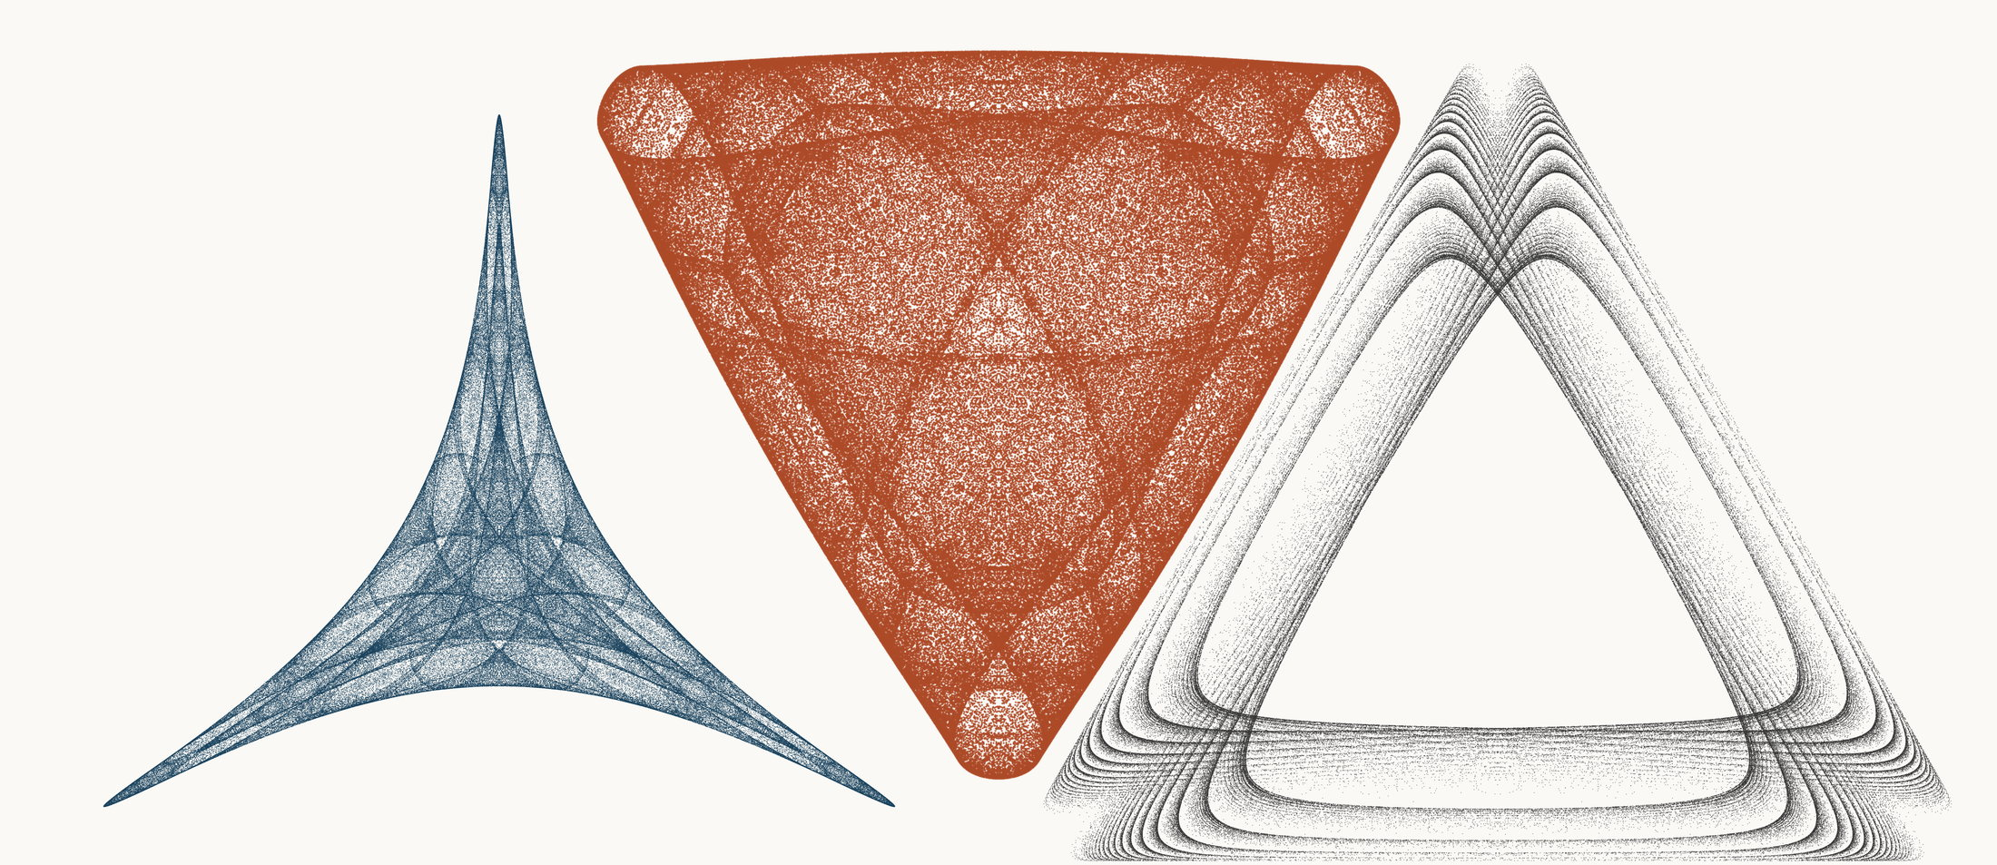
NEURAL INTERESTINGNESS 3 | RAW QUADTREE CODE BITS 3 | FORMER WUNDT GATE 3
X64658_M1  Definition X(64658); M1 cevian triangle  Neural score 64.769  Code bits 2,263 q/random 0.1225  Fitted taste 0.756 | X29935_M1  Definition X(29935); M1 cevian triangle  Code-bit rank 3 position 3  Quadtree code bits 590  q/random 0.04504 PNG/random 0.1664 | X9143_M3  Definition X(9143); M3 pedal triangle  Wundt position 3  Wundt gate 0.999992  q/random 0.5014 code bits 11,503
Each source plot uses 50,000 retained points after 4,000 discarded points and all six angle permutations. The center plot is visually oriented and enlarged only for presentation. Raw quadtree ranking is ascending by code bits.

Three Triangle Compressibility and Interestingness Atlas
Comparison position 4 of 120 Left and right upright Center visually inverted and maximized
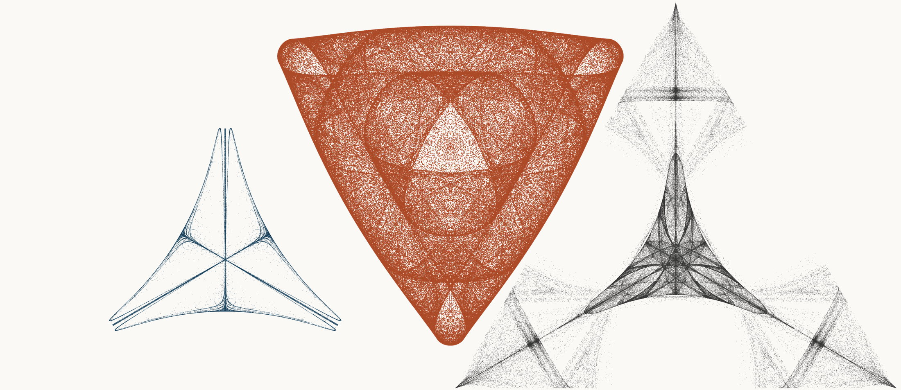
NEURAL INTERESTINGNESS 4 | RAW QUADTREE CODE BITS 4 | FORMER WUNDT GATE 4
X13470_M3  Definition X(13470); M3 pedal triangle  Neural score 64.224  Code bits 2,760 q/random 0.3240  Fitted taste 0.309 | X35951_M1  Definition X(35951); M1 cevian triangle  Code-bit rank 3 position 4  Quadtree code bits 590  q/random 0.04511 PNG/random 0.1682 | X2929_M1  Definition X(2929); M1 cevian triangle  Wundt position 4  Wundt gate 0.999991  q/random 0.4985 code bits 10,488
Each source plot uses 50,000 retained points after 4,000 discarded points and all six angle permutations. The center plot is visually oriented and enlarged only for presentation. Raw quadtree ranking is ascending by code bits.

Three Triangle Compressibility and Interestingness Atlas
Comparison position 5 of 120 Left and right upright Center visually inverted and maximized
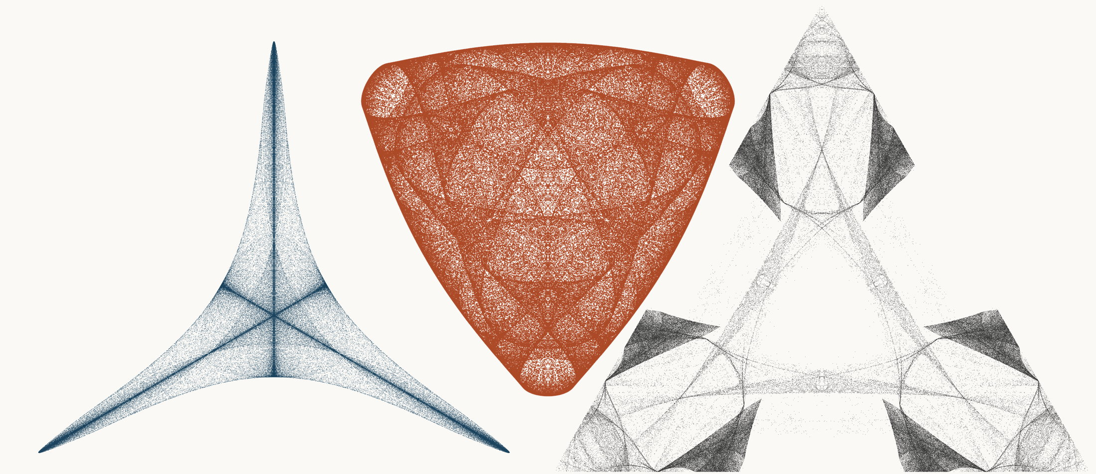
NEURAL INTERESTINGNESS 5 | RAW QUADTREE CODE BITS 5 | FORMER WUNDT GATE 5
X37644_M1  Definition X(37644); M1 cevian triangle  Neural score 64.168  Code bits 5,259 q/random 0.2863  Fitted taste 0.485 | X72137_M1  Definition X(72137); M1 cevian triangle  Code-bit rank 5 position 5  Quadtree code bits 597  q/random 0.04627 PNG/random 0.1671 | X486_M1  Definition X(486); M1 cevian triangle  Wundt position 5  Wundt gate 0.999990  q/random 0.5016 code bits 10,880
Each source plot uses 50,000 retained points after 4,000 discarded points and all six angle permutations. The center plot is visually oriented and enlarged only for presentation. Raw quadtree ranking is ascending by code bits.

Three Triangle Compressibility and Interestingness Atlas
Comparison position 6 of 120 Left and right upright Center visually inverted and maximized
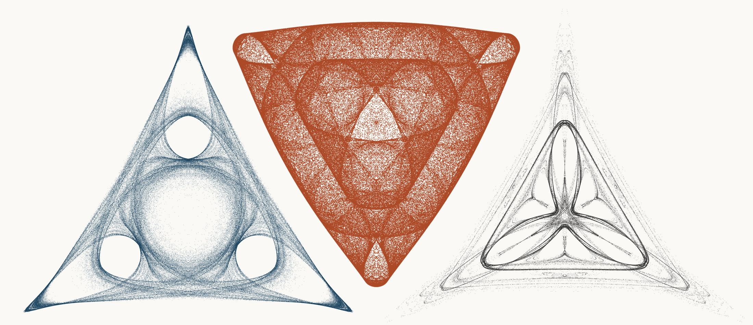
NEURAL INTERESTINGNESS 6 | RAW QUADTREE CODE BITS 6 | FORMER WUNDT GATE 6
X43449_M3  Definition X(43449); M3 pedal triangle  Neural score 63.852  Code bits 6,785 q/random 0.3010  Fitted taste 1.201 | X33007_M1  Definition X(33007); M1 cevian triangle  Code-bit rank 6 position 6  Quadtree code bits 611  q/random 0.04721 PNG/random 0.1716 | X47115_M1  Definition X(47115); M1 cevian triangle  Wundt position 6  Wundt gate 0.999989  q/random 0.4983 code bits 8,395
Each source plot uses 50,000 retained points after 4,000 discarded points and all six angle permutations. The center plot is visually oriented and enlarged only for presentation. Raw quadtree ranking is ascending by code bits.

Three Triangle Compressibility and Interestingness Atlas
Comparison position 7 of 120 Left and right upright Center visually inverted and maximized
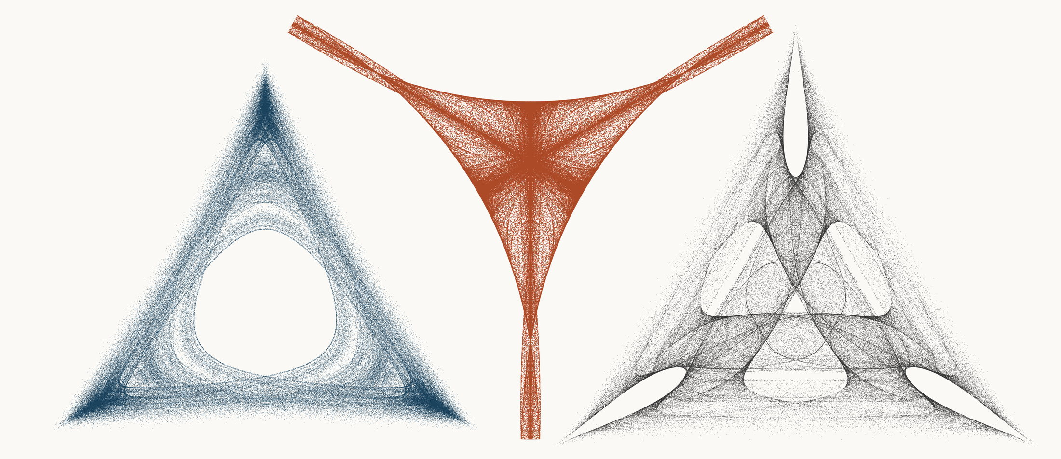
NEURAL INTERESTINGNESS 7 | RAW QUADTREE CODE BITS 7 | FORMER WUNDT GATE 7
X36696_M3  Definition X(36696); M3 pedal triangle  Neural score 63.815  Code bits 5,910 q/random 0.2683  Fitted taste 0.631 | X54594_M3  Definition X(54594); M3 pedal triangle  Code-bit rank 7 position 7  Quadtree code bits 618  q/random 0.05894 PNG/random 0.1509 | X18645_M1  Definition X(18645); M1 cevian triangle  Wundt position 7  Wundt gate 0.999984  q/random 0.4980 code bits 11,321
Each source plot uses 50,000 retained points after 4,000 discarded points and all six angle permutations. The center plot is visually oriented and enlarged only for presentation. Raw quadtree ranking is ascending by code bits.

Three Triangle Compressibility and Interestingness Atlas
Comparison position 8 of 120 Left and right upright Center visually inverted and maximized
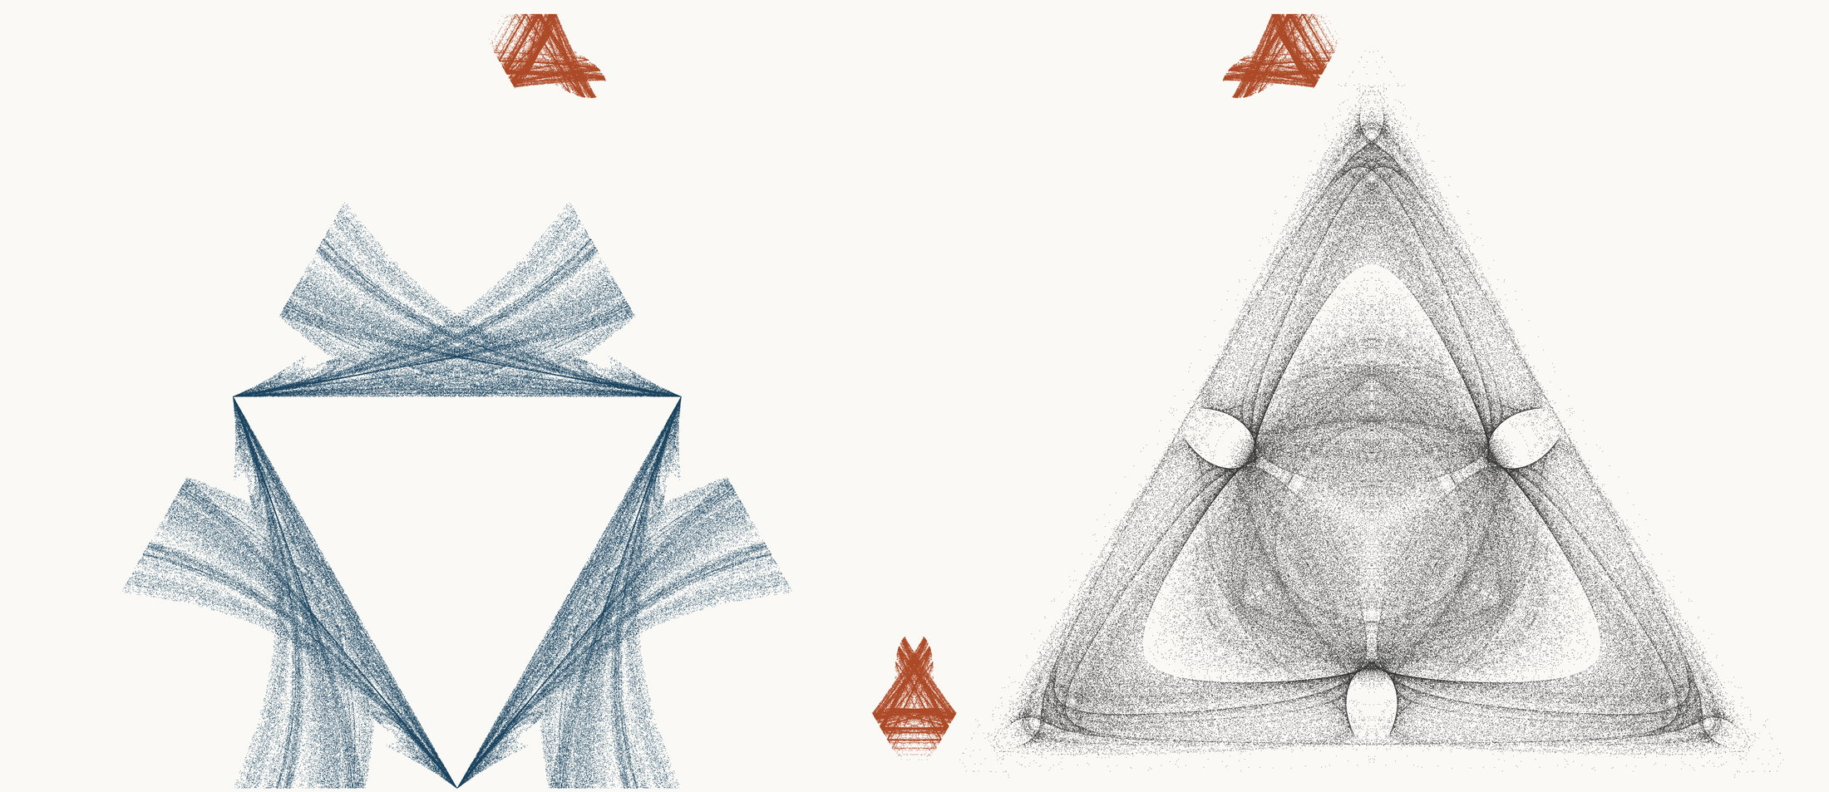
NEURAL INTERESTINGNESS 8 | RAW QUADTREE CODE BITS 8 | FORMER WUNDT GATE 8
X2861_M1  Definition X(2861); M1 cevian triangle  Neural score 63.806  Code bits 4,601 q/random 0.2090  Fitted taste 1.070 | X54323_M1  Definition X(54323); M1 cevian triangle  Code-bit rank 8 position 8  Quadtree code bits 625  q/random 0.07766 PNG/random 0.1832 | X15612_M3  Definition X(15612); M3 pedal triangle  Wundt position 8  Wundt gate 0.999979  q/random 0.4977 code bits 11,279
Each source plot uses 50,000 retained points after 4,000 discarded points and all six angle permutations. The center plot is visually oriented and enlarged only for presentation. Raw quadtree ranking is ascending by code bits.

Three Triangle Compressibility and Interestingness Atlas
Comparison position 9 of 120 Left and right upright Center visually inverted and maximized
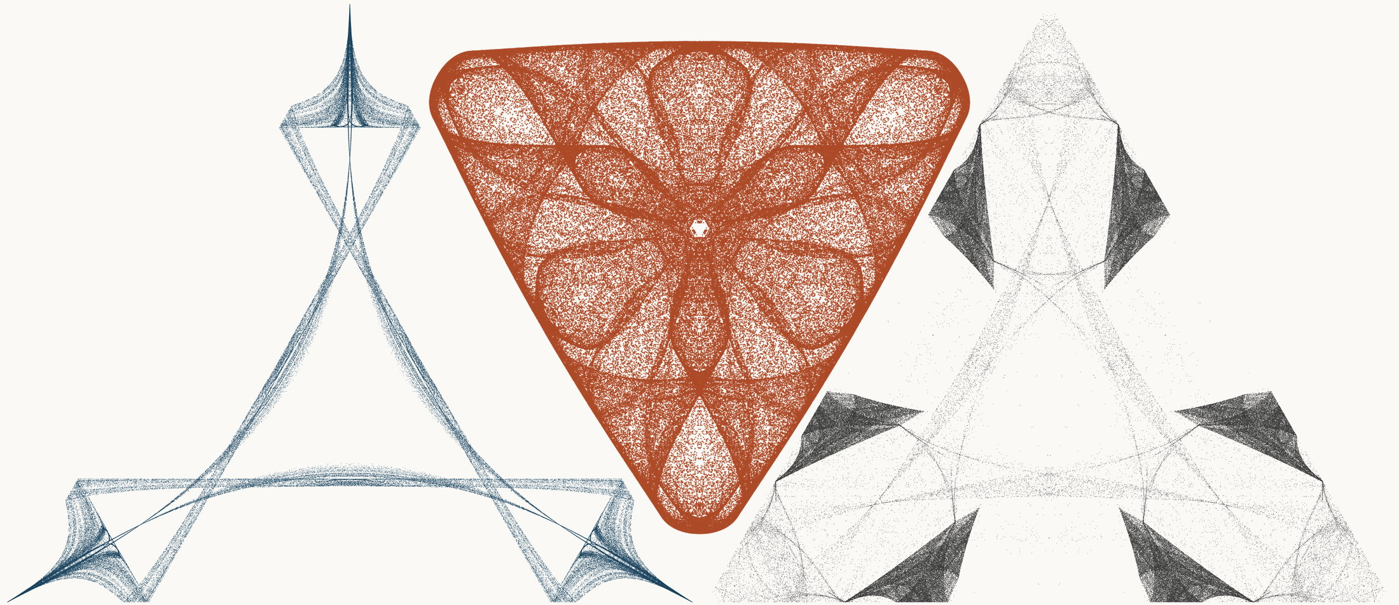
NEURAL INTERESTINGNESS 9 | RAW QUADTREE CODE BITS 9 | FORMER WUNDT GATE 9
X8135_M1  Definition X(8135); M1 cevian triangle  Neural score 62.755  Code bits 3,173 q/random 0.1827  Fitted taste 0.836 | X66435_M1  Definition X(66435); M1 cevian triangle  Code-bit rank 8 position 9  Quadtree code bits 625  q/random 0.04869 PNG/random 0.1686 | X33606_M1  Definition X(33606); M1 cevian triangle  Wundt position 9  Wundt gate 0.999977  q/random 0.4976 code bits 10,124
Each source plot uses 50,000 retained points after 4,000 discarded points and all six angle permutations. The center plot is visually oriented and enlarged only for presentation. Raw quadtree ranking is ascending by code bits.

Three Triangle Compressibility and Interestingness Atlas
Comparison position 10 of 120 Left and right upright Center visually inverted and maximized
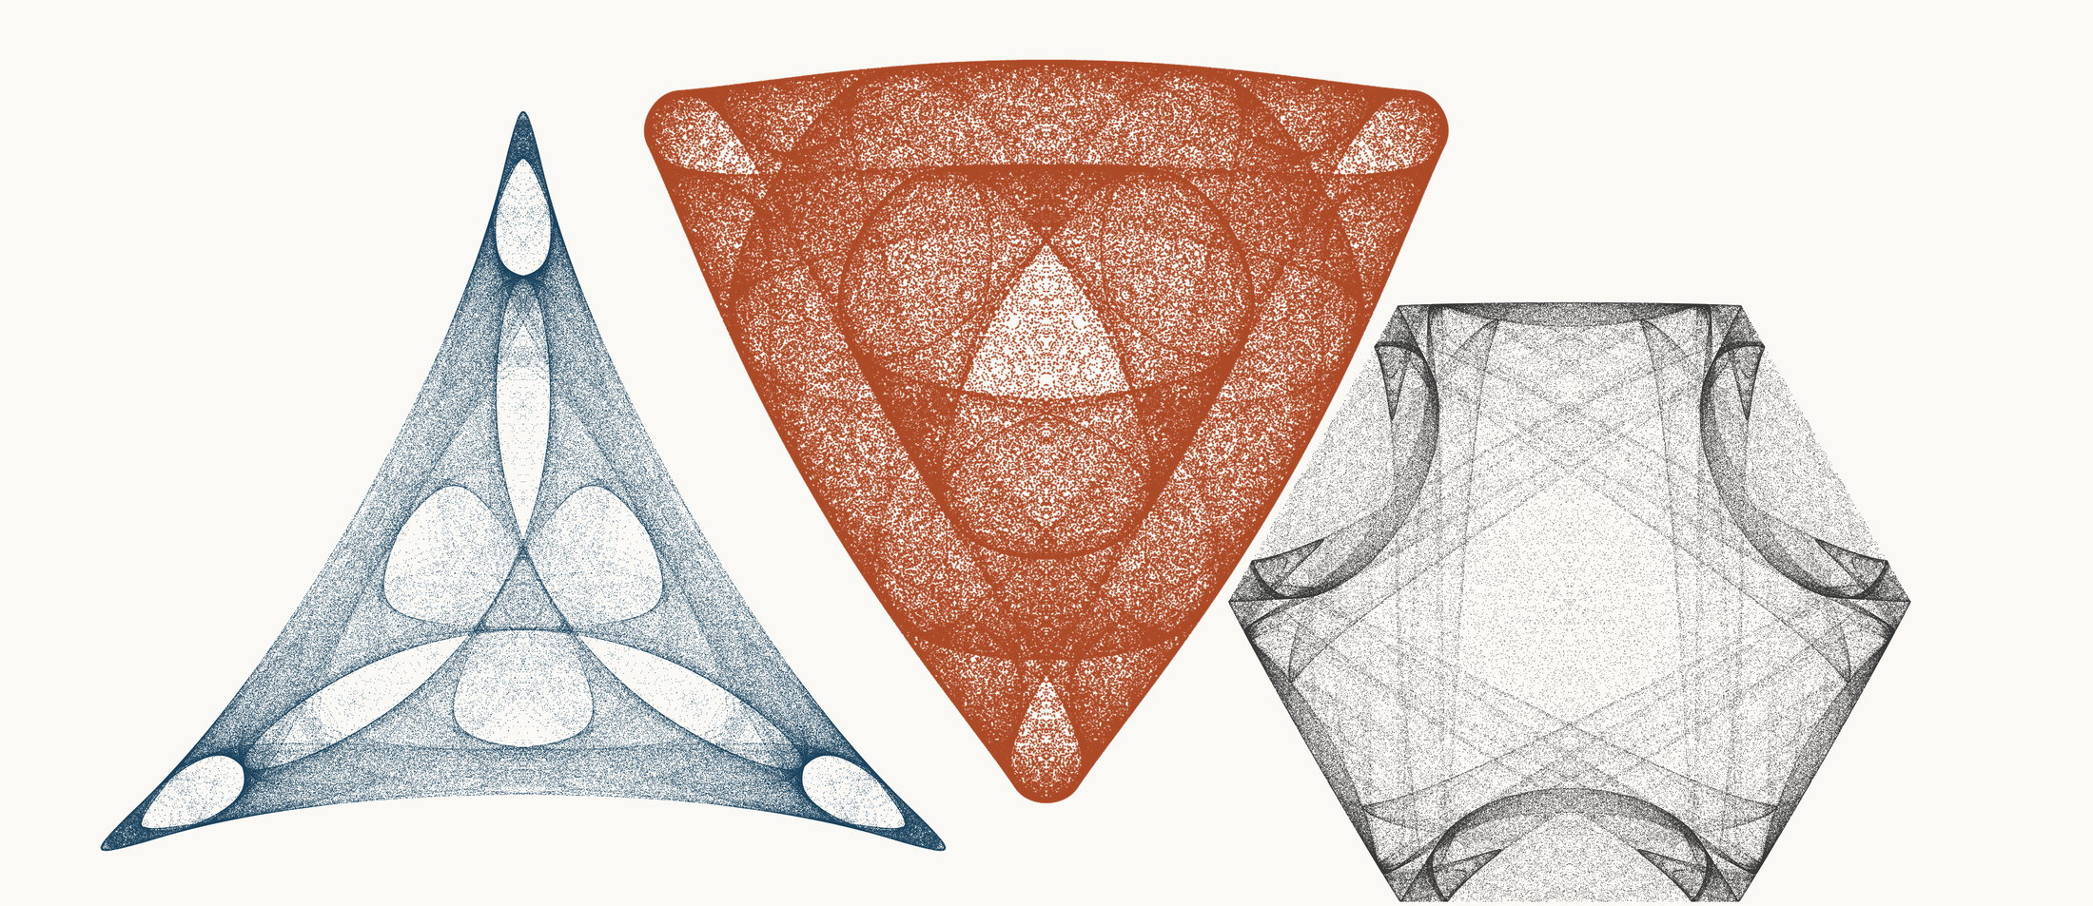
NEURAL INTERESTINGNESS 10 | RAW QUADTREE CODE BITS 10 | FORMER WUNDT GATE 10
X7208_M3  Definition X(7208); M3 pedal triangle  Neural score 62.295  Code bits 6,589 q/random 0.3017  Fitted taste 1.040 | X37173_M1  Definition X(37173); M1 cevian triangle  Code-bit rank 10 position 10  Quadtree code bits 632  q/random 0.04860 PNG/random 0.1671 | X54476_M3  Definition X(54476); M3 pedal triangle  Wundt position 10  Wundt gate 0.999951  q/random 0.5035 code bits 11,594
Each source plot uses 50,000 retained points after 4,000 discarded points and all six angle permutations. The center plot is visually oriented and enlarged only for presentation. Raw quadtree ranking is ascending by code bits.

Three Triangle Compressibility and Interestingness Atlas
Comparison position 11 of 120 Left and right upright Center visually inverted and maximized
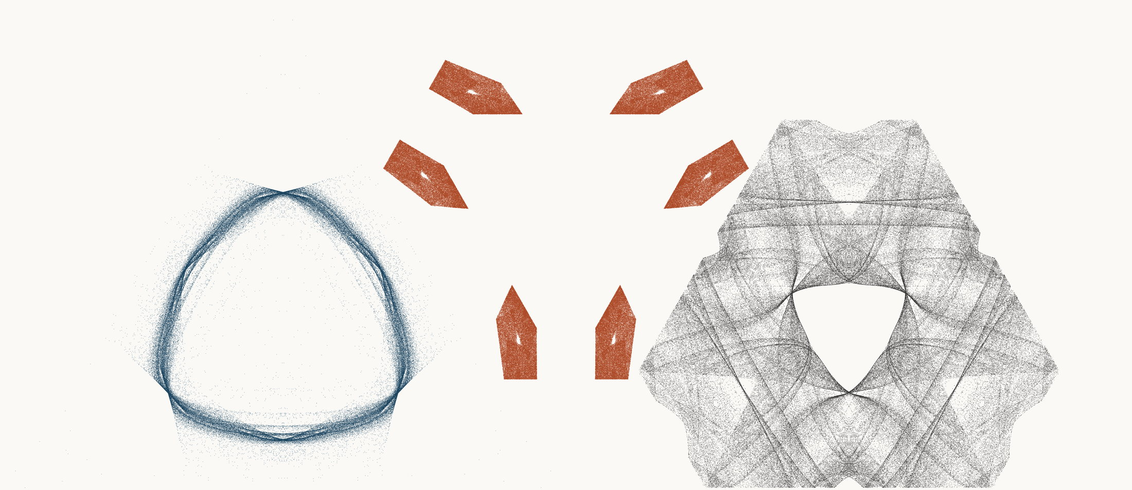
NEURAL INTERESTINGNESS 11 | RAW QUADTREE CODE BITS 11 | FORMER WUNDT GATE 11
X67673_M3  Definition X(67673); M3 pedal triangle  Neural score 61.551  Code bits 5,567 q/random 0.3286  Fitted taste 1.392 | X60168_M1  Definition X(60168); M1 cevian triangle  Code-bit rank 11 position 11  Quadtree code bits 653  q/random 0.05144 PNG/random 0.1324 | X55929_M1  Definition X(55929); M1 cevian triangle  Wundt position 11  Wundt gate 0.999917  q/random 0.4954 code bits 11,041
Each source plot uses 50,000 retained points after 4,000 discarded points and all six angle permutations. The center plot is visually oriented and enlarged only for presentation. Raw quadtree ranking is ascending by code bits.

Three Triangle Compressibility and Interestingness Atlas
Comparison position 12 of 120 Left and right upright Center visually inverted and maximized
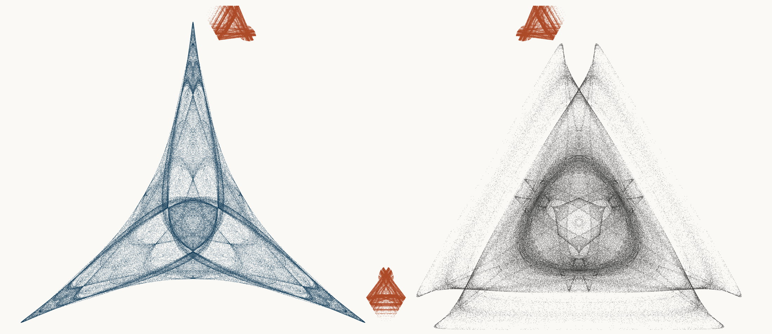
NEURAL INTERESTINGNESS 12 | RAW QUADTREE CODE BITS 12 | FORMER WUNDT GATE 12
X20266_M1  Definition X(20266); M1 cevian triangle  Neural score 61.464  Code bits 4,811 q/random 0.2206  Fitted taste 0.817 | X4276_M1  Definition X(4276); M1 cevian triangle  Code-bit rank 12 position 12  Quadtree code bits 660  q/random 0.07762 PNG/random 0.1939 | X6024_M3  Definition X(6024); M3 pedal triangle  Wundt position 12  Wundt gate 0.999900  q/random 0.4950 code bits 11,419
Each source plot uses 50,000 retained points after 4,000 discarded points and all six angle permutations. The center plot is visually oriented and enlarged only for presentation. Raw quadtree ranking is ascending by code bits.

Three Triangle Compressibility and Interestingness Atlas
Comparison position 13 of 120 Left and right upright Center visually inverted and maximized
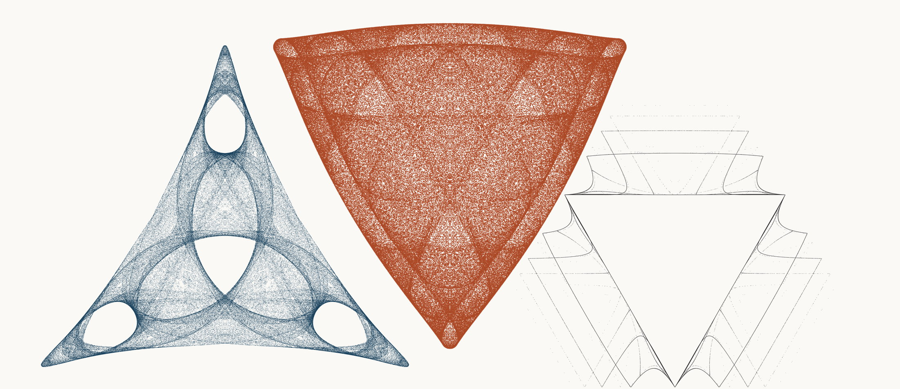
NEURAL INTERESTINGNESS 13 | RAW QUADTREE CODE BITS 13 | FORMER WUNDT GATE 13
X34943_M3  Definition X(34943); M3 pedal triangle  Neural score 61.393  Code bits 5,945 q/random 0.2666  Fitted taste 1.115 | X6658_M1  Definition X(6658); M1 cevian triangle  Code-bit rank 13 position 13  Quadtree code bits 674  q/random 0.04644 PNG/random 0.1721 | X65261_M1  Definition X(65261); M1 cevian triangle  Wundt position 13  Wundt gate 0.999899  q/random 0.4950 code bits 4,146
Each source plot uses 50,000 retained points after 4,000 discarded points and all six angle permutations. The center plot is visually oriented and enlarged only for presentation. Raw quadtree ranking is ascending by code bits.

Three Triangle Compressibility and Interestingness Atlas
Comparison position 14 of 120 Left and right upright Center visually inverted and maximized
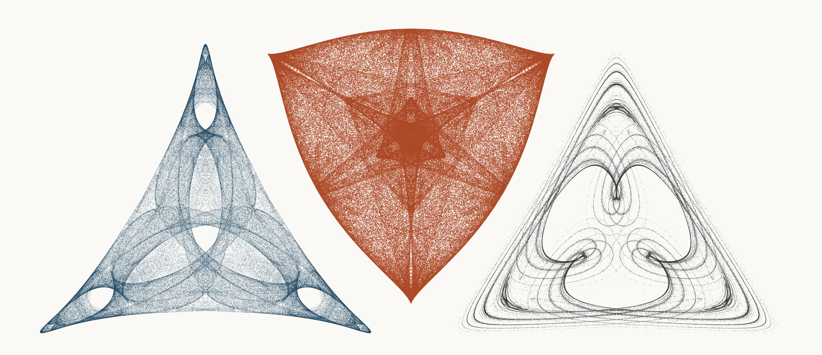
NEURAL INTERESTINGNESS 14 | RAW QUADTREE CODE BITS 14 | FORMER WUNDT GATE 14
X7200_M3  Definition X(7200); M3 pedal triangle  Neural score 61.352  Code bits 5,847 q/random 0.2589  Fitted taste 1.027 | X37465_M1  Definition X(37465); M1 cevian triangle  Code-bit rank 14 position 14  Quadtree code bits 681  q/random 0.05100 PNG/random 0.1788 | X9172_M3  Definition X(9172); M3 pedal triangle  Wundt position 14  Wundt gate 0.999868  q/random 0.5057 code bits 9,872
Each source plot uses 50,000 retained points after 4,000 discarded points and all six angle permutations. The center plot is visually oriented and enlarged only for presentation. Raw quadtree ranking is ascending by code bits.

Three Triangle Compressibility and Interestingness Atlas
Comparison position 15 of 120 Left and right upright Center visually inverted and maximized
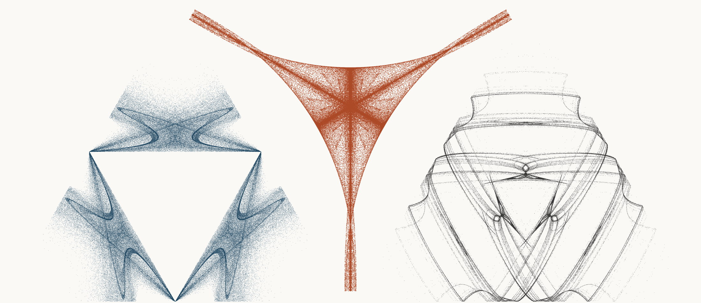
NEURAL INTERESTINGNESS 15 | RAW QUADTREE CODE BITS 15 | FORMER WUNDT GATE 15
X2755_M1  Definition X(2755); M1 cevian triangle  Neural score 61.326  Code bits 6,148 q/random 0.2791  Fitted taste 1.168 | X57721_M3  Definition X(57721); M3 pedal triangle  Code-bit rank 14 position 15  Quadtree code bits 681  q/random 0.06699 PNG/random 0.1621 | X9278_M1  Definition X(9278); M1 cevian triangle  Wundt position 15  Wundt gate 0.999828  q/random 0.4934 code bits 9,494
Each source plot uses 50,000 retained points after 4,000 discarded points and all six angle permutations. The center plot is visually oriented and enlarged only for presentation. Raw quadtree ranking is ascending by code bits.

Three Triangle Compressibility and Interestingness Atlas
Comparison position 16 of 120 Left and right upright Center visually inverted and maximized
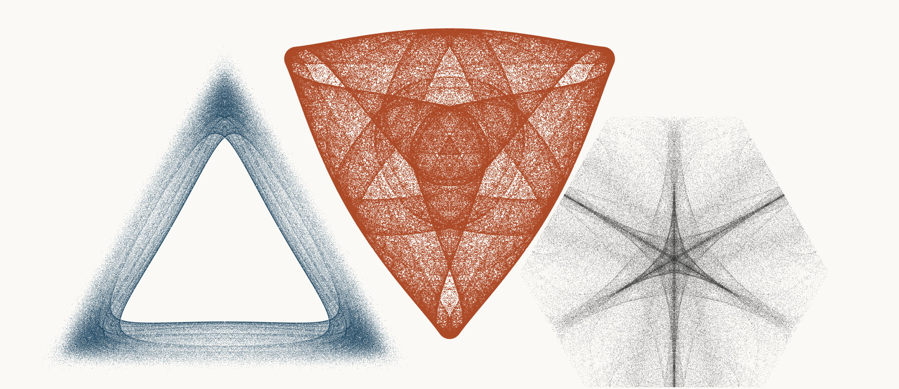
NEURAL INTERESTINGNESS 16 | RAW QUADTREE CODE BITS 16 | FORMER WUNDT GATE 16
X72131_M3  Definition X(72131); M3 pedal triangle  Neural score 61.263  Code bits 5,525 q/random 0.2459  Fitted taste 0.372 | X6959_M1  Definition X(6959); M1 cevian triangle  Code-bit rank 14 position 16  Quadtree code bits 681  q/random 0.05404 PNG/random 0.1806 | X5342_M1  Definition X(5342); M1 cevian triangle  Wundt position 16  Wundt gate 0.999827  q/random 0.5066 code bits 11,608
Each source plot uses 50,000 retained points after 4,000 discarded points and all six angle permutations. The center plot is visually oriented and enlarged only for presentation. Raw quadtree ranking is ascending by code bits.

Three Triangle Compressibility and Interestingness Atlas
Comparison position 17 of 120 Left and right upright Center visually inverted and maximized
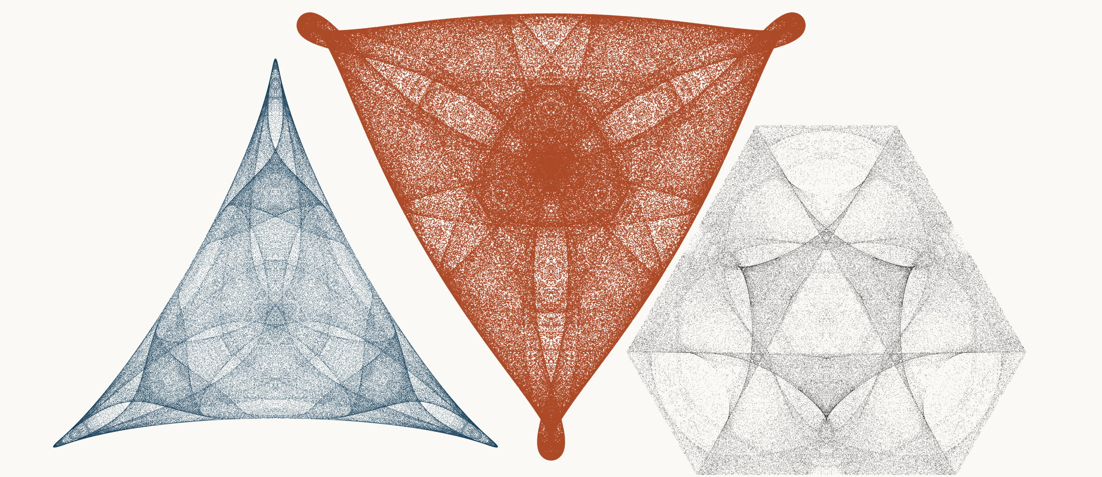
NEURAL INTERESTINGNESS 17 | RAW QUADTREE CODE BITS 17 | FORMER WUNDT GATE 17
X47008_M3  Definition X(47008); M3 pedal triangle  Neural score 61.167  Code bits 5,385 q/random 0.2362  Fitted taste 0.864 | X18539_M3  Definition X(18539); M3 pedal triangle  Code-bit rank 17 position 17  Quadtree code bits 702  q/random 0.05184 PNG/random 0.1723 | X19631_M3  Definition X(19631); M3 pedal triangle  Wundt position 17  Wundt gate 0.999821  q/random 0.5067 code bits 11,391
Each source plot uses 50,000 retained points after 4,000 discarded points and all six angle permutations. The center plot is visually oriented and enlarged only for presentation. Raw quadtree ranking is ascending by code bits.

Three Triangle Compressibility and Interestingness Atlas
Comparison position 18 of 120 Left and right upright Center visually inverted and maximized
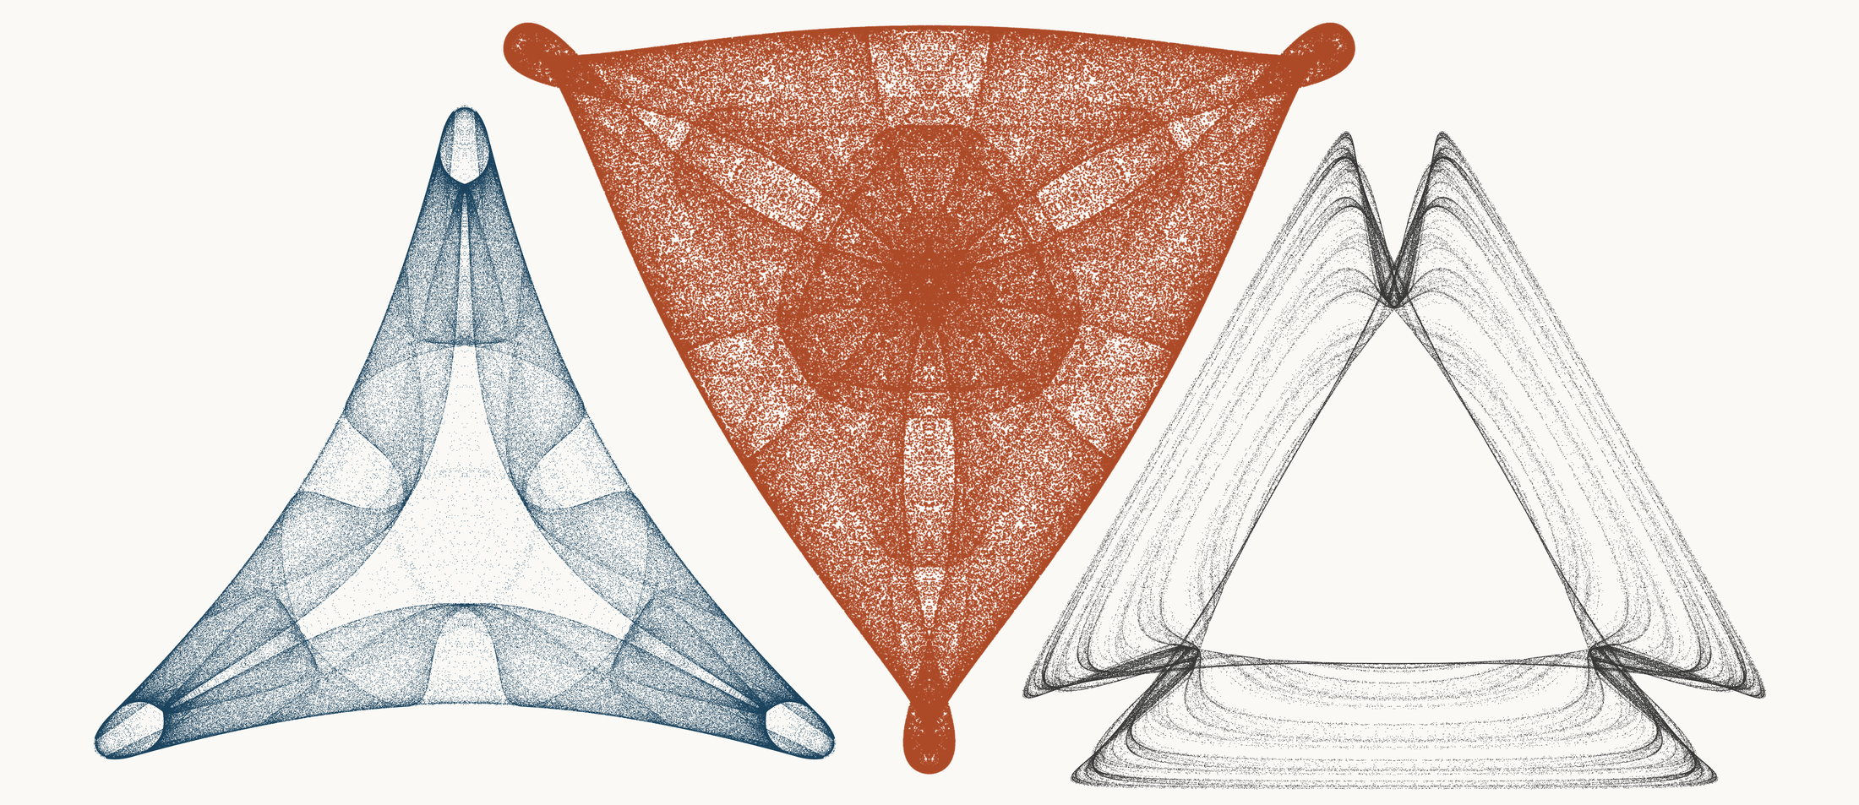
NEURAL INTERESTINGNESS 18 | RAW QUADTREE CODE BITS 18 | FORMER WUNDT GATE 18
X69465_M1  Definition X(69465); M1 cevian triangle  Neural score 60.860  Code bits 6,932 q/random 0.3147  Fitted taste 0.727 | X45593_M3  Definition X(45593); M3 pedal triangle  Code-bit rank 18 position 18  Quadtree code bits 709  q/random 0.05068 PNG/random 0.1837 | X20385_M3  Definition X(20385); M3 pedal triangle  Wundt position 18  Wundt gate 0.999805  q/random 0.4930 code bits 10,138
Each source plot uses 50,000 retained points after 4,000 discarded points and all six angle permutations. The center plot is visually oriented and enlarged only for presentation. Raw quadtree ranking is ascending by code bits.

Three Triangle Compressibility and Interestingness Atlas
Comparison position 19 of 120 Left and right upright Center visually inverted and maximized
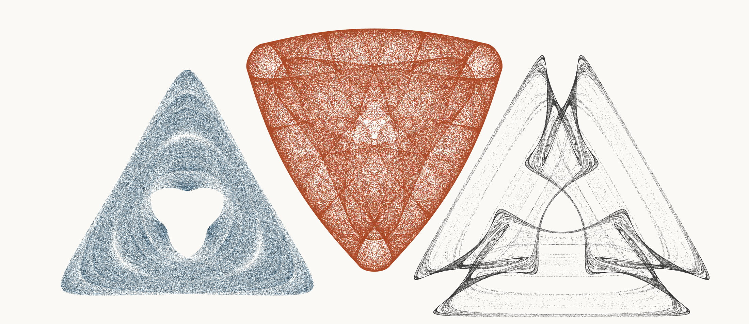
NEURAL INTERESTINGNESS 19 | RAW QUADTREE CODE BITS 19 | FORMER WUNDT GATE 19
X35020_M3  Definition X(35020); M3 pedal triangle  Neural score 60.601  Code bits 3,852 q/random 0.1690  Fitted taste 0.917 | X71803_M3  Definition X(71803); M3 pedal triangle  Code-bit rank 19 position 19  Quadtree code bits 730  q/random 0.04647 PNG/random 0.1662 | X34194_M3  Definition X(34194); M3 pedal triangle  Wundt position 19  Wundt gate 0.999777  q/random 0.4925 code bits 9,704
Each source plot uses 50,000 retained points after 4,000 discarded points and all six angle permutations. The center plot is visually oriented and enlarged only for presentation. Raw quadtree ranking is ascending by code bits.

Three Triangle Compressibility and Interestingness Atlas
Comparison position 20 of 120 Left and right upright Center visually inverted and maximized
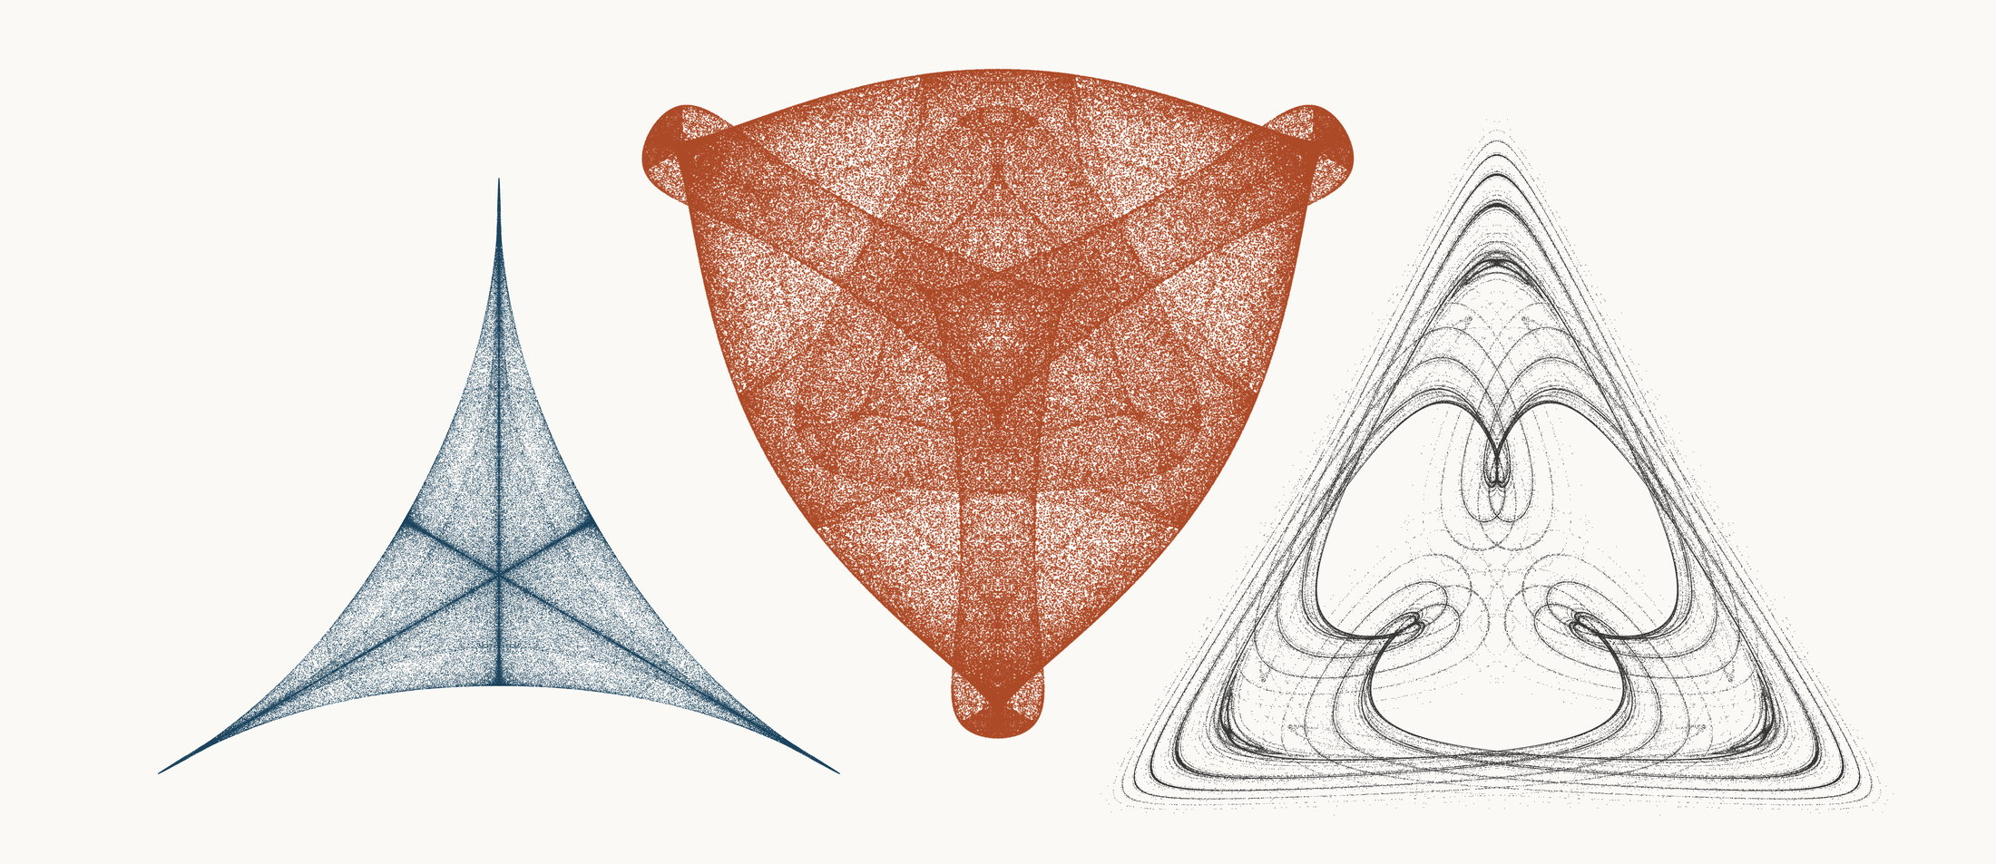
NEURAL INTERESTINGNESS 20 | RAW QUADTREE CODE BITS 20 | FORMER WUNDT GATE 20
X6279_M3  Definition X(6279); M3 pedal triangle  Neural score 60.564  Code bits 2,886 q/random 0.1749  Fitted taste 0.922 | X29914_M1  Definition X(29914); M1 cevian triangle  Code-bit rank 20 position 20  Quadtree code bits 737  q/random 0.04808 PNG/random 0.1787 | X33998_M3  Definition X(33998); M3 pedal triangle  Wundt position 20  Wundt gate 0.999776  q/random 0.5075 code bits 9,977
Each source plot uses 50,000 retained points after 4,000 discarded points and all six angle permutations. The center plot is visually oriented and enlarged only for presentation. Raw quadtree ranking is ascending by code bits.

Three Triangle Compressibility and Interestingness Atlas
Comparison position 21 of 120 Left and right upright Center visually inverted and maximized
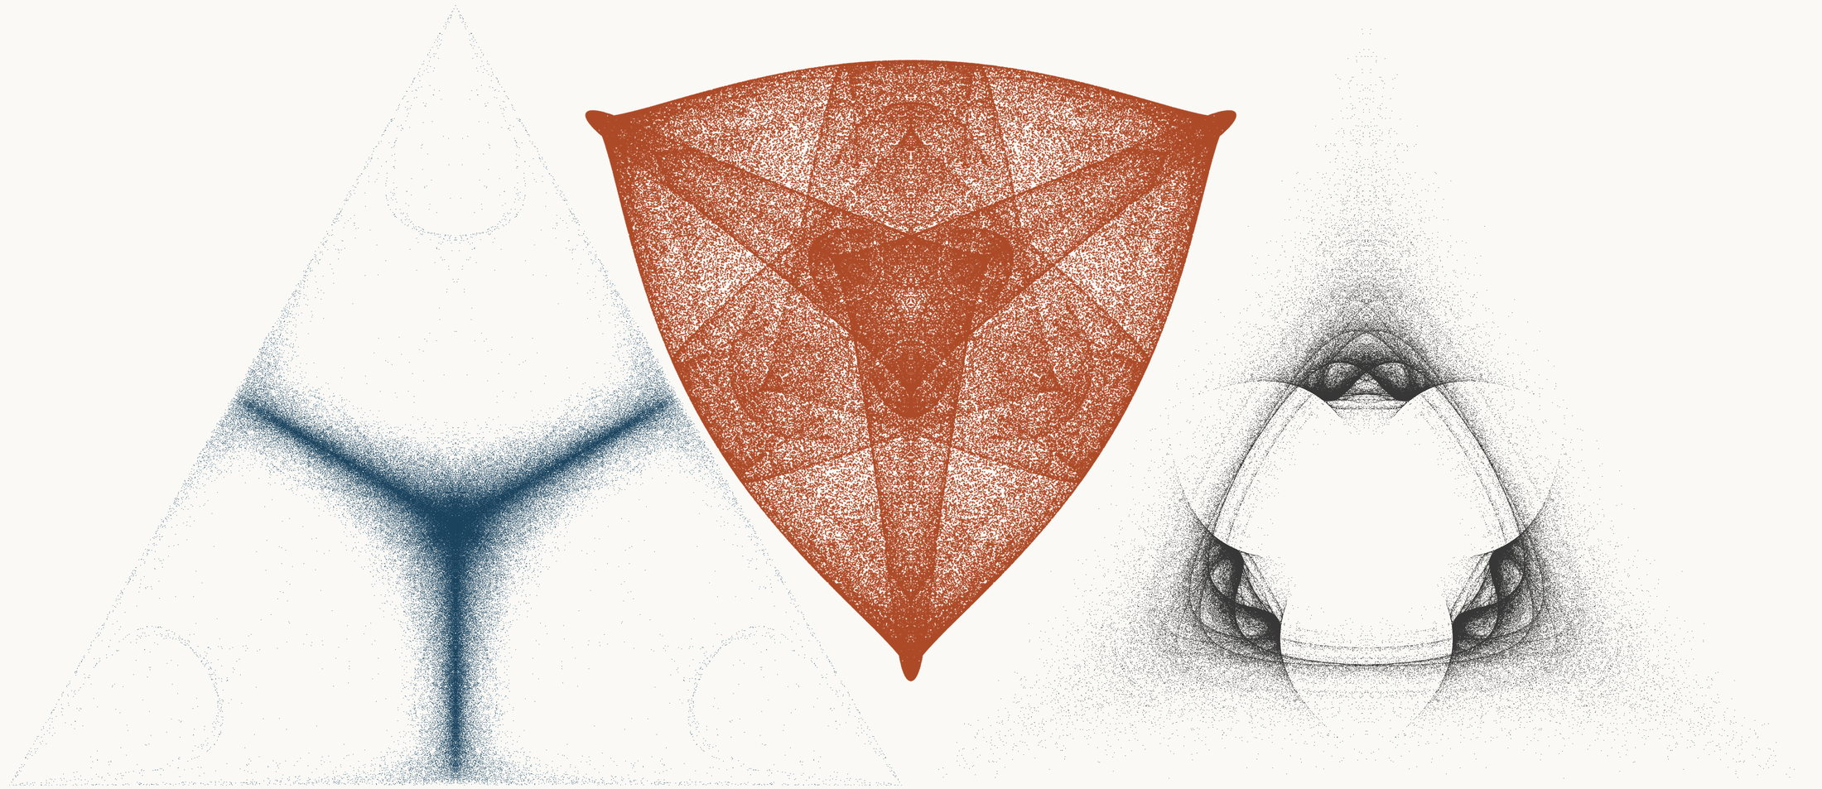
NEURAL INTERESTINGNESS 21 | RAW QUADTREE CODE BITS 21 | FORMER WUNDT GATE 21
X13951_M3  Definition X(13951); M3 pedal triangle  Neural score 60.508  Code bits 6,659 q/random 0.3566  Fitted taste 1.310 | X16414_M1  Definition X(16414); M1 cevian triangle  Code-bit rank 21 position 21  Quadtree code bits 744  q/random 0.05201 PNG/random 0.1779 | X27245_M3  Definition X(27245); M3 pedal triangle  Wundt position 21  Wundt gate 0.999776  q/random 0.4925 code bits 9,676
Each source plot uses 50,000 retained points after 4,000 discarded points and all six angle permutations. The center plot is visually oriented and enlarged only for presentation. Raw quadtree ranking is ascending by code bits.

Three Triangle Compressibility and Interestingness Atlas
Comparison position 22 of 120 Left and right upright Center visually inverted and maximized
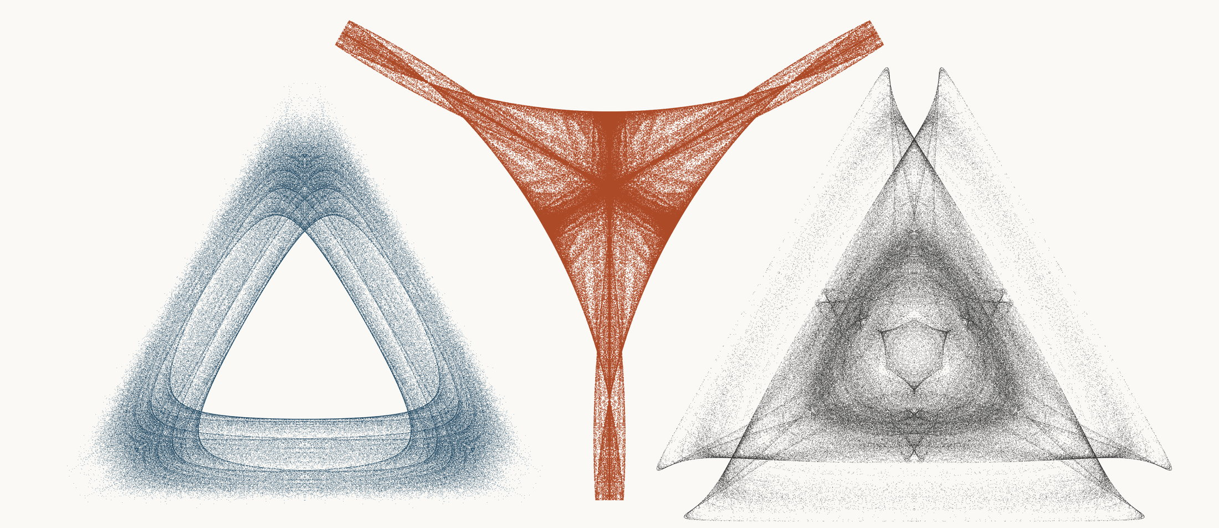
NEURAL INTERESTINGNESS 22 | RAW QUADTREE CODE BITS 22 | FORMER WUNDT GATE 22
X5182_M3  Definition X(5182); M3 pedal triangle  Neural score 60.502  Code bits 6,624 q/random 0.2906  Fitted taste 0.734 | X2672_M3  Definition X(2672); M3 pedal triangle  Code-bit rank 21 position 22  Quadtree code bits 744  q/random 0.06202 PNG/random 0.1490 | X65153_M3  Definition X(65153); M3 pedal triangle  Wundt position 22  Wundt gate 0.999729  q/random 0.4918 code bits 11,286
Each source plot uses 50,000 retained points after 4,000 discarded points and all six angle permutations. The center plot is visually oriented and enlarged only for presentation. Raw quadtree ranking is ascending by code bits.

Three Triangle Compressibility and Interestingness Atlas
Comparison position 23 of 120 Left and right upright Center visually inverted and maximized
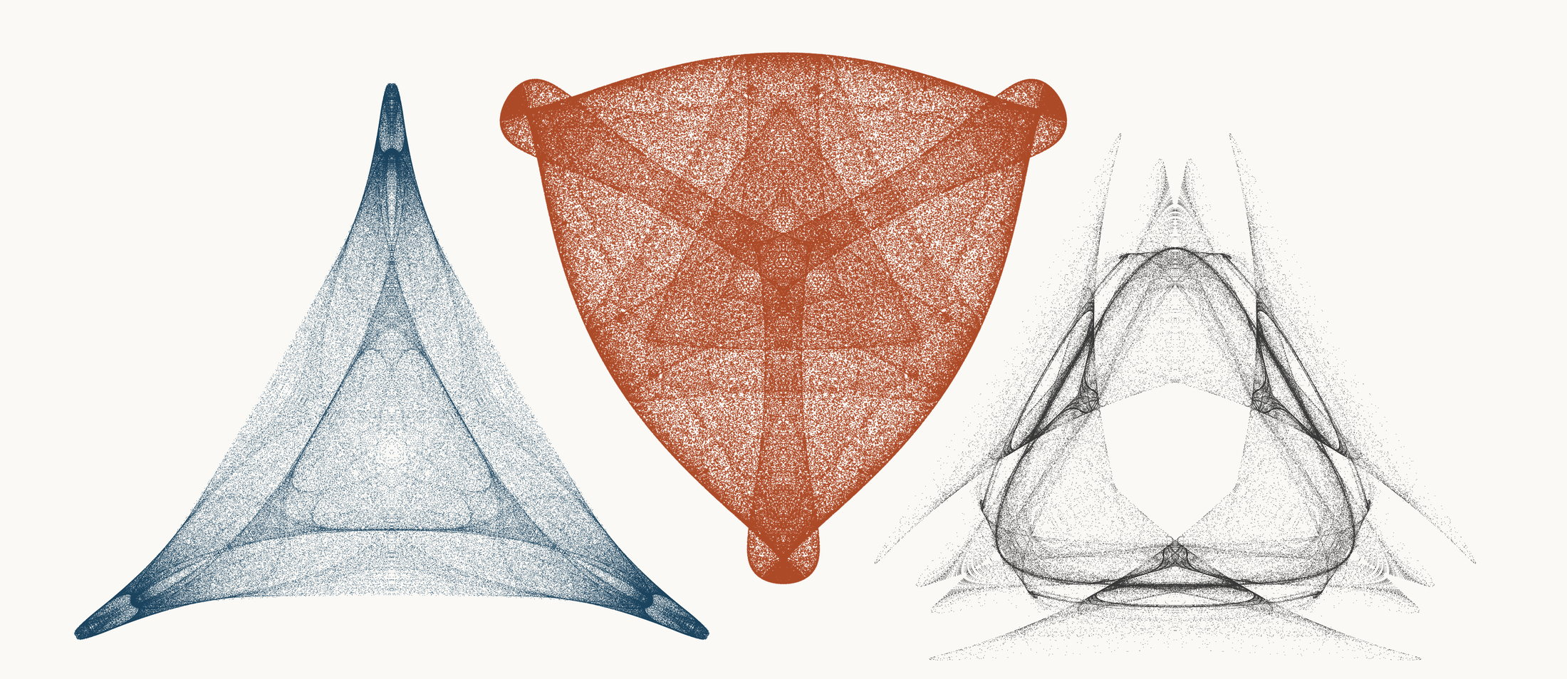
NEURAL INTERESTINGNESS 23 | RAW QUADTREE CODE BITS 23 | FORMER WUNDT GATE 23
X65512_M3  Definition X(65512); M3 pedal triangle  Neural score 60.298  Code bits 7,128 q/random 0.3205  Fitted taste 0.671 | X19245_M1  Definition X(19245); M1 cevian triangle  Code-bit rank 23 position 23  Quadtree code bits 751  q/random 0.04818 PNG/random 0.1744 | X53374_M3  Definition X(53374); M3 pedal triangle  Wundt position 23  Wundt gate 0.999663  q/random 0.4908 code bits 10,110
Each source plot uses 50,000 retained points after 4,000 discarded points and all six angle permutations. The center plot is visually oriented and enlarged only for presentation. Raw quadtree ranking is ascending by code bits.

Three Triangle Compressibility and Interestingness Atlas
Comparison position 24 of 120 Left and right upright Center visually inverted and maximized
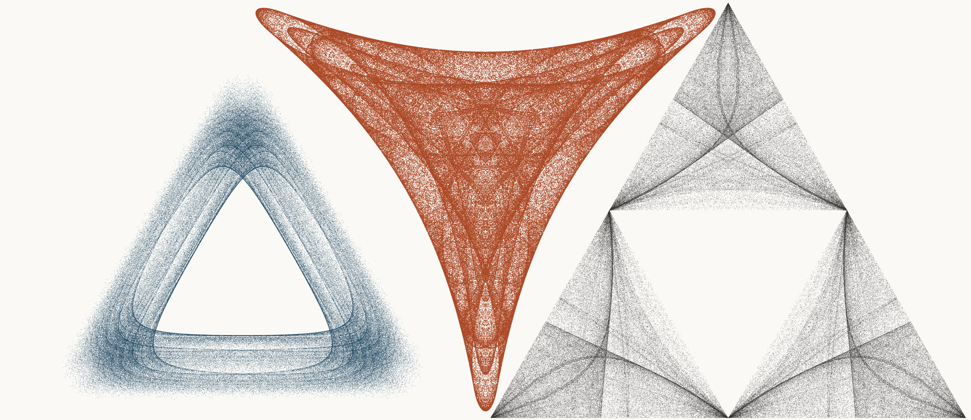
NEURAL INTERESTINGNESS 24 | RAW QUADTREE CODE BITS 24 | FORMER WUNDT GATE 24
X41252_M3  Definition X(41252); M3 pedal triangle  Neural score 60.287  Code bits 6,379 q/random 0.2798  Fitted taste 0.665 | X56361_M3  Definition X(56361); M3 pedal triangle  Code-bit rank 24 position 24  Quadtree code bits 758  q/random 0.05471 PNG/random 0.1681 | X2752_M1  Definition X(2752); M1 cevian triangle  Wundt position 24  Wundt gate 0.999634  q/random 0.5096 code bits 11,559
Each source plot uses 50,000 retained points after 4,000 discarded points and all six angle permutations. The center plot is visually oriented and enlarged only for presentation. Raw quadtree ranking is ascending by code bits.

Three Triangle Compressibility and Interestingness Atlas
Comparison position 25 of 120 Left and right upright Center visually inverted and maximized
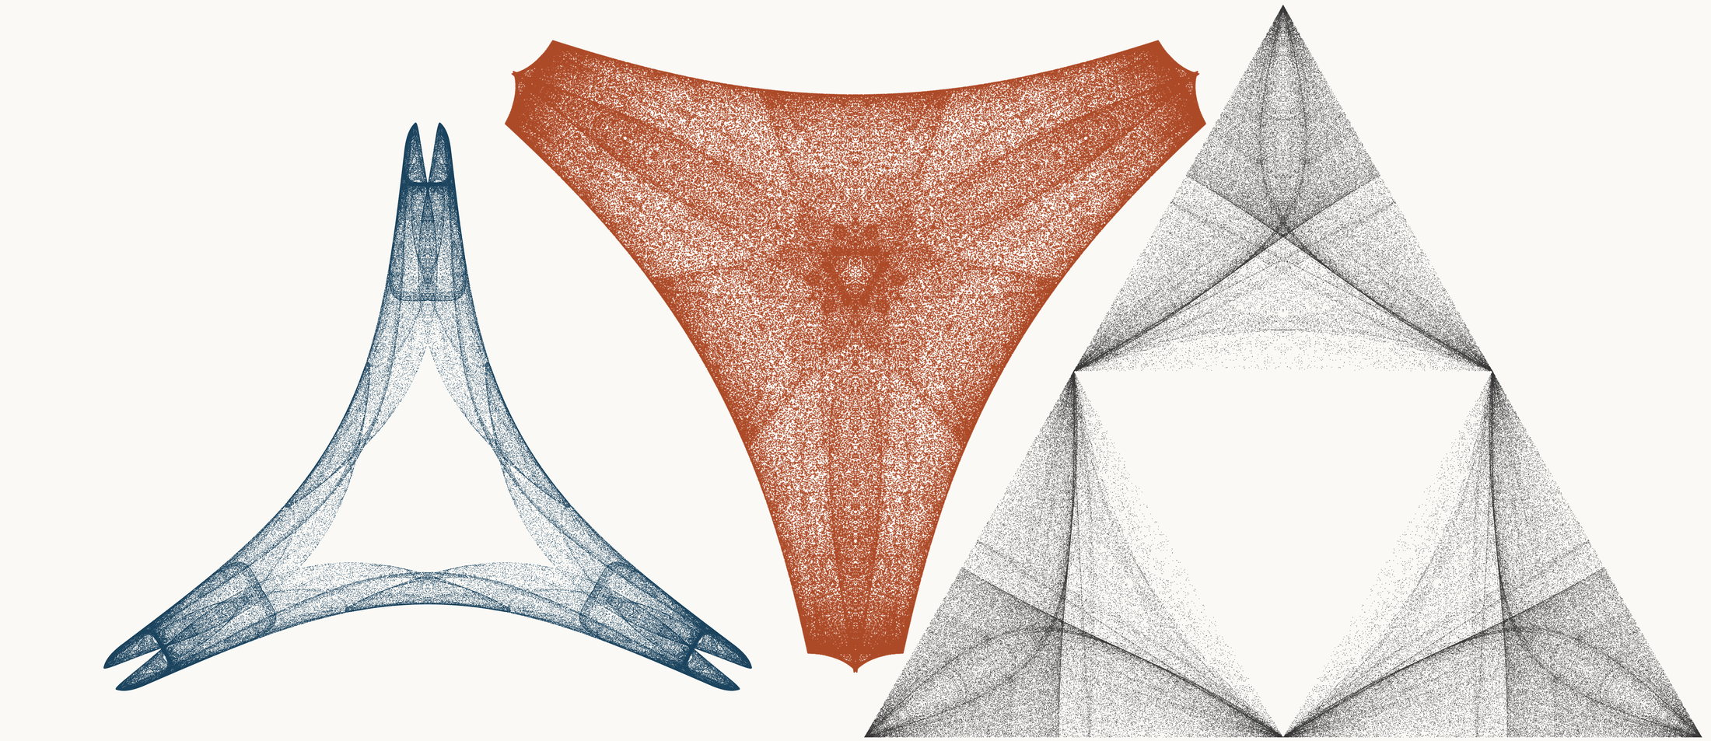
NEURAL INTERESTINGNESS 25 | RAW QUADTREE CODE BITS 25 | FORMER WUNDT GATE 25
X49259_M1  Definition X(49259); M1 cevian triangle  Neural score 60.255  Code bits 3,565 q/random 0.1954  Fitted taste 0.017 | X57844_M3  Definition X(57844); M3 pedal triangle  Code-bit rank 25 position 25  Quadtree code bits 765  q/random 0.04961 PNG/random 0.1648 | X2770_M1  Definition X(2770); M1 cevian triangle  Wundt position 25  Wundt gate 0.999543  q/random 0.4893 code bits 11,055
Each source plot uses 50,000 retained points after 4,000 discarded points and all six angle permutations. The center plot is visually oriented and enlarged only for presentation. Raw quadtree ranking is ascending by code bits.

Three Triangle Compressibility and Interestingness Atlas
Comparison position 26 of 120 Left and right upright Center visually inverted and maximized
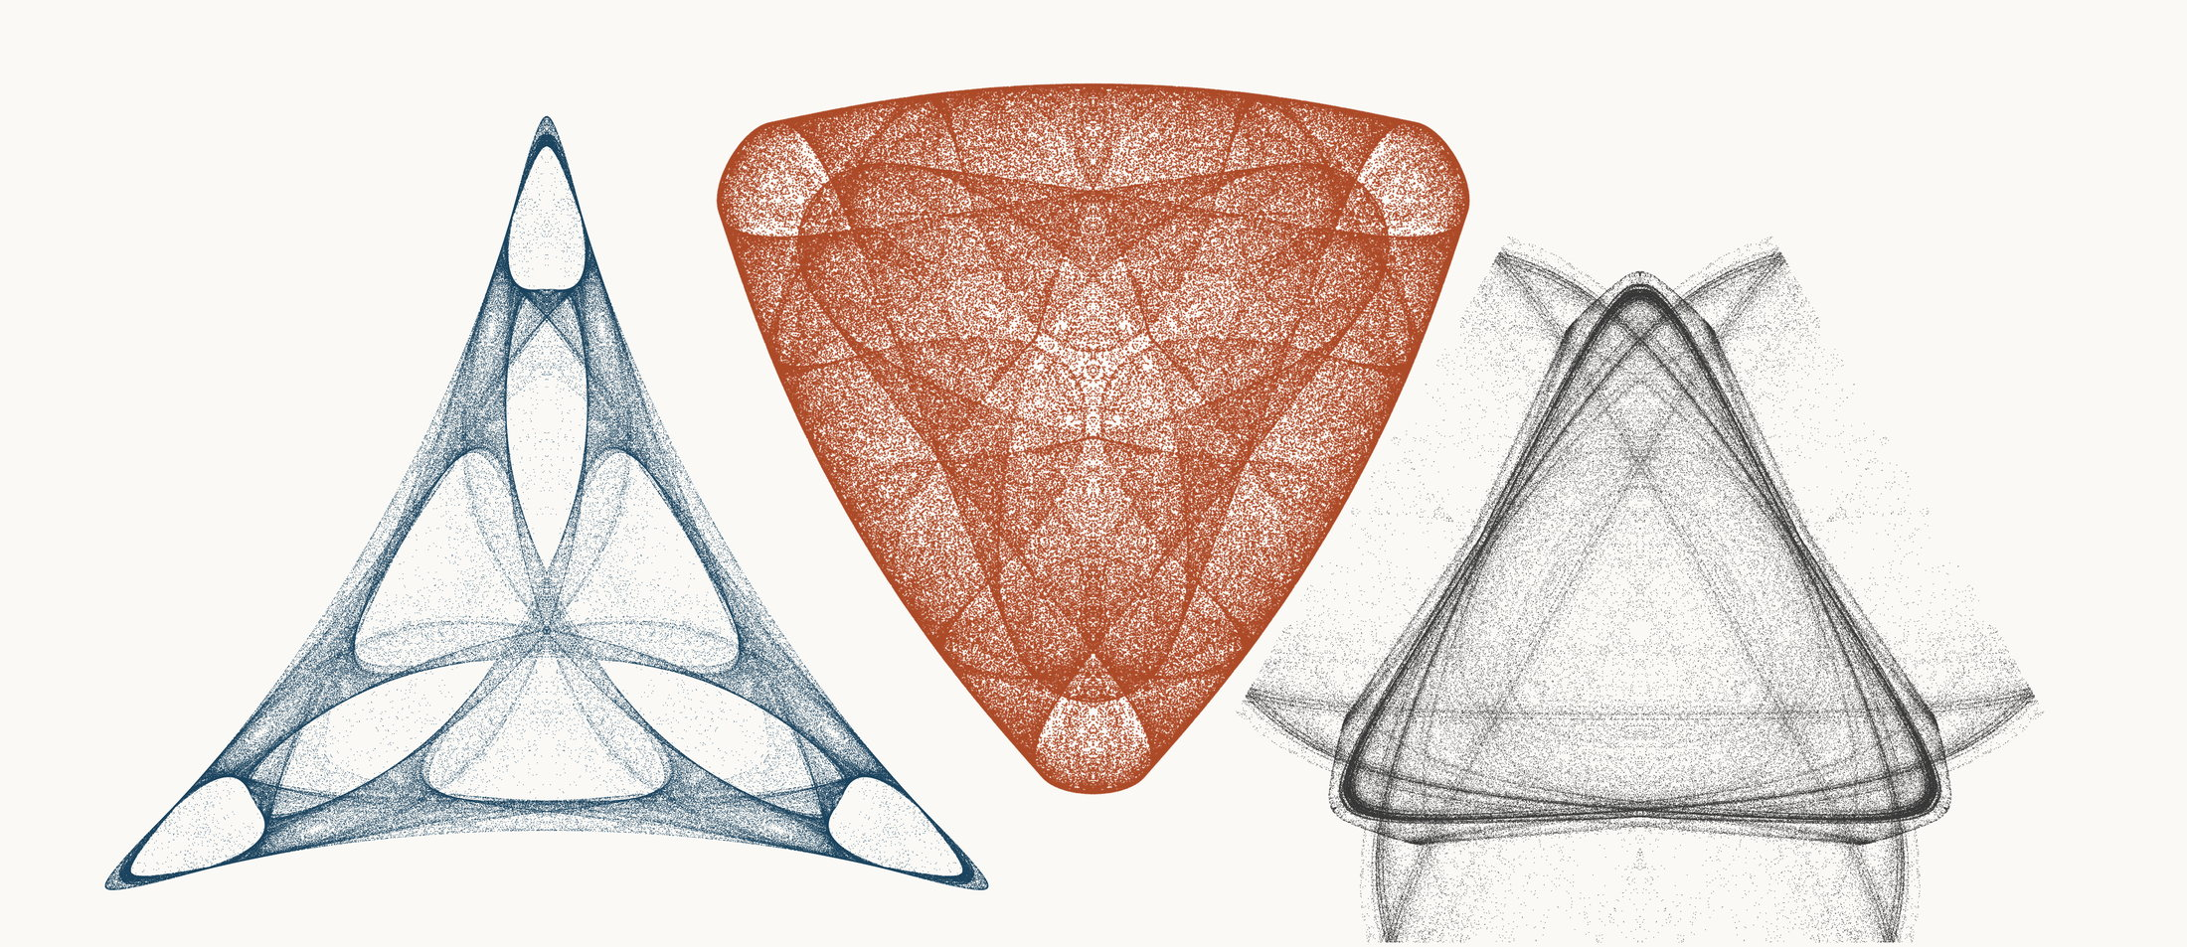
NEURAL INTERESTINGNESS 26 | RAW QUADTREE CODE BITS 26 | FORMER WUNDT GATE 26
X61072_M3  Definition X(61072); M3 pedal triangle  Neural score 59.797  Code bits 6,918 q/random 0.3420  Fitted taste 0.967 | X72137_M3  Definition X(72137); M3 pedal triangle  Code-bit rank 26 position 26  Quadtree code bits 772  q/random 0.04980 PNG/random 0.1654 | X26428_M3  Definition X(26428); M3 pedal triangle  Wundt position 26  Wundt gate 0.999486  q/random 0.4887 code bits 11,020
Each source plot uses 50,000 retained points after 4,000 discarded points and all six angle permutations. The center plot is visually oriented and enlarged only for presentation. Raw quadtree ranking is ascending by code bits.

Three Triangle Compressibility and Interestingness Atlas
Comparison position 27 of 120 Left and right upright Center visually inverted and maximized
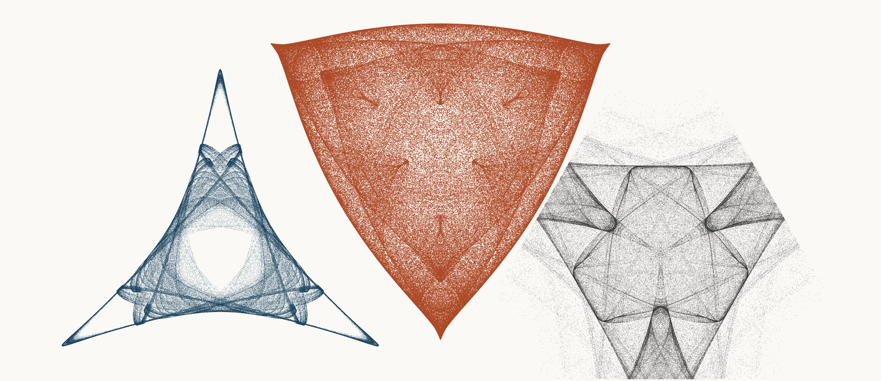
NEURAL INTERESTINGNESS 27 | RAW QUADTREE CODE BITS 27 | FORMER WUNDT GATE 27
X45213_M3  Definition X(45213); M3 pedal triangle  Neural score 59.697  Code bits 3,208 q/random 0.1794  Fitted taste 1.106 | X29567_M1  Definition X(29567); M1 cevian triangle  Code-bit rank 27 position 27  Quadtree code bits 779  q/random 0.05113 PNG/random 0.1801 | X11736_M1  Definition X(11736); M1 cevian triangle  Wundt position 27  Wundt gate 0.999473  q/random 0.5115 code bits 11,699
Each source plot uses 50,000 retained points after 4,000 discarded points and all six angle permutations. The center plot is visually oriented and enlarged only for presentation. Raw quadtree ranking is ascending by code bits.

Three Triangle Compressibility and Interestingness Atlas
Comparison position 28 of 120 Left and right upright Center visually inverted and maximized
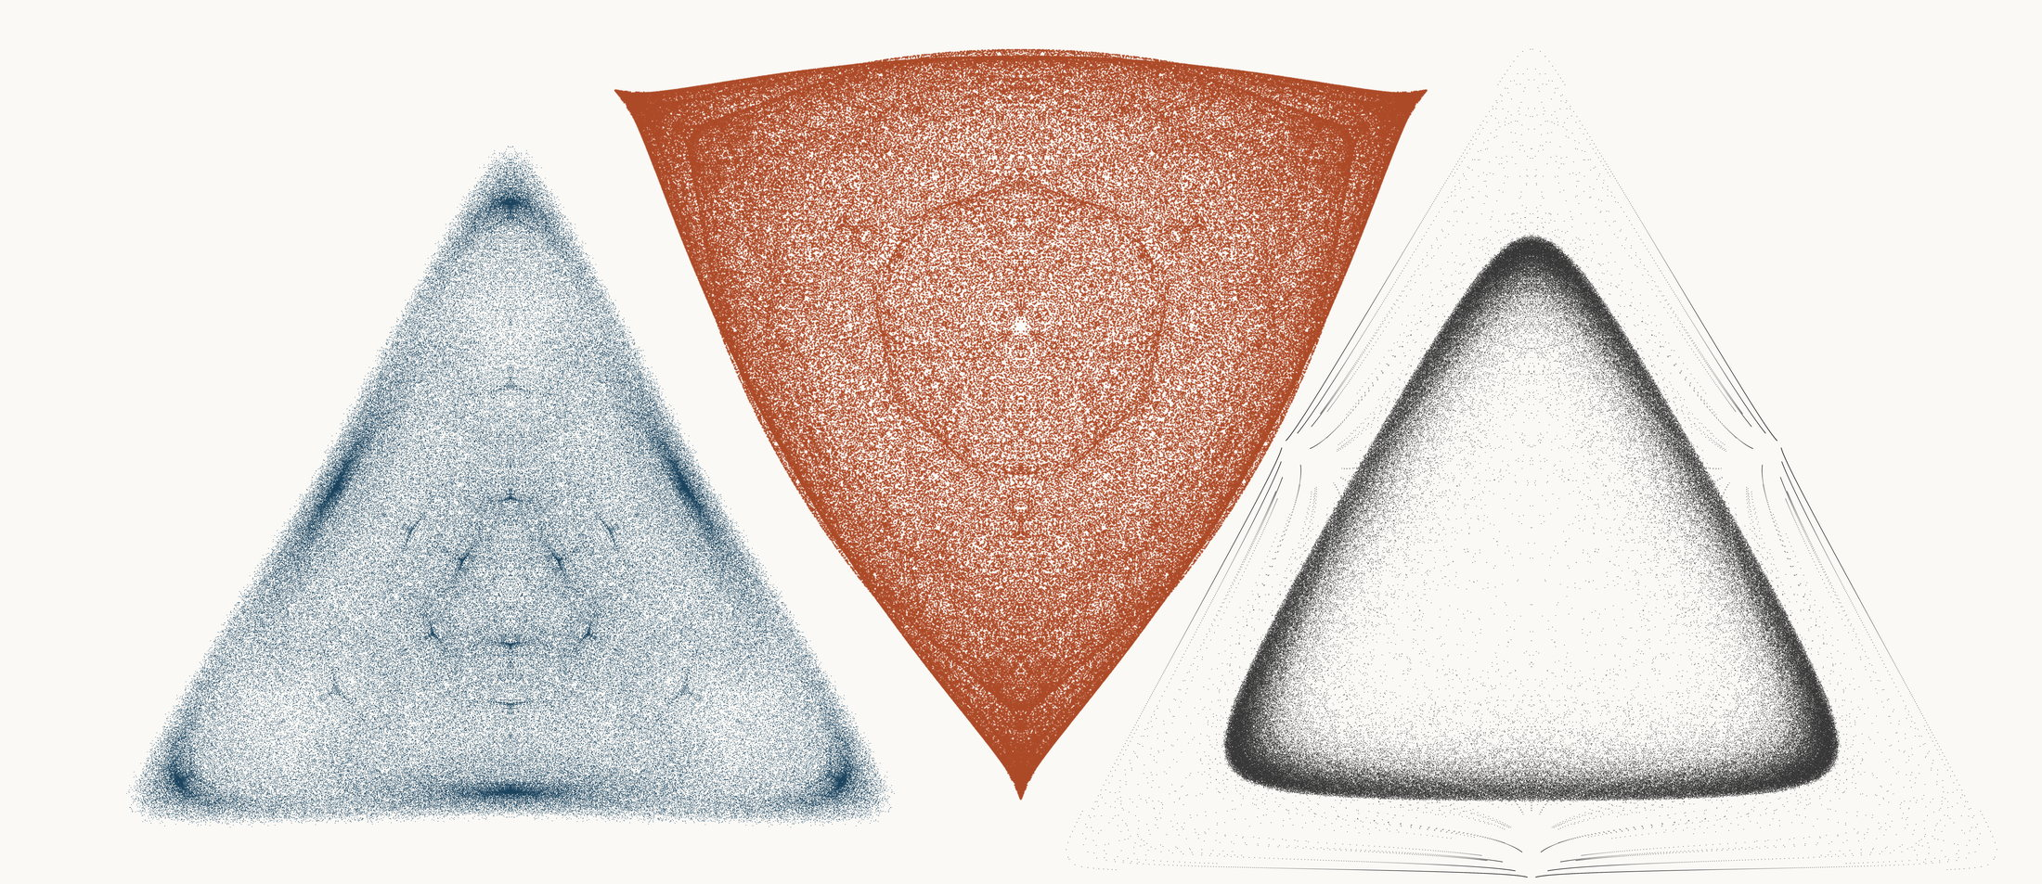
NEURAL INTERESTINGNESS 28 | RAW QUADTREE CODE BITS 28 | FORMER WUNDT GATE 28
X32191_M3  Definition X(32191); M3 pedal triangle  Neural score 59.659  Code bits 7,912 q/random 0.3438  Fitted taste 0.226 | X33280_M1  Definition X(33280); M1 cevian triangle  Code-bit rank 27 position 28  Quadtree code bits 779  q/random 0.04920 PNG/random 0.1825 | X59695_M3  Definition X(59695); M3 pedal triangle  Wundt position 28  Wundt gate 0.999440  q/random 0.5118 code bits 10,446
Each source plot uses 50,000 retained points after 4,000 discarded points and all six angle permutations. The center plot is visually oriented and enlarged only for presentation. Raw quadtree ranking is ascending by code bits.

Three Triangle Compressibility and Interestingness Atlas
Comparison position 29 of 120 Left and right upright Center visually inverted and maximized
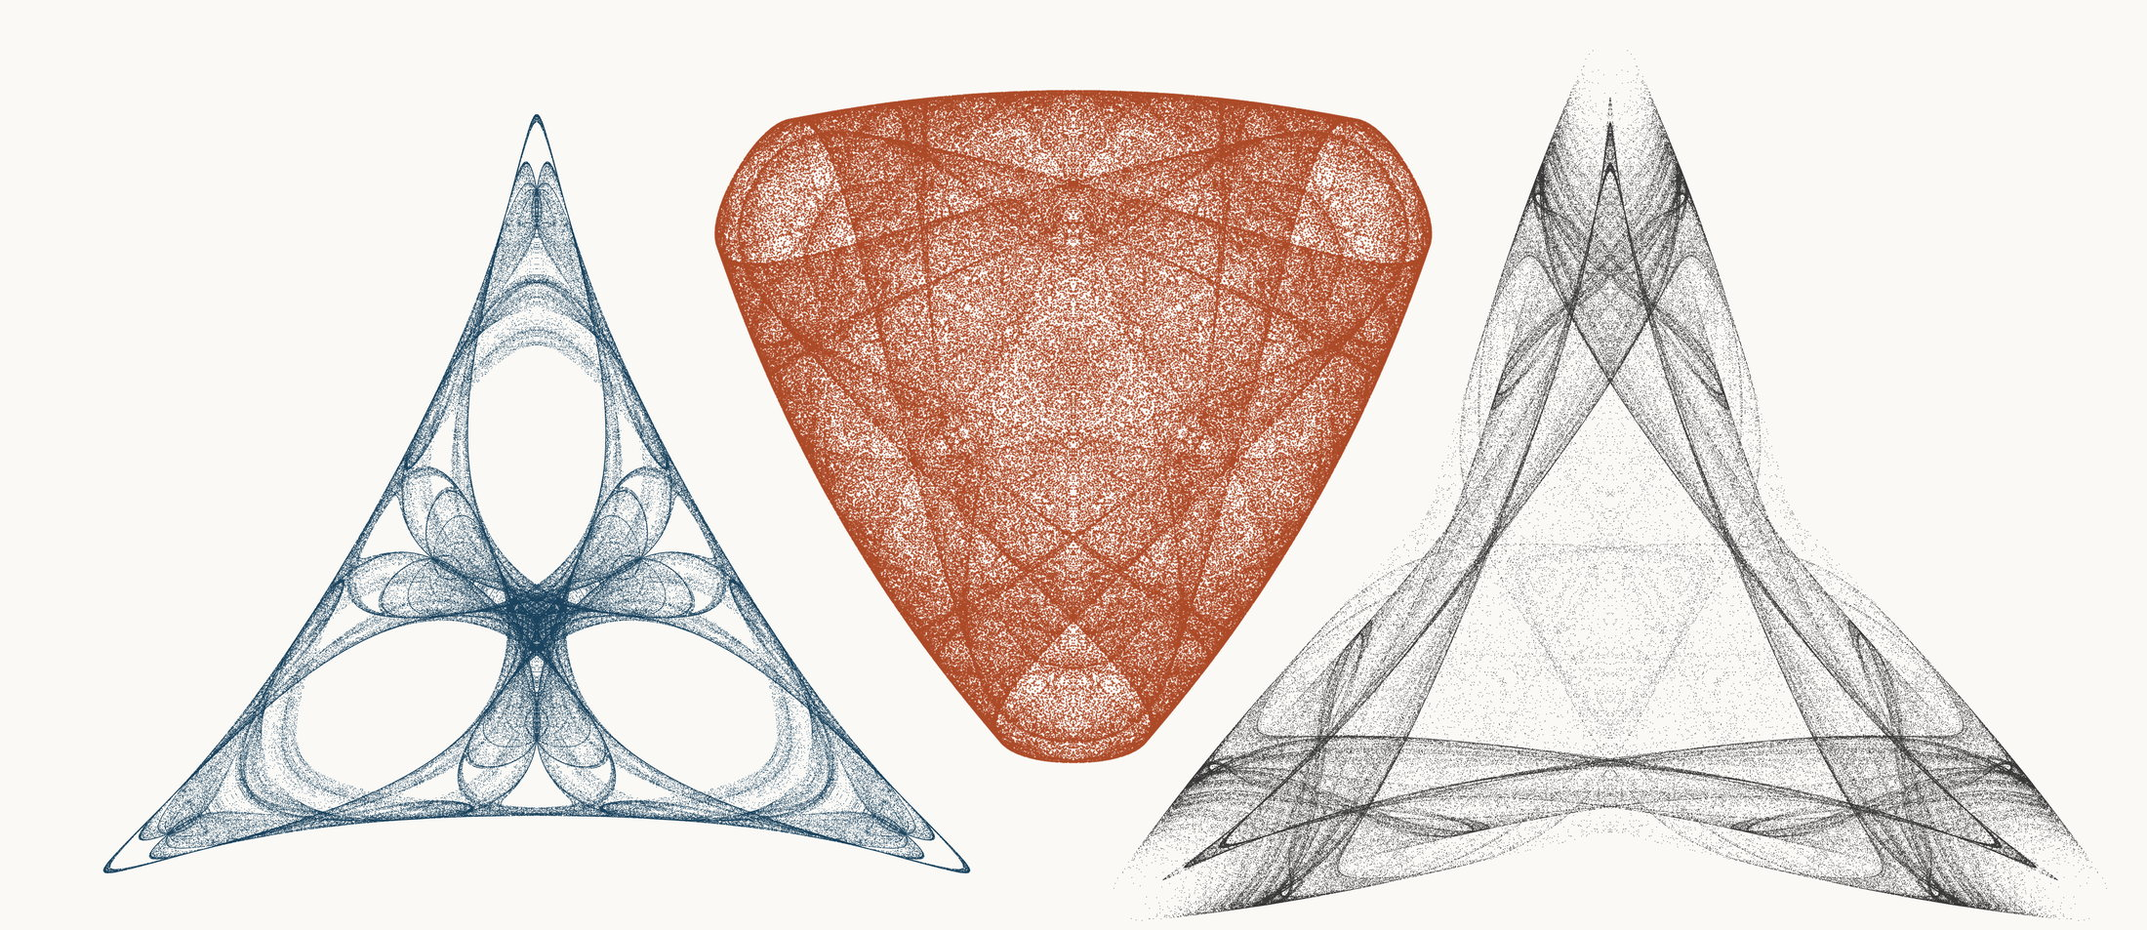
NEURAL INTERESTINGNESS 29 | RAW QUADTREE CODE BITS 29 | FORMER WUNDT GATE 29
X15449_M3  Definition X(15449); M3 pedal triangle  Neural score 59.593  Code bits 4,839 q/random 0.2449  Fitted taste 0.756 | X25296_M3  Definition X(25296); M3 pedal triangle  Code-bit rank 29 position 29  Quadtree code bits 786  q/random 0.05034 PNG/random 0.1699 | X72496_M3  Definition X(72496); M3 pedal triangle  Wundt position 29  Wundt gate 0.999430  q/random 0.5119 code bits 11,713
Each source plot uses 50,000 retained points after 4,000 discarded points and all six angle permutations. The center plot is visually oriented and enlarged only for presentation. Raw quadtree ranking is ascending by code bits.

Three Triangle Compressibility and Interestingness Atlas
Comparison position 30 of 120 Left and right upright Center visually inverted and maximized
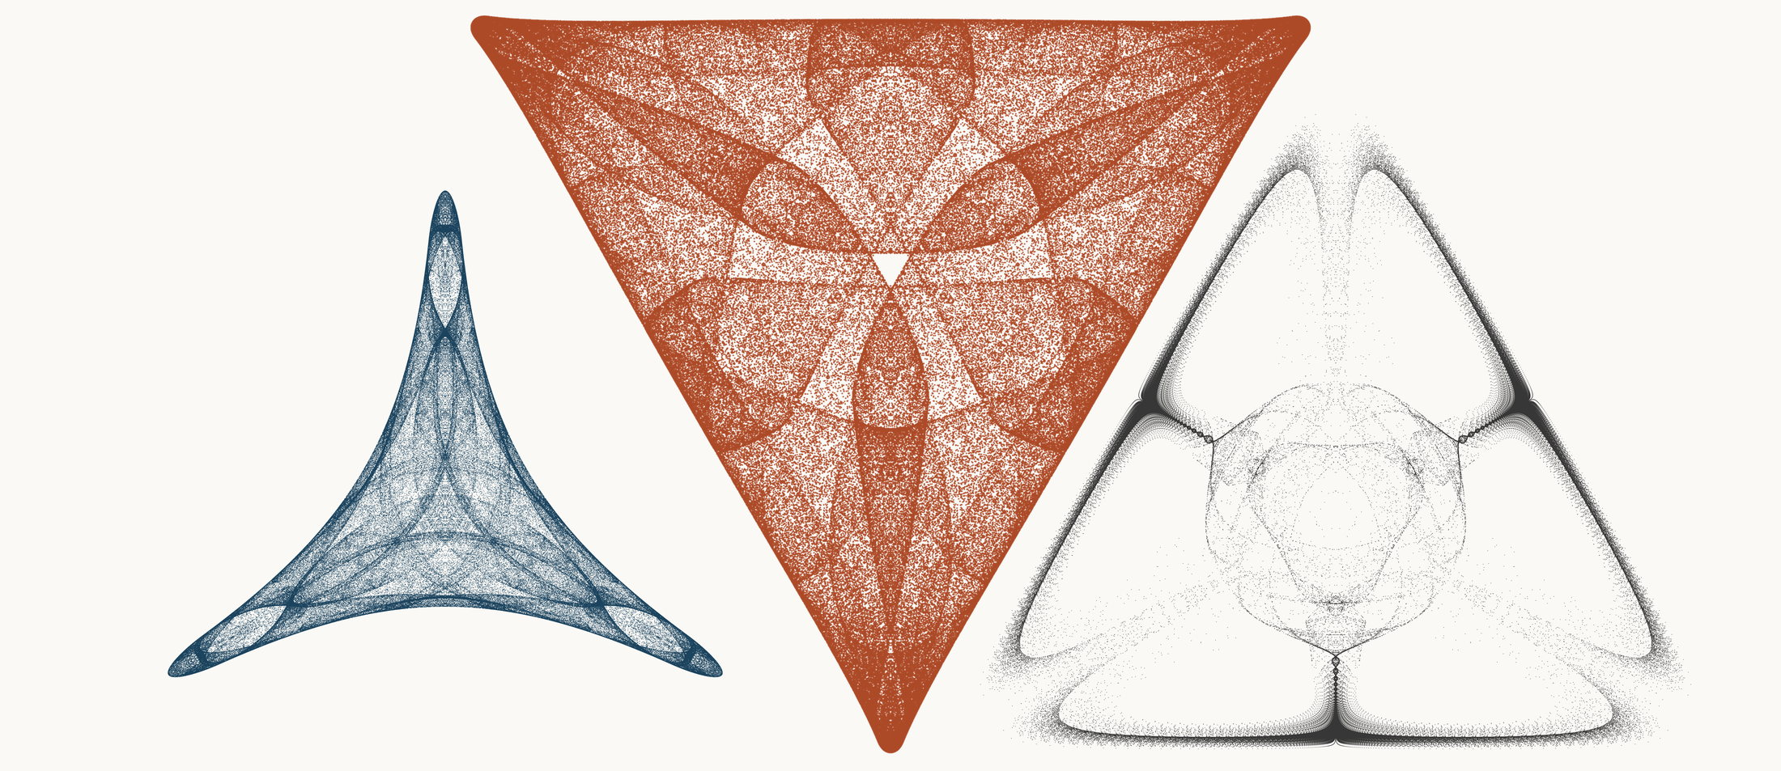
NEURAL INTERESTINGNESS 30 | RAW QUADTREE CODE BITS 30 | FORMER WUNDT GATE 30
X25843_M1  Definition X(25843); M1 cevian triangle  Neural score 59.501  Code bits 2,214 q/random 0.1265  Fitted taste 0.427 | X56022_M1  Definition X(56022); M1 cevian triangle  Code-bit rank 29 position 30  Quadtree code bits 786  q/random 0.05271 PNG/random 0.1696 | X22996_M3  Definition X(22996); M3 pedal triangle  Wundt position 30  Wundt gate 0.999415  q/random 0.4879 code bits 8,759
Each source plot uses 50,000 retained points after 4,000 discarded points and all six angle permutations. The center plot is visually oriented and enlarged only for presentation. Raw quadtree ranking is ascending by code bits.

Three Triangle Compressibility and Interestingness Atlas
Comparison position 31 of 120 Left and right upright Center visually inverted and maximized
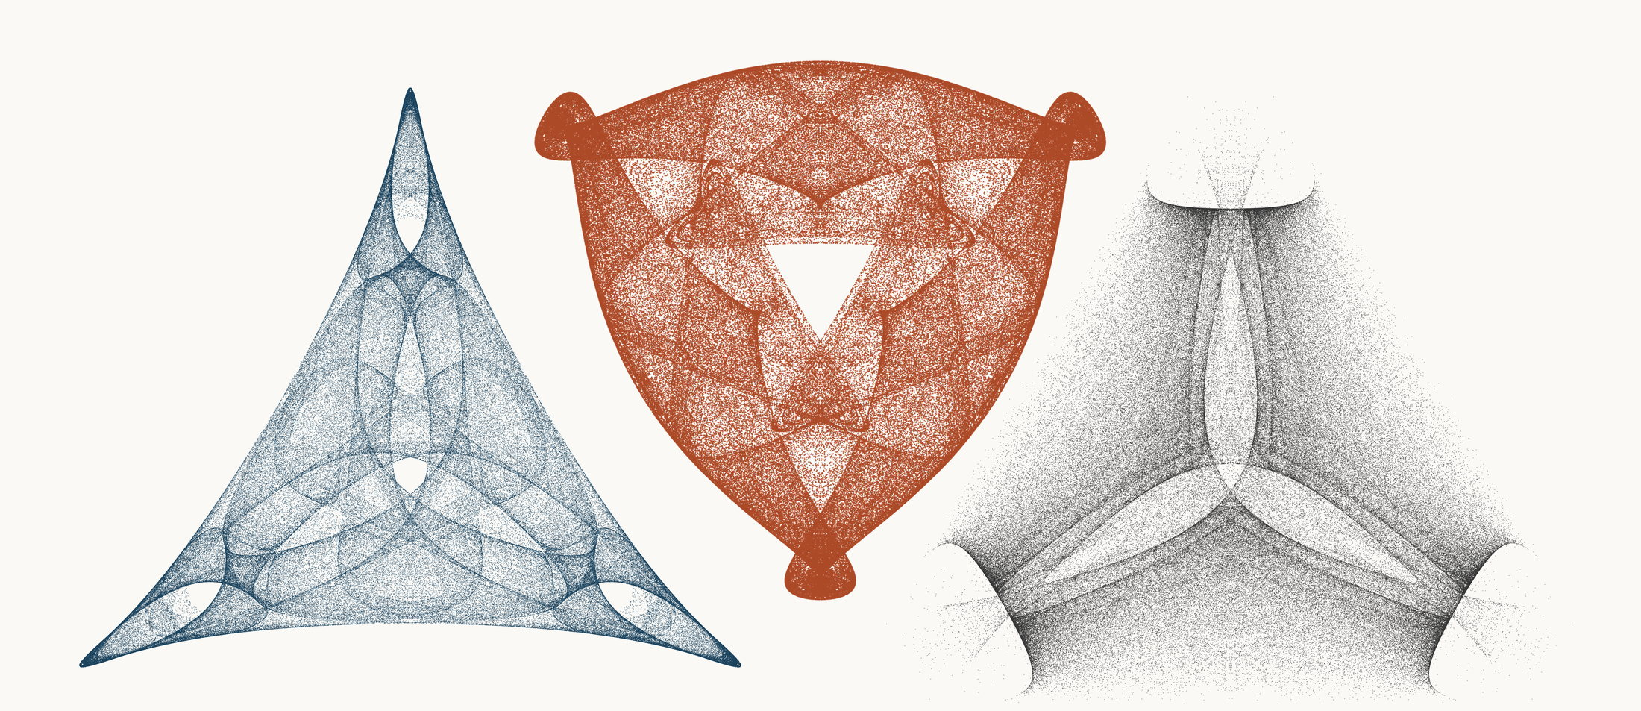
NEURAL INTERESTINGNESS 31 | RAW QUADTREE CODE BITS 31 | FORMER WUNDT GATE 31
X38959_M3  Definition X(38959); M3 pedal triangle  Neural score 59.493  Code bits 6,176 q/random 0.2717  Fitted taste 0.989 | X20843_M1  Definition X(20843); M1 cevian triangle  Code-bit rank 31 position 31  Quadtree code bits 807  q/random 0.05356 PNG/random 0.1869 | X56550_M1  Definition X(56550); M1 cevian triangle  Wundt position 31  Wundt gate 0.999391  q/random 0.4877 code bits 11,209
Each source plot uses 50,000 retained points after 4,000 discarded points and all six angle permutations. The center plot is visually oriented and enlarged only for presentation. Raw quadtree ranking is ascending by code bits.

Three Triangle Compressibility and Interestingness Atlas
Comparison position 32 of 120 Left and right upright Center visually inverted and maximized
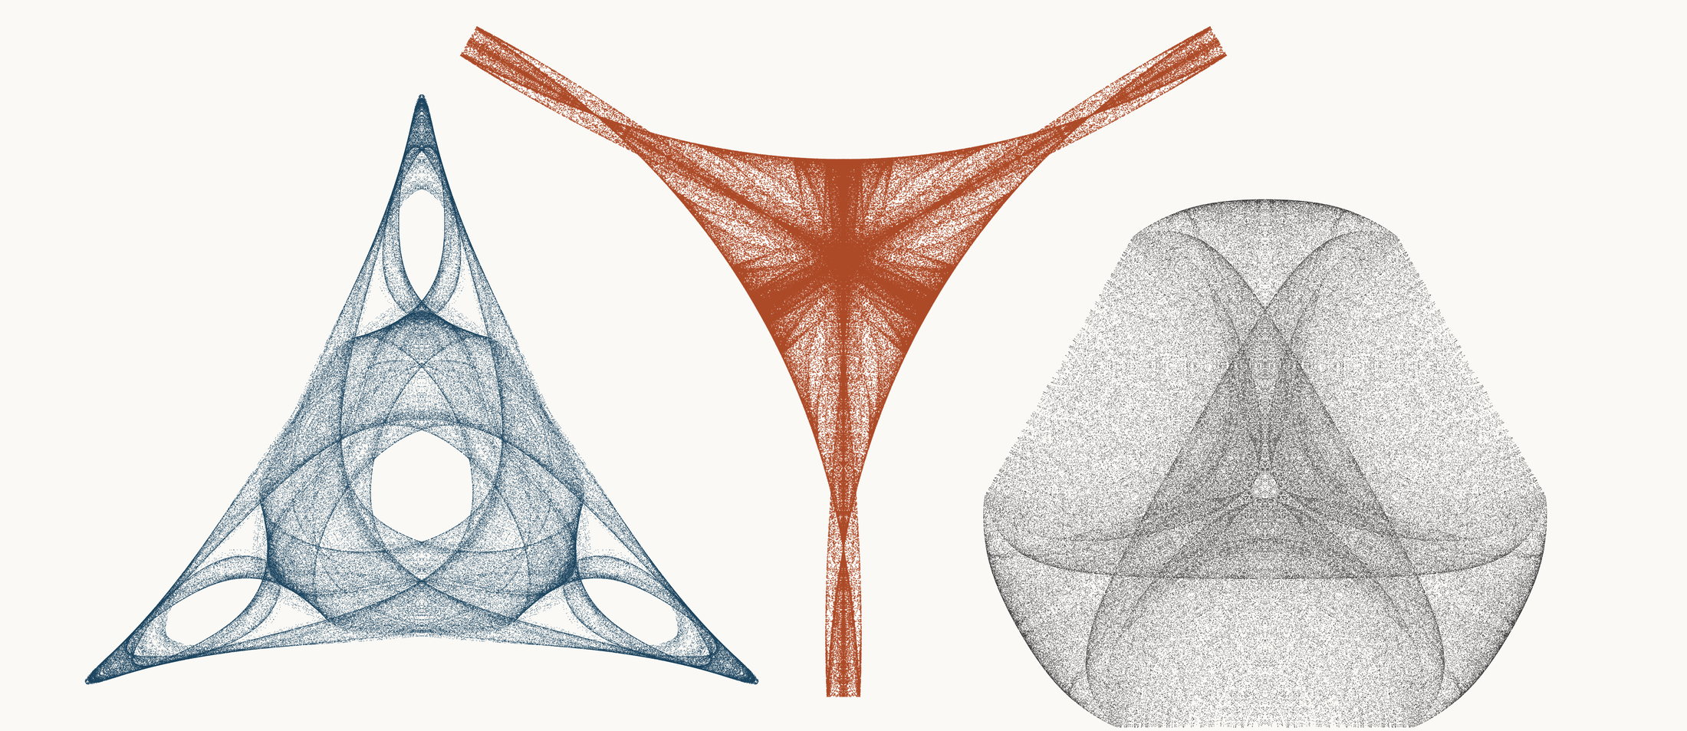
NEURAL INTERESTINGNESS 32 | RAW QUADTREE CODE BITS 32 | FORMER WUNDT GATE 32
X33966_M3  Definition X(33966); M3 pedal triangle  Neural score 59.479  Code bits 5,014 q/random 0.2287  Fitted taste 1.254 | X54597_M3  Definition X(54597); M3 pedal triangle  Code-bit rank 32 position 32  Quadtree code bits 814  q/random 0.07273 PNG/random 0.1572 | X28431_M3  Definition X(28431); M3 pedal triangle  Wundt position 32  Wundt gate 0.999332  q/random 0.5129 code bits 11,258
Each source plot uses 50,000 retained points after 4,000 discarded points and all six angle permutations. The center plot is visually oriented and enlarged only for presentation. Raw quadtree ranking is ascending by code bits.

Three Triangle Compressibility and Interestingness Atlas
Comparison position 33 of 120 Left and right upright Center visually inverted and maximized
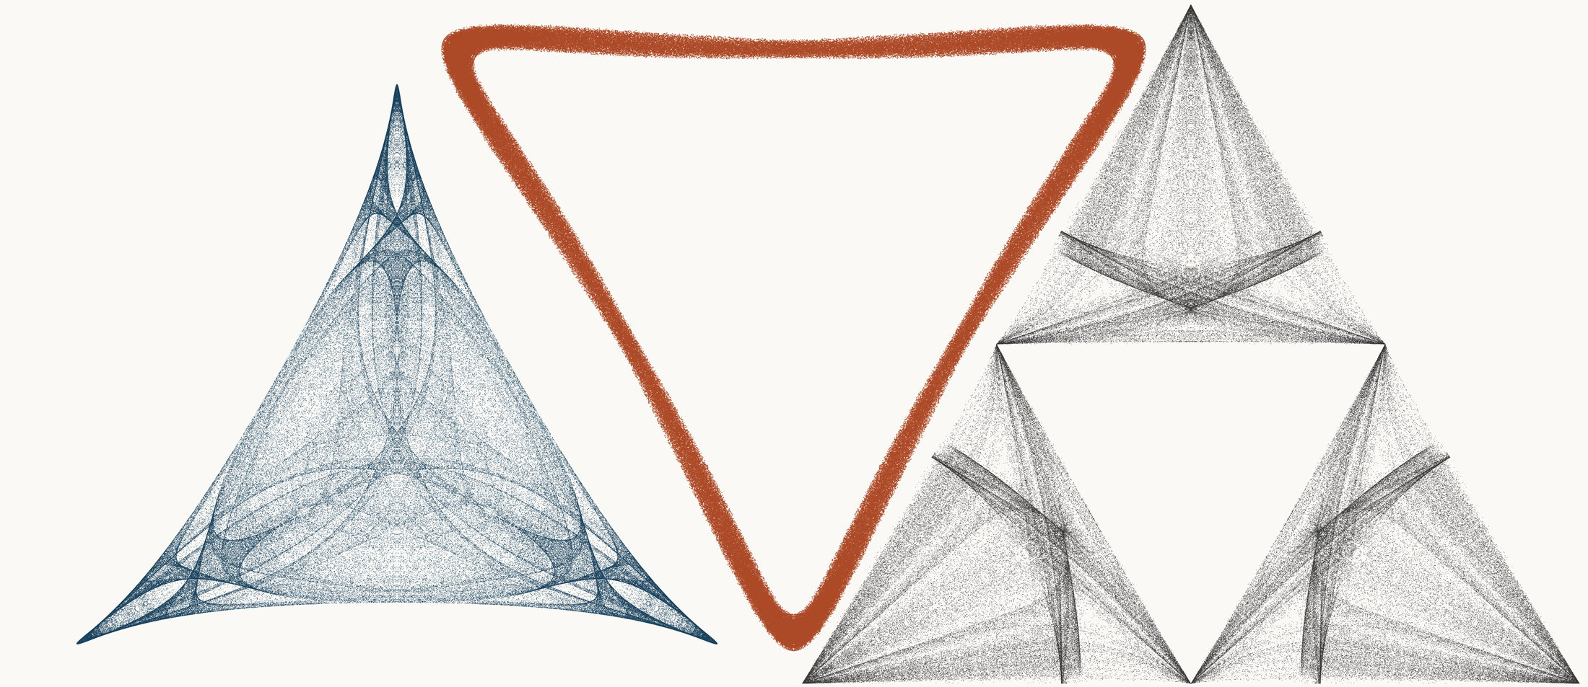
NEURAL INTERESTINGNESS 33 | RAW QUADTREE CODE BITS 33 | FORMER WUNDT GATE 33
X7207_M3  Definition X(7207); M3 pedal triangle  Neural score 59.447  Code bits 6,988 q/random 0.3123  Fitted taste 0.990 | X31863_M1  Definition X(31863); M1 cevian triangle  Code-bit rank 33 position 33  Quadtree code bits 828  q/random 0.08607 PNG/random 0.0952 | X1300_M1  Definition X(1300); M1 cevian triangle  Wundt position 33  Wundt gate 0.999196  q/random 0.5142 code bits 11,804
Each source plot uses 50,000 retained points after 4,000 discarded points and all six angle permutations. The center plot is visually oriented and enlarged only for presentation. Raw quadtree ranking is ascending by code bits.

Three Triangle Compressibility and Interestingness Atlas
Comparison position 34 of 120 Left and right upright Center visually inverted and maximized
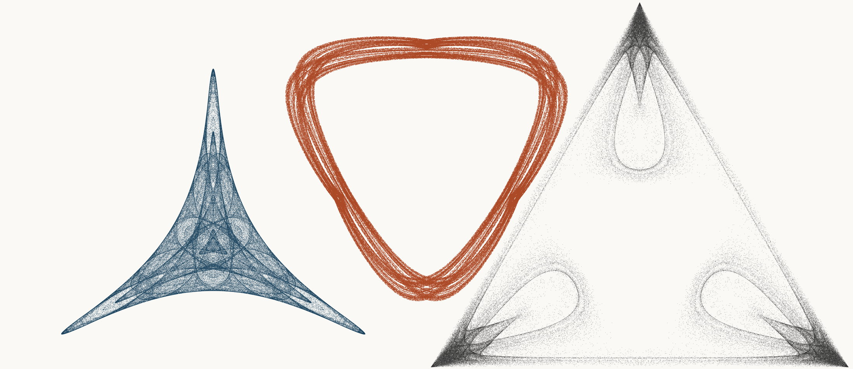
NEURAL INTERESTINGNESS 34 | RAW QUADTREE CODE BITS 34 | FORMER WUNDT GATE 34
X20270_M1  Definition X(20270); M1 cevian triangle  Neural score 59.440  Code bits 2,053 q/random 0.1143  Fitted taste 0.532 | X32297_M3  Definition X(32297); M3 pedal triangle  Code-bit rank 33 position 34  Quadtree code bits 828  q/random 0.07139 PNG/random 0.1372 | X4650_M3  Definition X(4650); M3 pedal triangle  Wundt position 34  Wundt gate 0.999126  q/random 0.5148 code bits 11,097
Each source plot uses 50,000 retained points after 4,000 discarded points and all six angle permutations. The center plot is visually oriented and enlarged only for presentation. Raw quadtree ranking is ascending by code bits.

Three Triangle Compressibility and Interestingness Atlas
Comparison position 35 of 120 Left and right upright Center visually inverted and maximized
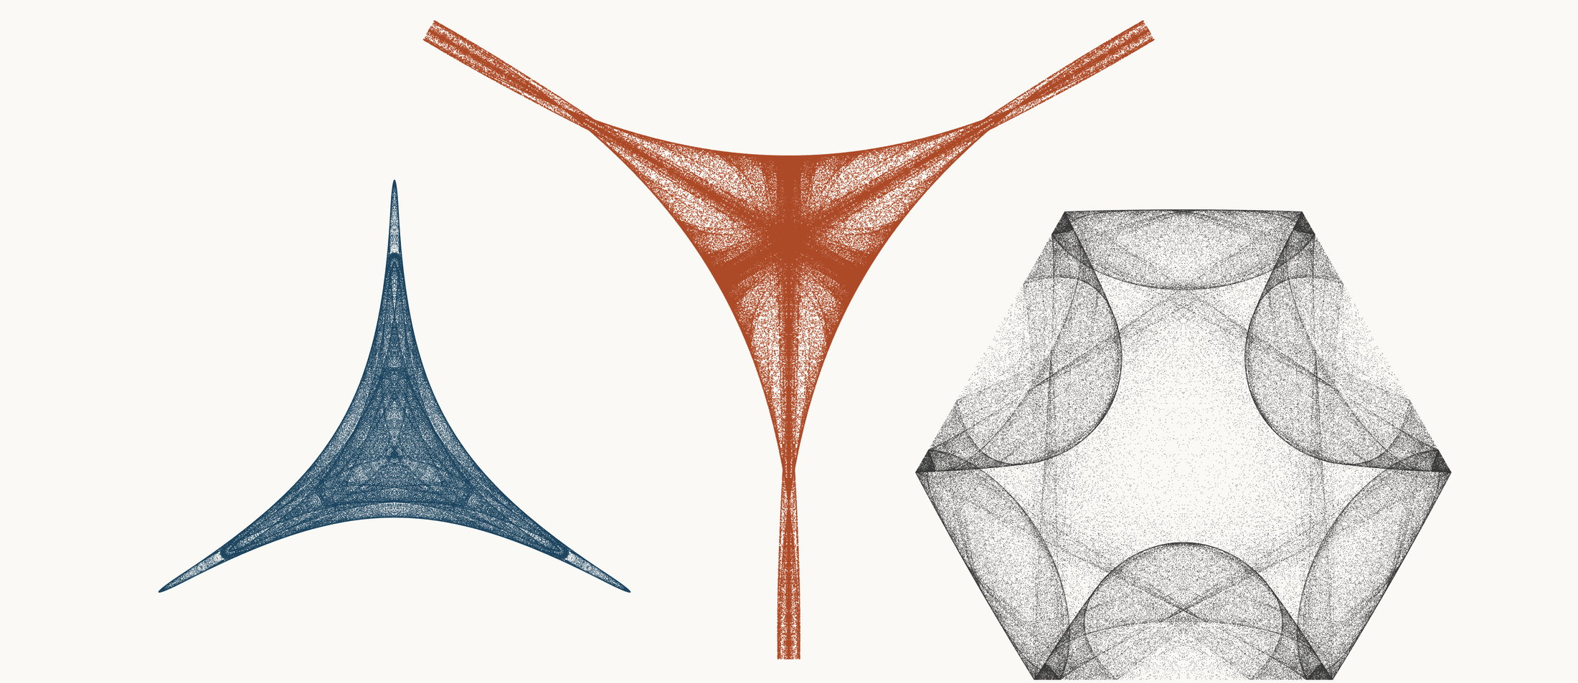
NEURAL INTERESTINGNESS 35 | RAW QUADTREE CODE BITS 35 | FORMER WUNDT GATE 35
X69153_M1  Definition X(69153); M1 cevian triangle  Neural score 59.195  Code bits 1,430 q/random 0.1044  Fitted taste 0.183 | X3382_M3  Definition X(3382); M3 pedal triangle  Code-bit rank 33 position 35  Quadtree code bits 828  q/random 0.08939 PNG/random 0.1586 | X54901_M3  Definition X(54901); M3 pedal triangle  Wundt position 35  Wundt gate 0.998934  q/random 0.4837 code bits 11,202
Each source plot uses 50,000 retained points after 4,000 discarded points and all six angle permutations. The center plot is visually oriented and enlarged only for presentation. Raw quadtree ranking is ascending by code bits.

Three Triangle Compressibility and Interestingness Atlas
Comparison position 36 of 120 Left and right upright Center visually inverted and maximized
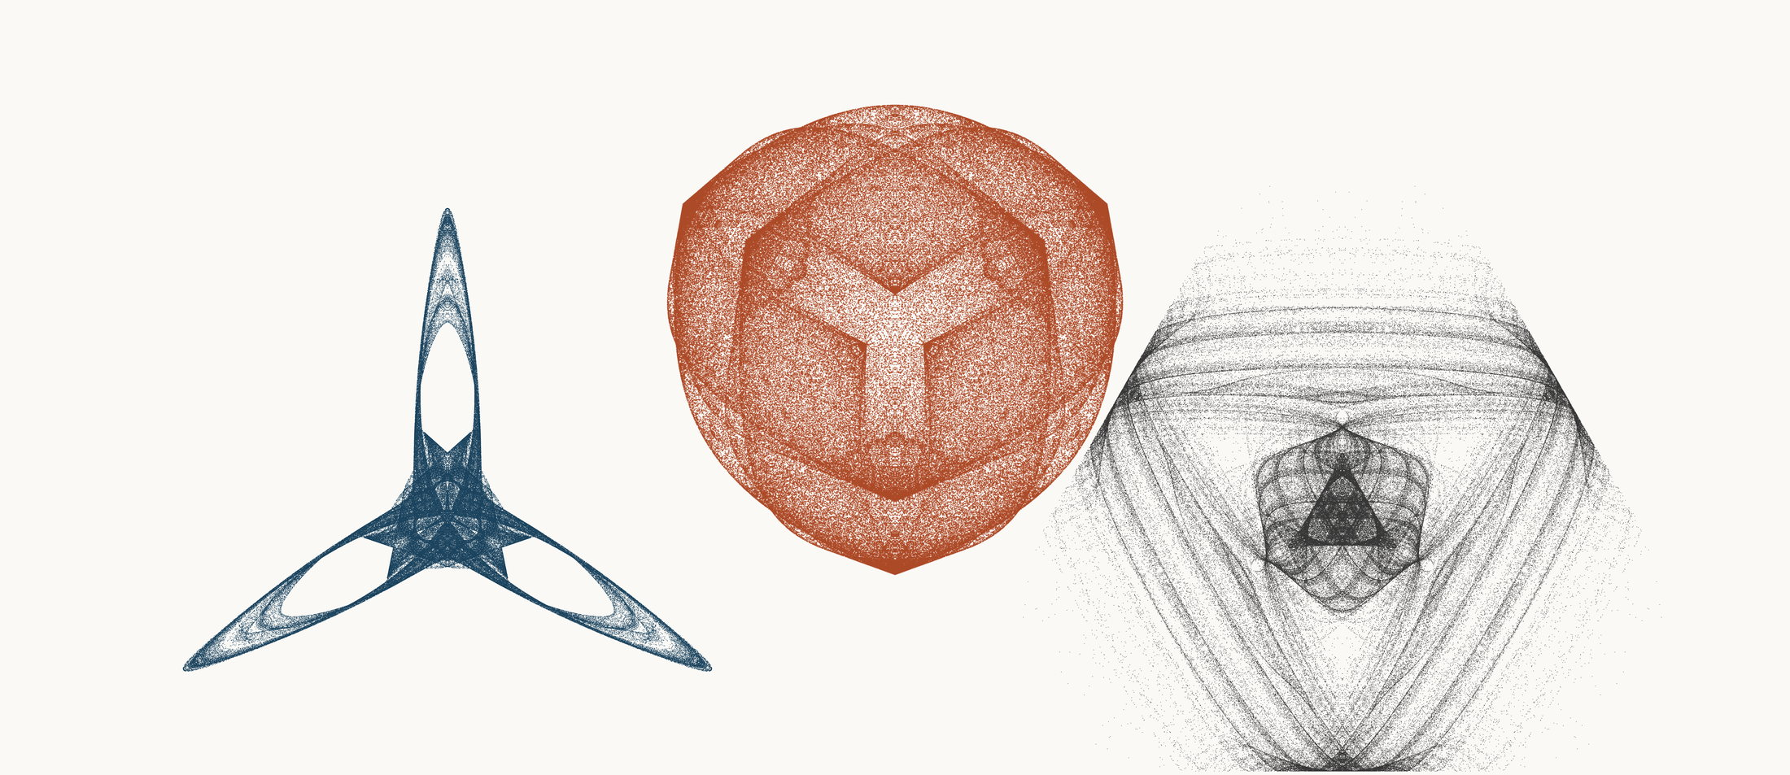
NEURAL INTERESTINGNESS 36 | RAW QUADTREE CODE BITS 36 | FORMER WUNDT GATE 36
X67397_M3  Definition X(67397); M3 pedal triangle  Neural score 59.167  Code bits 1,521 q/random 0.1283  Fitted taste -0.343 | X35302_M1  Definition X(35302); M1 cevian triangle  Code-bit rank 33 position 36  Quadtree code bits 828  q/random 0.05160 PNG/random 0.1697 | X2665_M1  Definition X(2665); M1 cevian triangle  Wundt position 36  Wundt gate 0.998892  q/random 0.5166 code bits 11,629
Each source plot uses 50,000 retained points after 4,000 discarded points and all six angle permutations. The center plot is visually oriented and enlarged only for presentation. Raw quadtree ranking is ascending by code bits.

Three Triangle Compressibility and Interestingness Atlas
Comparison position 37 of 120 Left and right upright Center visually inverted and maximized
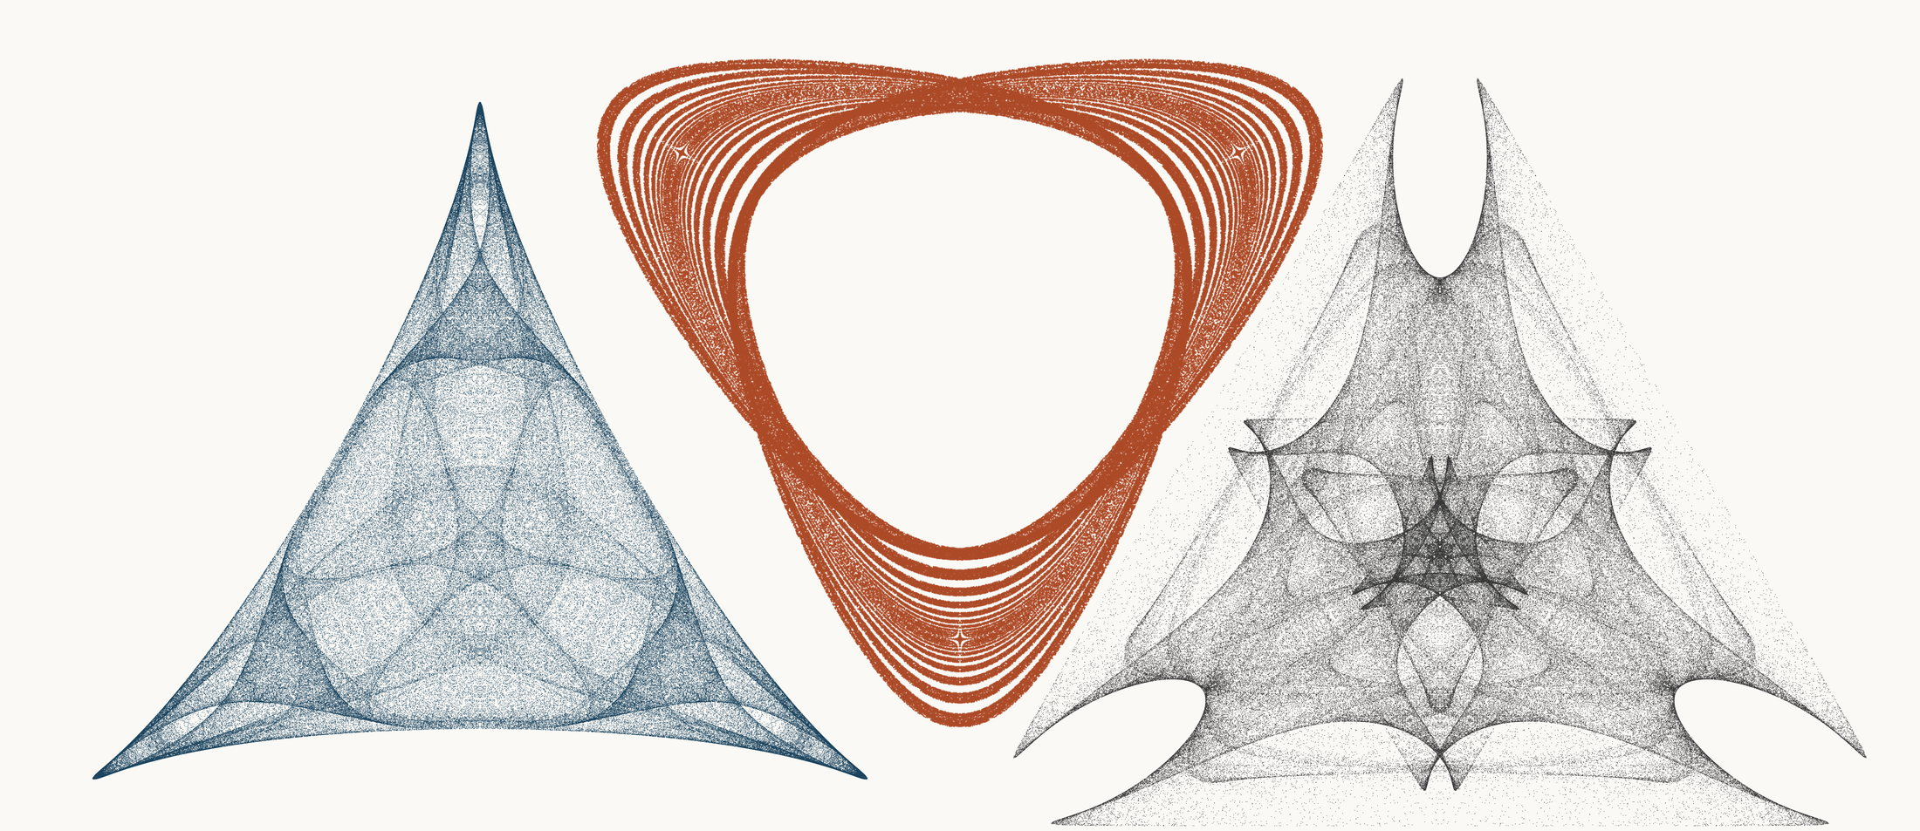
NEURAL INTERESTINGNESS 37 | RAW QUADTREE CODE BITS 37 | FORMER WUNDT GATE 37
X47006_M3  Definition X(47006); M3 pedal triangle  Neural score 59.114  Code bits 5,805 q/random 0.2564  Fitted taste 0.933 | X49836_M3  Definition X(49836); M3 pedal triangle  Code-bit rank 37 position 37  Quadtree code bits 835  q/random 0.07981 PNG/random 0.1495 | X63774_M3  Definition X(63774); M3 pedal triangle  Wundt position 37  Wundt gate 0.998873  q/random 0.5168 code bits 11,965
Each source plot uses 50,000 retained points after 4,000 discarded points and all six angle permutations. The center plot is visually oriented and enlarged only for presentation. Raw quadtree ranking is ascending by code bits.

Three Triangle Compressibility and Interestingness Atlas
Comparison position 38 of 120 Left and right upright Center visually inverted and maximized
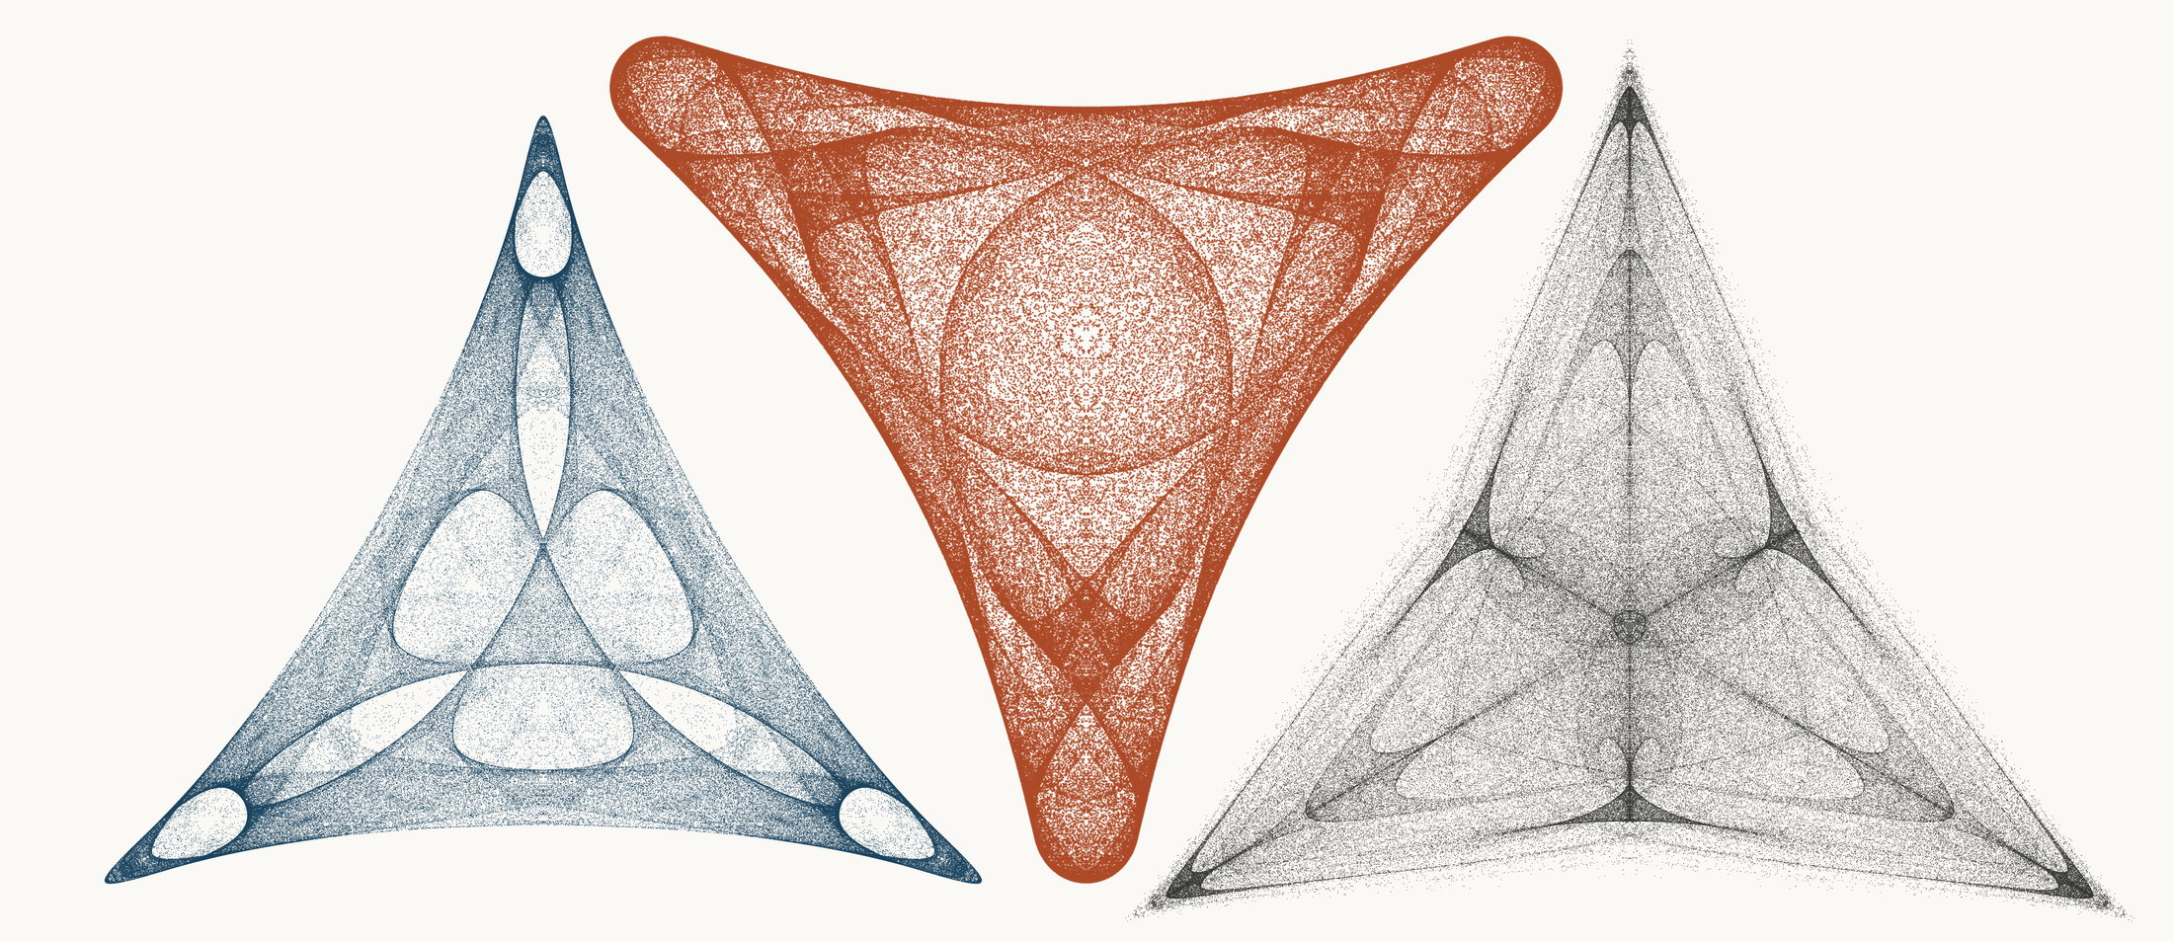
NEURAL INTERESTINGNESS 38 | RAW QUADTREE CODE BITS 38 | FORMER WUNDT GATE 38
X43266_M3  Definition X(43266); M3 pedal triangle  Neural score 59.030  Code bits 6,785 q/random 0.3061  Fitted taste 0.983 | X64993_M3  Definition X(64993); M3 pedal triangle  Code-bit rank 37 position 38  Quadtree code bits 835  q/random 0.05859 PNG/random 0.1665 | X67872_M3  Definition X(67872); M3 pedal triangle  Wundt position 38  Wundt gate 0.998799  q/random 0.4827 code bits 11,118
Each source plot uses 50,000 retained points after 4,000 discarded points and all six angle permutations. The center plot is visually oriented and enlarged only for presentation. Raw quadtree ranking is ascending by code bits.

Three Triangle Compressibility and Interestingness Atlas
Comparison position 39 of 120 Left and right upright Center visually inverted and maximized
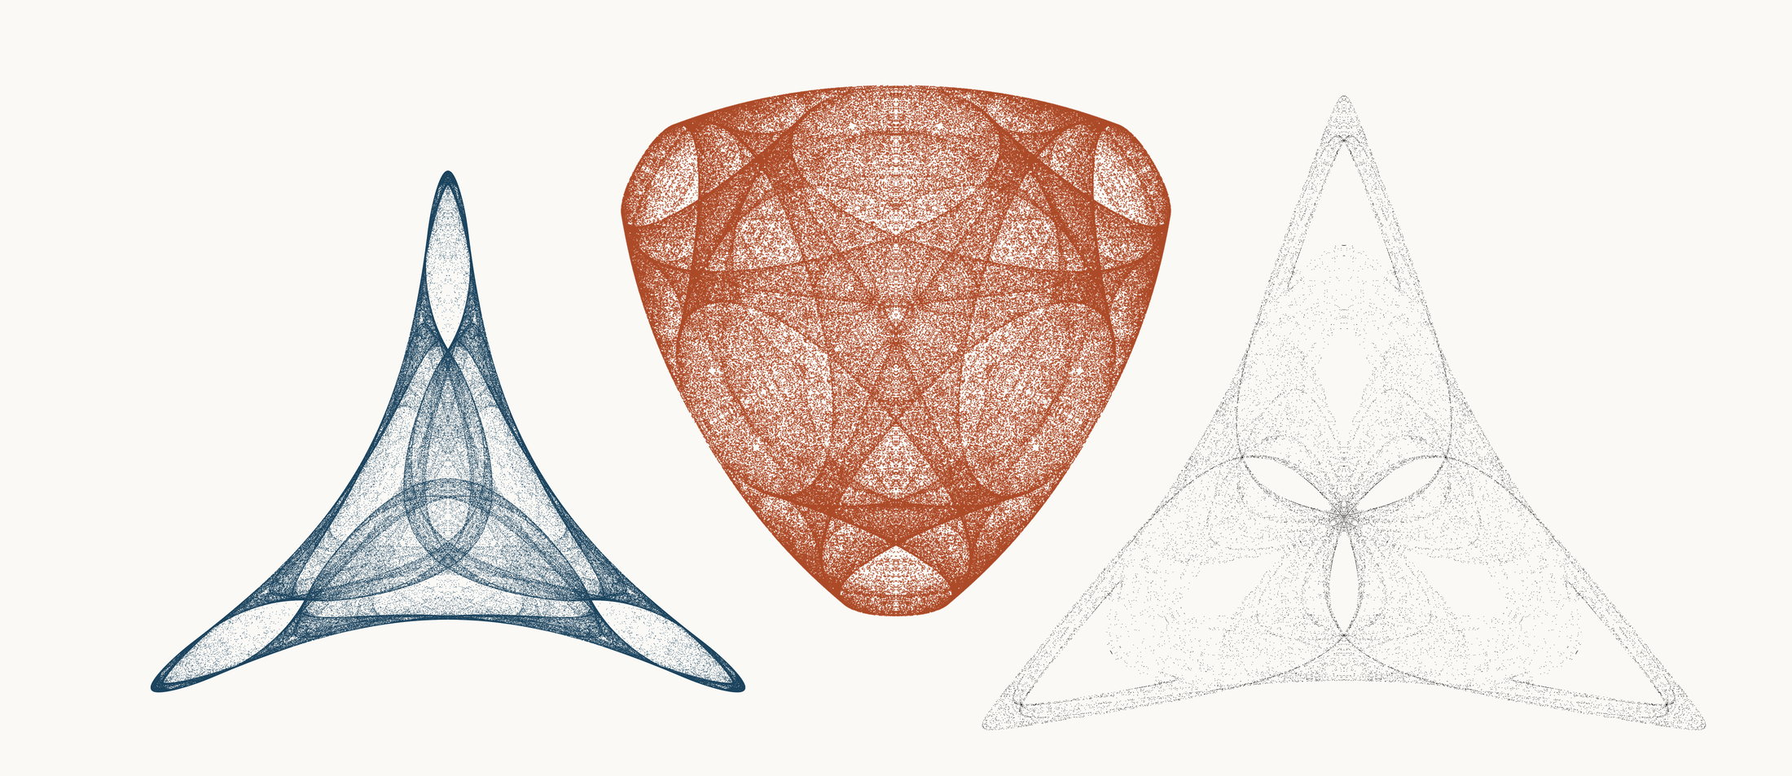
NEURAL INTERESTINGNESS 39 | RAW QUADTREE CODE BITS 39 | FORMER WUNDT GATE 39
X62199_M1  Definition X(62199); M1 cevian triangle  Neural score 58.978  Code bits 3,663 q/random 0.2085  Fitted taste 0.853 | X21742_M3  Definition X(21742); M3 pedal triangle  Code-bit rank 39 position 39  Quadtree code bits 849  q/random 0.05305 PNG/random 0.1797 | X5522_M3  Definition X(5522); M3 pedal triangle  Wundt position 39  Wundt gate 0.998732  q/random 0.5178 code bits 9,368
Each source plot uses 50,000 retained points after 4,000 discarded points and all six angle permutations. The center plot is visually oriented and enlarged only for presentation. Raw quadtree ranking is ascending by code bits.

Three Triangle Compressibility and Interestingness Atlas
Comparison position 40 of 120 Left and right upright Center visually inverted and maximized
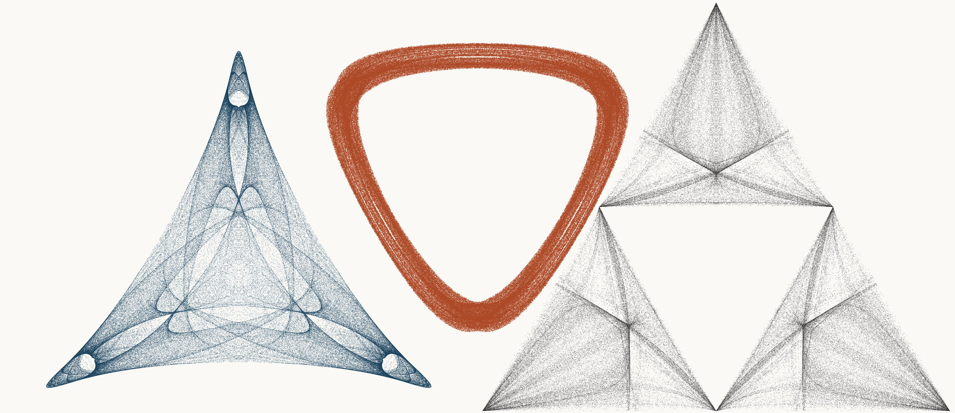
NEURAL INTERESTINGNESS 40 | RAW QUADTREE CODE BITS 40 | FORMER WUNDT GATE 40
X53541_M3  Definition X(53541); M3 pedal triangle  Neural score 58.961  Code bits 7,429 q/random 0.3302  Fitted taste 0.895 | X12743_M3  Definition X(12743); M3 pedal triangle  Code-bit rank 40 position 40  Quadtree code bits 856  q/random 0.07615 PNG/random 0.1440 | X917_M1  Definition X(917); M1 cevian triangle  Wundt position 40  Wundt gate 0.998668  q/random 0.5182 code bits 11,832
Each source plot uses 50,000 retained points after 4,000 discarded points and all six angle permutations. The center plot is visually oriented and enlarged only for presentation. Raw quadtree ranking is ascending by code bits.

Three Triangle Compressibility and Interestingness Atlas
Comparison position 41 of 120 Left and right upright Center visually inverted and maximized
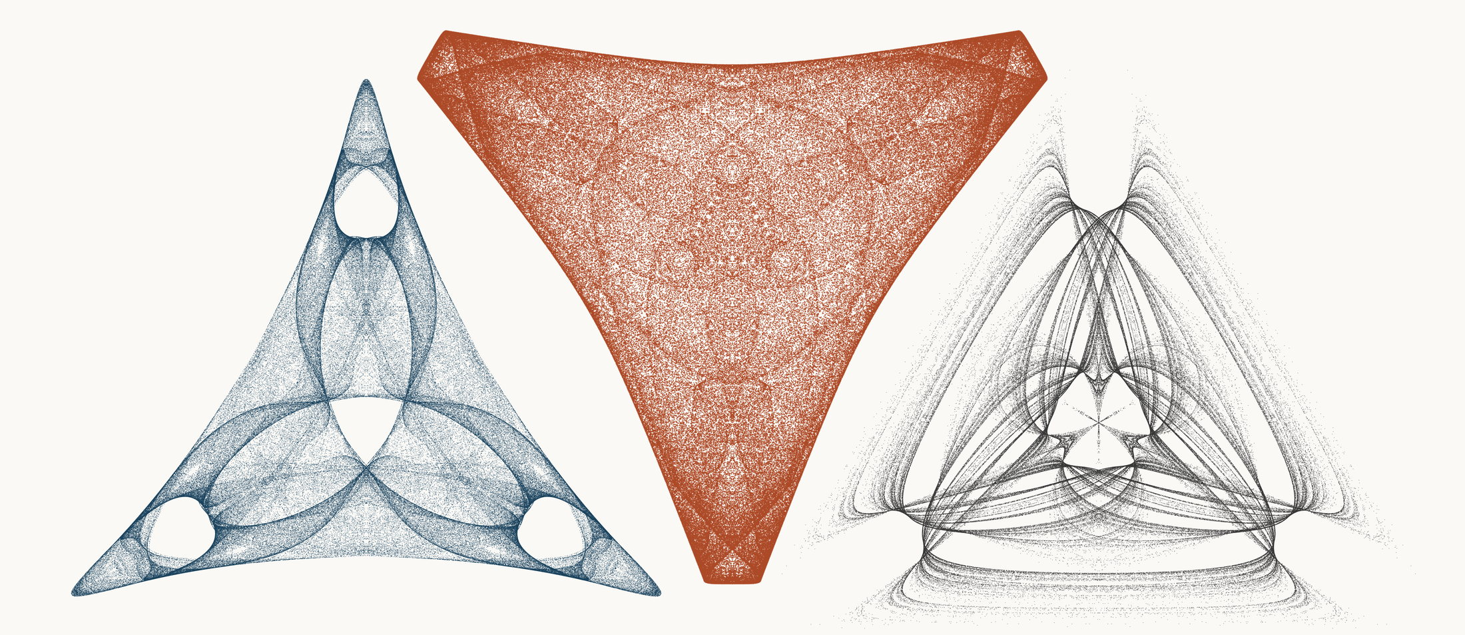
NEURAL INTERESTINGNESS 41 | RAW QUADTREE CODE BITS 41 | FORMER WUNDT GATE 41
X65116_M3  Definition X(65116); M3 pedal triangle  Neural score 58.941  Code bits 6,008 q/random 0.2708  Fitted taste 1.147 | X37765_M3  Definition X(37765); M3 pedal triangle  Code-bit rank 41 position 41  Quadtree code bits 870  q/random 0.05193 PNG/random 0.1633 | X8435_M3  Definition X(8435); M3 pedal triangle  Wundt position 41  Wundt gate 0.998613  q/random 0.5186 code bits 11,503
Each source plot uses 50,000 retained points after 4,000 discarded points and all six angle permutations. The center plot is visually oriented and enlarged only for presentation. Raw quadtree ranking is ascending by code bits.

Three Triangle Compressibility and Interestingness Atlas
Comparison position 42 of 120 Left and right upright Center visually inverted and maximized
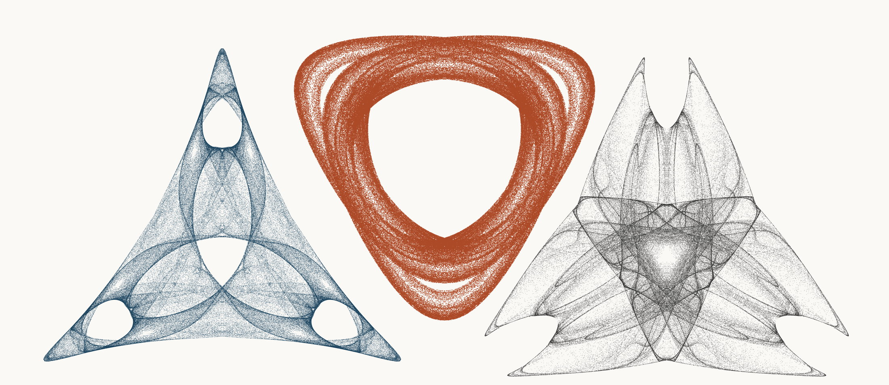
NEURAL INTERESTINGNESS 42 | RAW QUADTREE CODE BITS 42 | FORMER WUNDT GATE 42
X72767_M3  Definition X(72767); M3 pedal triangle  Neural score 58.857  Code bits 6,113 q/random 0.2778  Fitted taste 1.083 | X15560_M3  Definition X(15560); M3 pedal triangle  Code-bit rank 42 position 42  Quadtree code bits 877  q/random 0.06929 PNG/random 0.1491 | X39760_M3  Definition X(39760); M3 pedal triangle  Wundt position 42  Wundt gate 0.998612  q/random 0.4814 code bits 11,125
Each source plot uses 50,000 retained points after 4,000 discarded points and all six angle permutations. The center plot is visually oriented and enlarged only for presentation. Raw quadtree ranking is ascending by code bits.

Three Triangle Compressibility and Interestingness Atlas
Comparison position 43 of 120 Left and right upright Center visually inverted and maximized
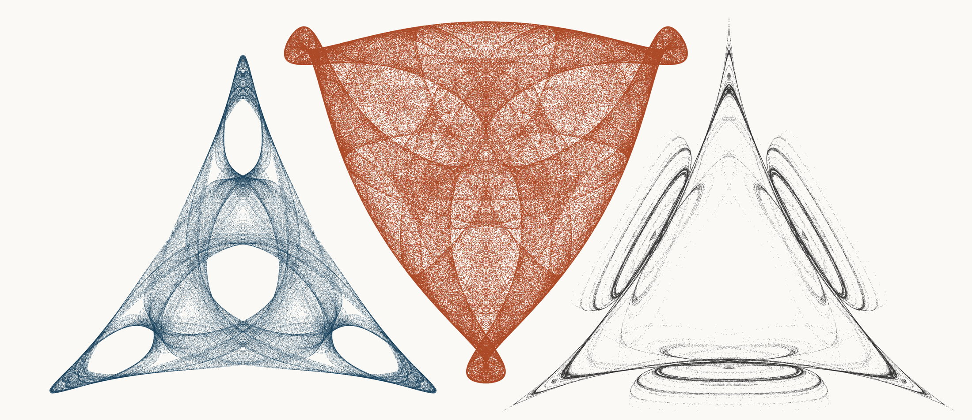
NEURAL INTERESTINGNESS 43 | RAW QUADTREE CODE BITS 43 | FORMER WUNDT GATE 43
X69098_M3  Definition X(69098); M3 pedal triangle  Neural score 58.786  Code bits 4,244 q/random 0.1967  Fitted taste 1.332 | X22819_M3  Definition X(22819); M3 pedal triangle  Code-bit rank 43 position 43  Quadtree code bits 884  q/random 0.05287 PNG/random 0.1890 | X18636_M3  Definition X(18636); M3 pedal triangle  Wundt position 43  Wundt gate 0.998610  q/random 0.4814 code bits 8,045
Each source plot uses 50,000 retained points after 4,000 discarded points and all six angle permutations. The center plot is visually oriented and enlarged only for presentation. Raw quadtree ranking is ascending by code bits.

Three Triangle Compressibility and Interestingness Atlas
Comparison position 44 of 120 Left and right upright Center visually inverted and maximized
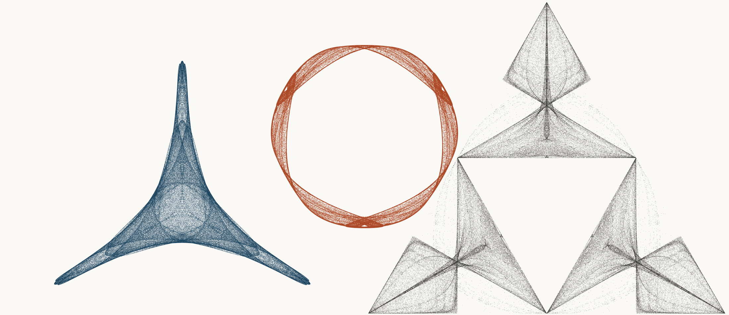
NEURAL INTERESTINGNESS 44 | RAW QUADTREE CODE BITS 44 | FORMER WUNDT GATE 44
X10079_M1  Definition X(10079); M1 cevian triangle  Neural score 58.750  Code bits 1,829 q/random 0.1089  Fitted taste 0.284 | X59655_M3  Definition X(59655); M3 pedal triangle  Code-bit rank 44 position 44  Quadtree code bits 905  q/random 0.09281 PNG/random 0.1844 | X1298_M1  Definition X(1298); M1 cevian triangle  Wundt position 44  Wundt gate 0.998559  q/random 0.5190 code bits 11,678
Each source plot uses 50,000 retained points after 4,000 discarded points and all six angle permutations. The center plot is visually oriented and enlarged only for presentation. Raw quadtree ranking is ascending by code bits.

Three Triangle Compressibility and Interestingness Atlas
Comparison position 45 of 120 Left and right upright Center visually inverted and maximized
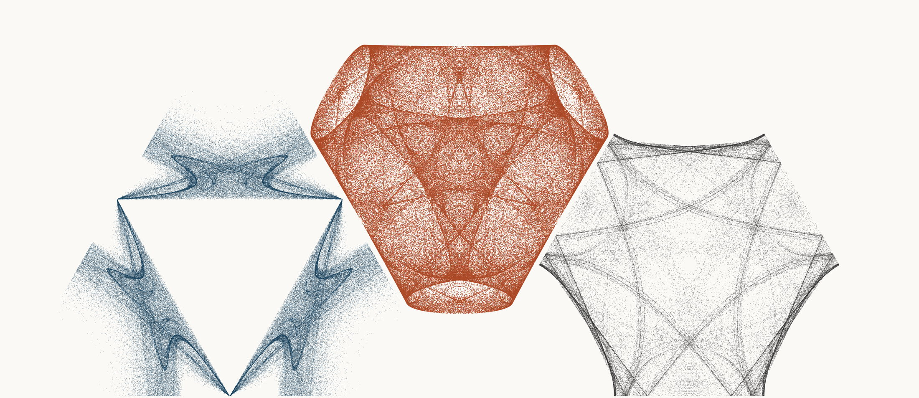
NEURAL INTERESTINGNESS 45 | RAW QUADTREE CODE BITS 45 | FORMER WUNDT GATE 45
X2763_M1  Definition X(2763); M1 cevian triangle  Neural score 58.641  Code bits 6,127 q/random 0.2743  Fitted taste 0.988 | X20958_M3  Definition X(20958); M3 pedal triangle  Code-bit rank 45 position 45  Quadtree code bits 912  q/random 0.05469 PNG/random 0.1738 | X60226_M3  Definition X(60226); M3 pedal triangle  Wundt position 45  Wundt gate 0.998537  q/random 0.4809 code bits 10,915
Each source plot uses 50,000 retained points after 4,000 discarded points and all six angle permutations. The center plot is visually oriented and enlarged only for presentation. Raw quadtree ranking is ascending by code bits.

Three Triangle Compressibility and Interestingness Atlas
Comparison position 46 of 120 Left and right upright Center visually inverted and maximized
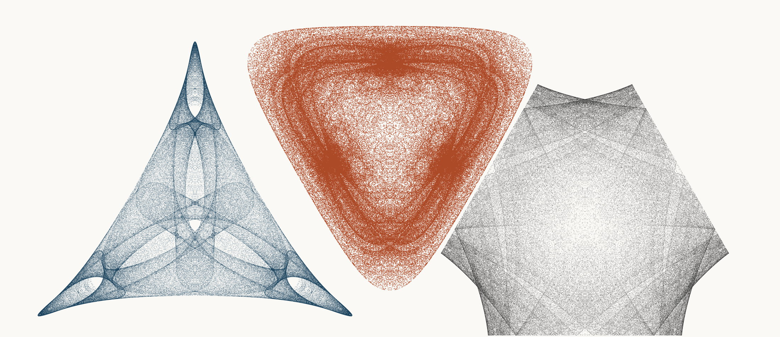
NEURAL INTERESTINGNESS 46 | RAW QUADTREE CODE BITS 46 | FORMER WUNDT GATE 46
X35971_M3  Definition X(35971); M3 pedal triangle  Neural score 58.587  Code bits 6,099 q/random 0.2699  Fitted taste 1.051 | X12227_M1  Definition X(12227); M1 cevian triangle  Code-bit rank 46 position 46  Quadtree code bits 919  q/random 0.06070 PNG/random 0.1607 | X70312_M3  Definition X(70312); M3 pedal triangle  Wundt position 46  Wundt gate 0.998464  q/random 0.5196 code bits 11,601
Each source plot uses 50,000 retained points after 4,000 discarded points and all six angle permutations. The center plot is visually oriented and enlarged only for presentation. Raw quadtree ranking is ascending by code bits.

Three Triangle Compressibility and Interestingness Atlas
Comparison position 47 of 120 Left and right upright Center visually inverted and maximized
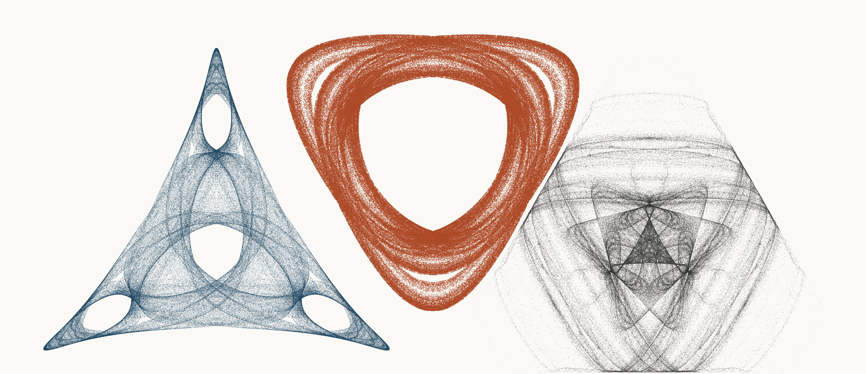
NEURAL INTERESTINGNESS 47 | RAW QUADTREE CODE BITS 47 | FORMER WUNDT GATE 47
X34294_M3  Definition X(34294); M3 pedal triangle  Neural score 58.567  Code bits 4,769 q/random 0.2182  Fitted taste 1.194 | X14669_M3  Definition X(14669); M3 pedal triangle  Code-bit rank 47 position 47  Quadtree code bits 926  q/random 0.07135 PNG/random 0.1455 | X27810_M1  Definition X(27810); M1 cevian triangle  Wundt position 47  Wundt gate 0.998349  q/random 0.5203 code bits 11,923
Each source plot uses 50,000 retained points after 4,000 discarded points and all six angle permutations. The center plot is visually oriented and enlarged only for presentation. Raw quadtree ranking is ascending by code bits.

Three Triangle Compressibility and Interestingness Atlas
Comparison position 48 of 120 Left and right upright Center visually inverted and maximized
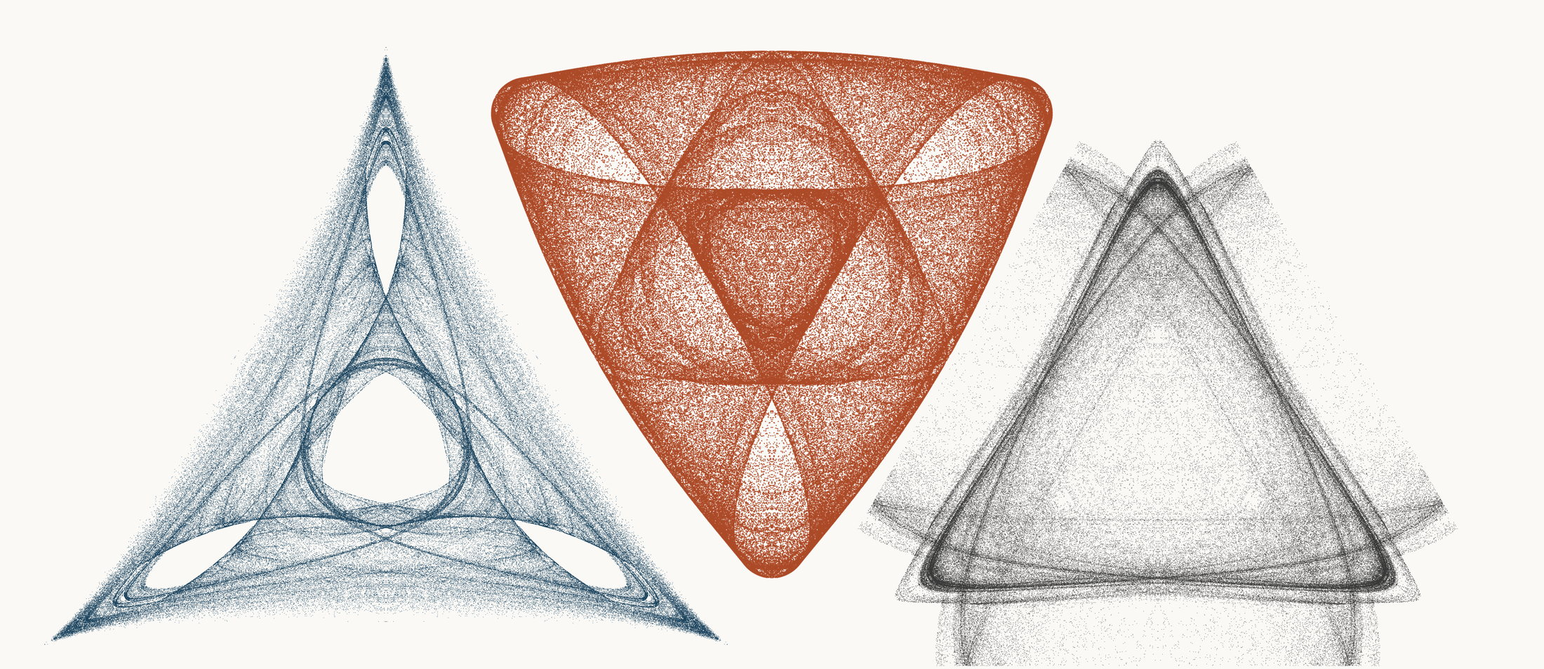
NEURAL INTERESTINGNESS 48 | RAW QUADTREE CODE BITS 48 | FORMER WUNDT GATE 48
X45233_M3  Definition X(45233); M3 pedal triangle  Neural score 58.475  Code bits 7,702 q/random 0.3367  Fitted taste 0.984 | X33239_M3  Definition X(33239); M3 pedal triangle  Code-bit rank 48 position 48  Quadtree code bits 940  q/random 0.06181 PNG/random 0.1954 | X26368_M3  Definition X(26368); M3 pedal triangle  Wundt position 48  Wundt gate 0.998281  q/random 0.5207 code bits 12,133
Each source plot uses 50,000 retained points after 4,000 discarded points and all six angle permutations. The center plot is visually oriented and enlarged only for presentation. Raw quadtree ranking is ascending by code bits.

Three Triangle Compressibility and Interestingness Atlas
Comparison position 49 of 120 Left and right upright Center visually inverted and maximized
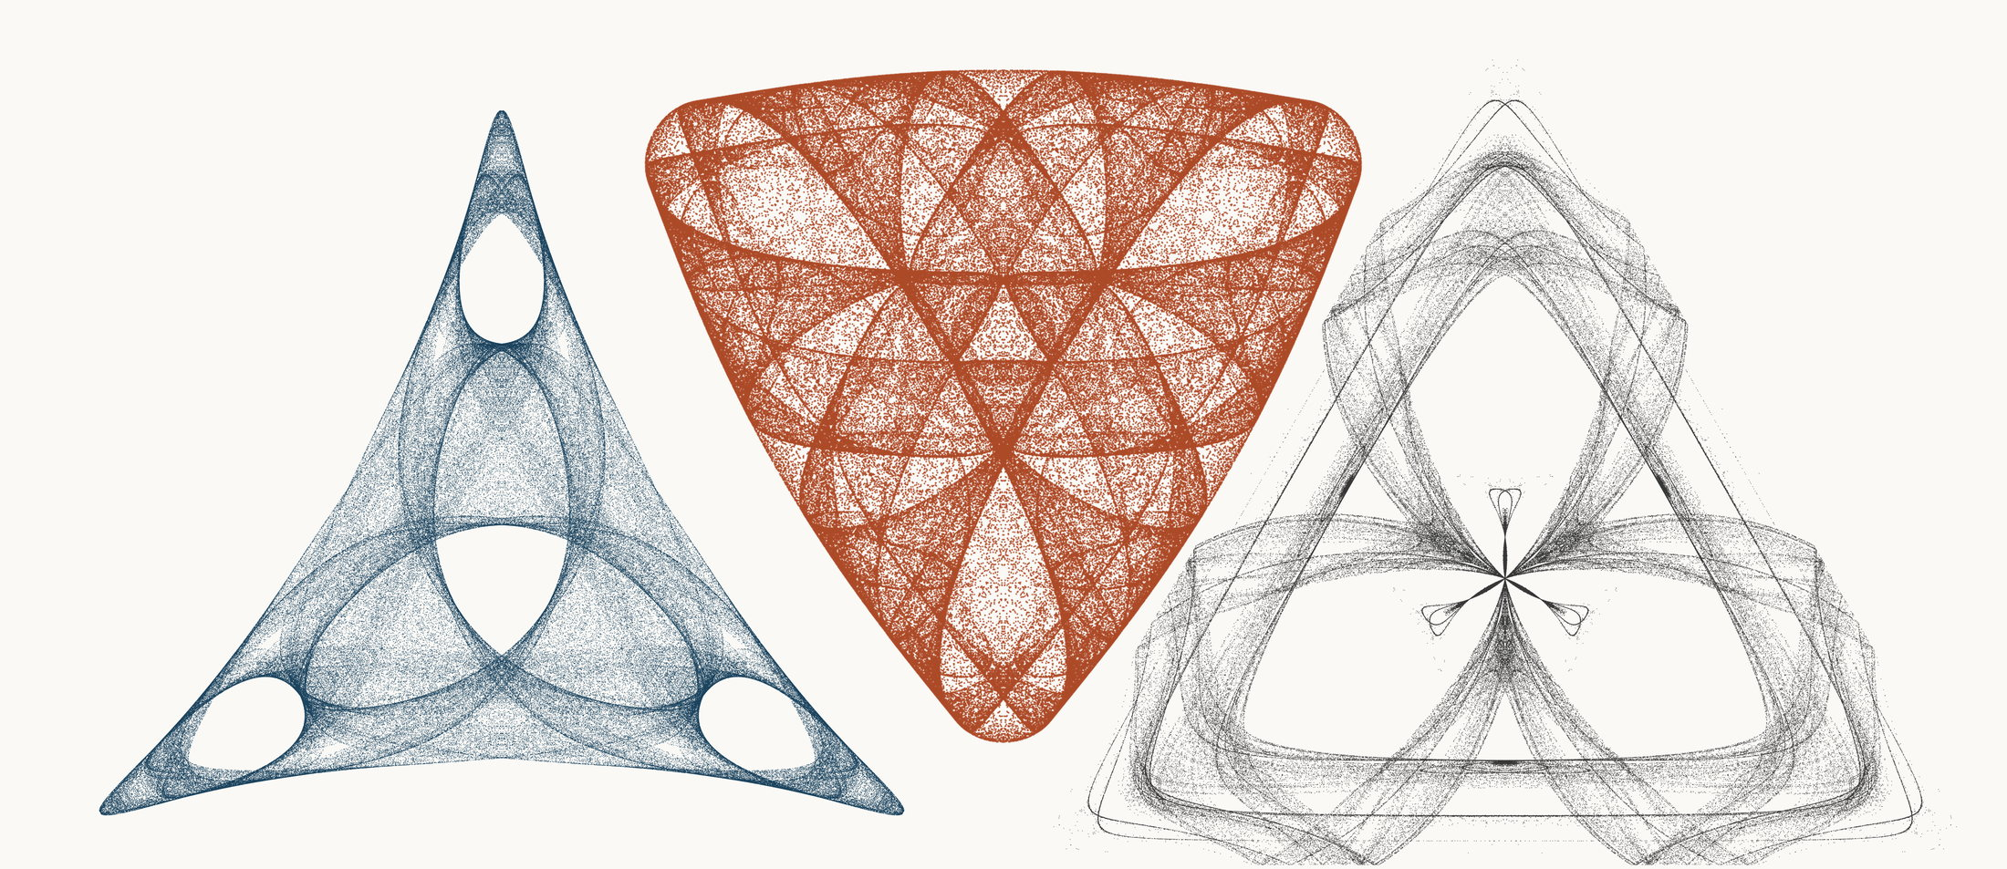
NEURAL INTERESTINGNESS 49 | RAW QUADTREE CODE BITS 49 | FORMER WUNDT GATE 49
X53167_M3  Definition X(53167); M3 pedal triangle  Neural score 58.444  Code bits 5,315 q/random 0.2396  Fitted taste 1.094 | X3552_M3  Definition X(3552); M3 pedal triangle  Code-bit rank 49 position 49  Quadtree code bits 961  q/random 0.06867 PNG/random 0.2048 | X8523_M3  Definition X(8523); M3 pedal triangle  Wundt position 49  Wundt gate 0.998273  q/random 0.4792 code bits 10,901
Each source plot uses 50,000 retained points after 4,000 discarded points and all six angle permutations. The center plot is visually oriented and enlarged only for presentation. Raw quadtree ranking is ascending by code bits.

Three Triangle Compressibility and Interestingness Atlas
Comparison position 50 of 120 Left and right upright Center visually inverted and maximized
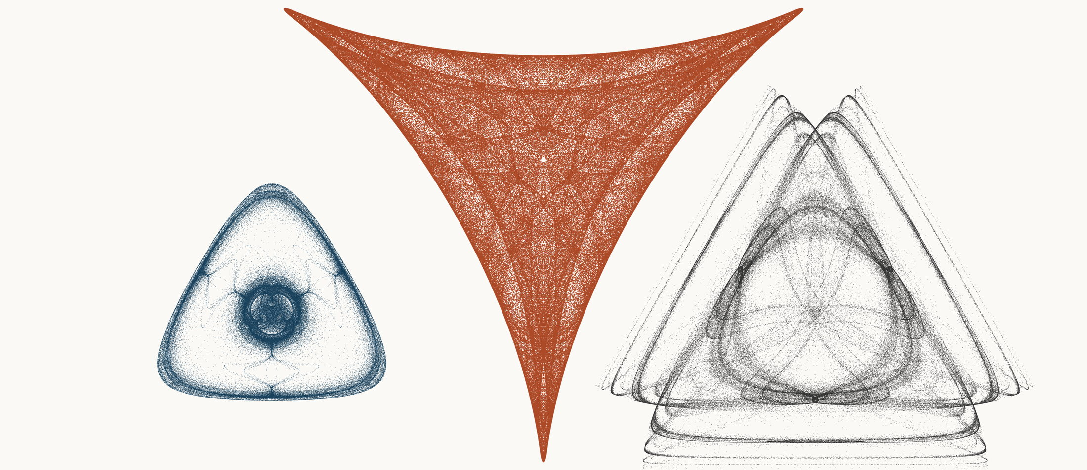
NEURAL INTERESTINGNESS 50 | RAW QUADTREE CODE BITS 50 | FORMER WUNDT GATE 50
X41051_M3  Definition X(41051); M3 pedal triangle  Neural score 58.419  Code bits 3,383 q/random 0.2182  Fitted taste 0.505 | X36998_M3  Definition X(36998); M3 pedal triangle  Code-bit rank 49 position 50  Quadtree code bits 961  q/random 0.07842 PNG/random 0.1918 | X66820_M3  Definition X(66820); M3 pedal triangle  Wundt position 50  Wundt gate 0.998221  q/random 0.5211 code bits 11,762
Each source plot uses 50,000 retained points after 4,000 discarded points and all six angle permutations. The center plot is visually oriented and enlarged only for presentation. Raw quadtree ranking is ascending by code bits.

Three Triangle Compressibility and Interestingness Atlas
Comparison position 51 of 120 Left and right upright Center visually inverted and maximized
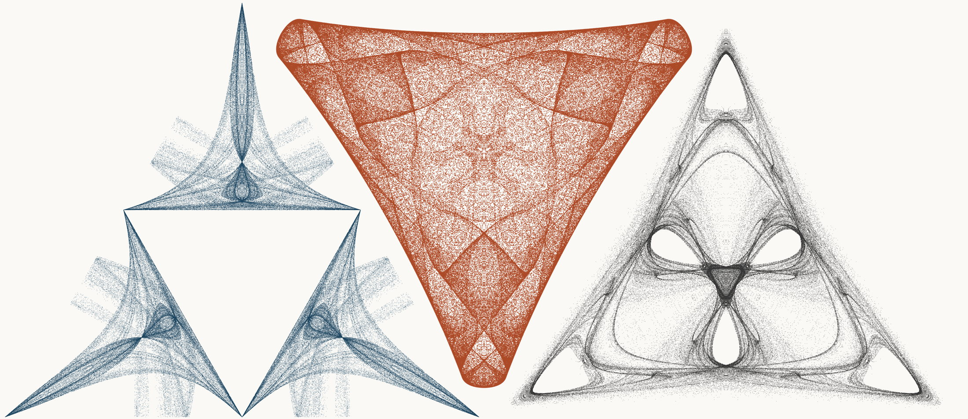
NEURAL INTERESTINGNESS 51 | RAW QUADTREE CODE BITS 51 | FORMER WUNDT GATE 51
X2700_M1  Definition X(2700); M1 cevian triangle  Neural score 58.402  Code bits 8,108 q/random 0.3623  Fitted taste 1.060 | X55480_M3  Definition X(55480); M3 pedal triangle  Code-bit rank 49 position 51  Quadtree code bits 961  q/random 0.05805 PNG/random 0.1742 | X17198_M3  Definition X(17198); M3 pedal triangle  Wundt position 51  Wundt gate 0.998107  q/random 0.4782 code bits 10,929
Each source plot uses 50,000 retained points after 4,000 discarded points and all six angle permutations. The center plot is visually oriented and enlarged only for presentation. Raw quadtree ranking is ascending by code bits.

Three Triangle Compressibility and Interestingness Atlas
Comparison position 52 of 120 Left and right upright Center visually inverted and maximized
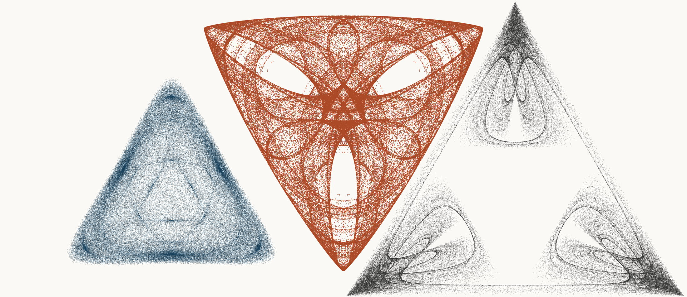
NEURAL INTERESTINGNESS 52 | RAW QUADTREE CODE BITS 52 | FORMER WUNDT GATE 52
X31771_M3  Definition X(31771); M3 pedal triangle  Neural score 58.320  Code bits 4,468 q/random 0.1993  Fitted taste 1.003 | X46482_M3  Definition X(46482); M3 pedal triangle  Code-bit rank 52 position 52  Quadtree code bits 968  q/random 0.07570 PNG/random 0.1730 | X1724_M3  Definition X(1724); M3 pedal triangle  Wundt position 52  Wundt gate 0.998084  q/random 0.5219 code bits 11,937
Each source plot uses 50,000 retained points after 4,000 discarded points and all six angle permutations. The center plot is visually oriented and enlarged only for presentation. Raw quadtree ranking is ascending by code bits.

Three Triangle Compressibility and Interestingness Atlas
Comparison position 53 of 120 Left and right upright Center visually inverted and maximized
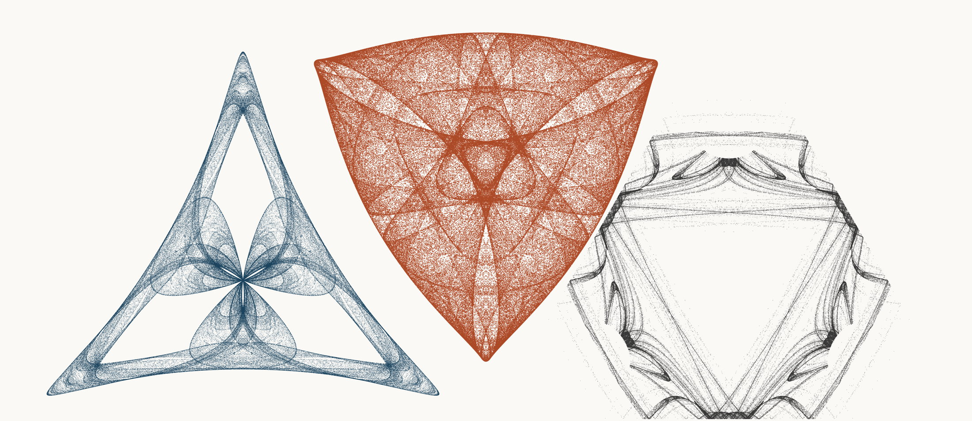
NEURAL INTERESTINGNESS 53 | RAW QUADTREE CODE BITS 53 | FORMER WUNDT GATE 53
X30465_M3  Definition X(30465); M3 pedal triangle  Neural score 58.285  Code bits 4,706 q/random 0.2211  Fitted taste 0.836 | X6959_M3  Definition X(6959); M3 pedal triangle  Code-bit rank 52 position 53  Quadtree code bits 968  q/random 0.05772 PNG/random 0.1879 | X65054_M1  Definition X(65054); M1 cevian triangle  Wundt position 53  Wundt gate 0.997808  q/random 0.4766 code bits 9,550
Each source plot uses 50,000 retained points after 4,000 discarded points and all six angle permutations. The center plot is visually oriented and enlarged only for presentation. Raw quadtree ranking is ascending by code bits.

Three Triangle Compressibility and Interestingness Atlas
Comparison position 54 of 120 Left and right upright Center visually inverted and maximized
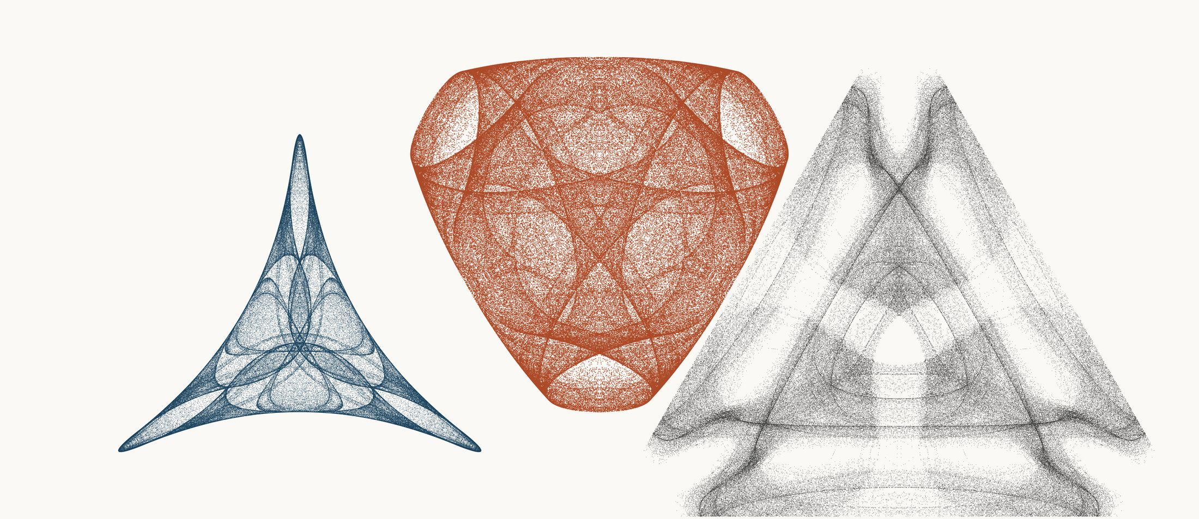
NEURAL INTERESTINGNESS 54 | RAW QUADTREE CODE BITS 54 | FORMER WUNDT GATE 54
X5166_M3  Definition X(5166); M3 pedal triangle  Neural score 58.278  Code bits 2,830 q/random 0.1671  Fitted taste 0.723 | X21756_M3  Definition X(21756); M3 pedal triangle  Code-bit rank 54 position 54  Quadtree code bits 975  q/random 0.06010 PNG/random 0.1835 | X56719_M3  Definition X(56719); M3 pedal triangle  Wundt position 54  Wundt gate 0.997807  q/random 0.5234 code bits 11,972
Each source plot uses 50,000 retained points after 4,000 discarded points and all six angle permutations. The center plot is visually oriented and enlarged only for presentation. Raw quadtree ranking is ascending by code bits.

Three Triangle Compressibility and Interestingness Atlas
Comparison position 55 of 120 Left and right upright Center visually inverted and maximized
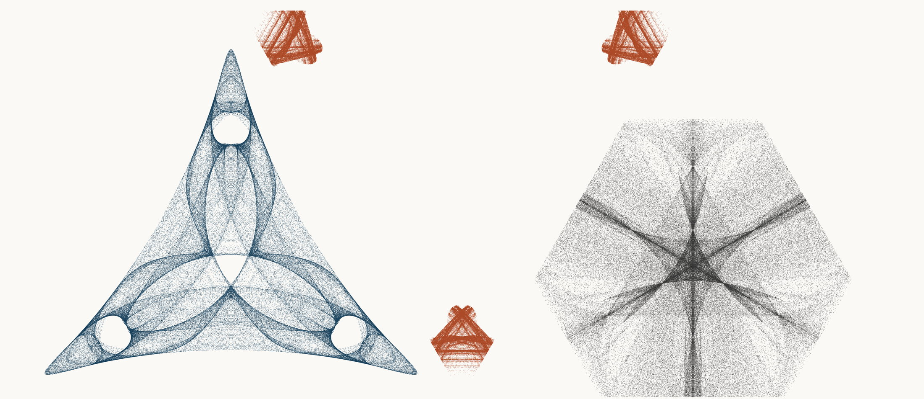
NEURAL INTERESTINGNESS 55 | RAW QUADTREE CODE BITS 55 | FORMER WUNDT GATE 55
X55056_M3  Definition X(55056); M3 pedal triangle  Neural score 58.256  Code bits 7,002 q/random 0.3133  Fitted taste 1.164 | X68664_M1  Definition X(68664); M1 cevian triangle  Code-bit rank 54 position 55  Quadtree code bits 975  q/random 0.08715 PNG/random 0.1976 | X30501_M1  Definition X(30501); M1 cevian triangle  Wundt position 55  Wundt gate 0.997768  q/random 0.5236 code bits 12,105
Each source plot uses 50,000 retained points after 4,000 discarded points and all six angle permutations. The center plot is visually oriented and enlarged only for presentation. Raw quadtree ranking is ascending by code bits.

Three Triangle Compressibility and Interestingness Atlas
Comparison position 56 of 120 Left and right upright Center visually inverted and maximized
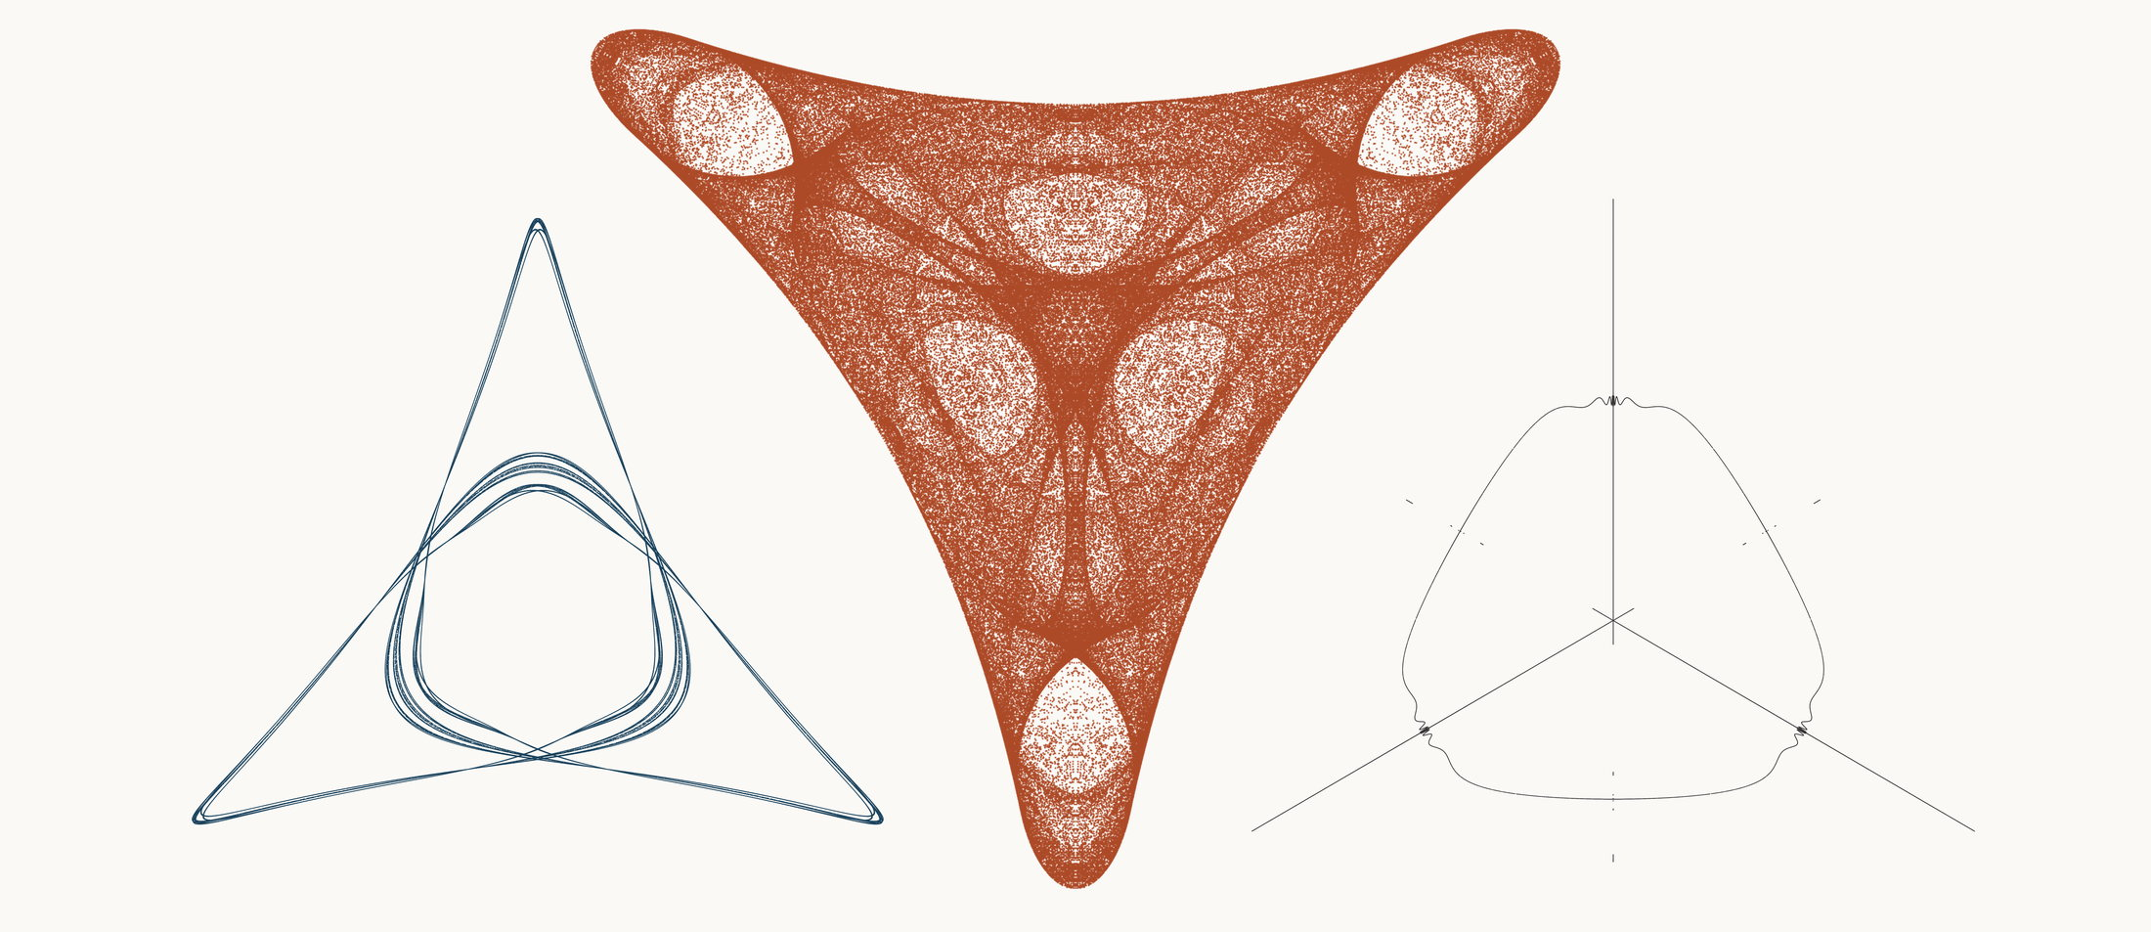
NEURAL INTERESTINGNESS 56 | RAW QUADTREE CODE BITS 56 | FORMER WUNDT GATE 56
X6128_M1  Definition X(6128); M1 cevian triangle  Neural score 58.214  Code bits 2,214 q/random 0.2383  Fitted taste 0.476 | X39024_M3  Definition X(39024); M3 pedal triangle  Code-bit rank 56 position 56  Quadtree code bits 982  q/random 0.07372 PNG/random 0.1838 | X51813_M3  Definition X(51813); M3 pedal triangle  Wundt position 56  Wundt gate 0.997608  q/random 0.4755 code bits 1,976
Each source plot uses 50,000 retained points after 4,000 discarded points and all six angle permutations. The center plot is visually oriented and enlarged only for presentation. Raw quadtree ranking is ascending by code bits.

Three Triangle Compressibility and Interestingness Atlas
Comparison position 57 of 120 Left and right upright Center visually inverted and maximized
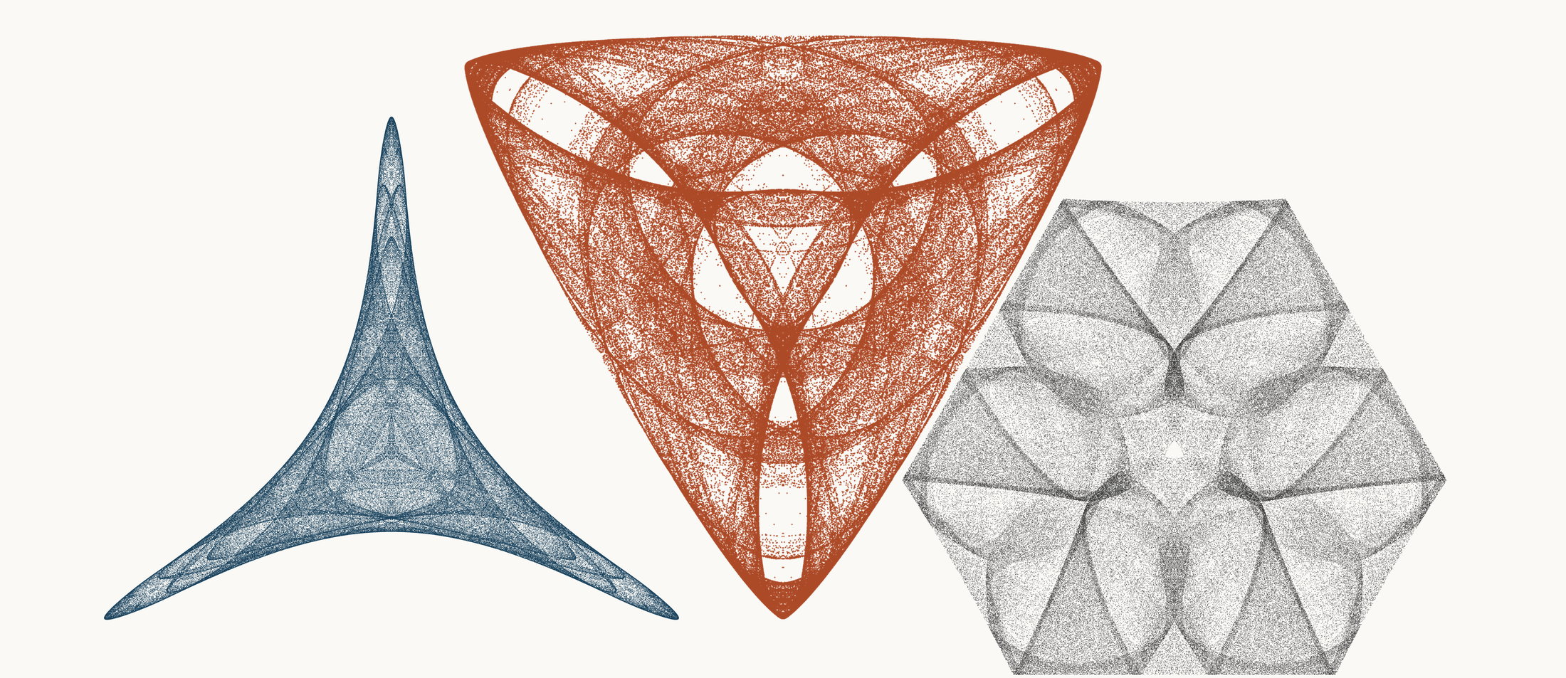
NEURAL INTERESTINGNESS 57 | RAW QUADTREE CODE BITS 57 | FORMER WUNDT GATE 57
X10573_M1  Definition X(10573); M1 cevian triangle  Neural score 58.209  Code bits 2,074 q/random 0.1138  Fitted taste 0.293 | X61594_M3  Definition X(61594); M3 pedal triangle  Code-bit rank 56 position 57  Quadtree code bits 982  q/random 0.07572 PNG/random 0.1729 | X26751_M1  Definition X(26751); M1 cevian triangle  Wundt position 57  Wundt gate 0.997477  q/random 0.4749 code bits 10,656
Each source plot uses 50,000 retained points after 4,000 discarded points and all six angle permutations. The center plot is visually oriented and enlarged only for presentation. Raw quadtree ranking is ascending by code bits.

Three Triangle Compressibility and Interestingness Atlas
Comparison position 58 of 120 Left and right upright Center visually inverted and maximized
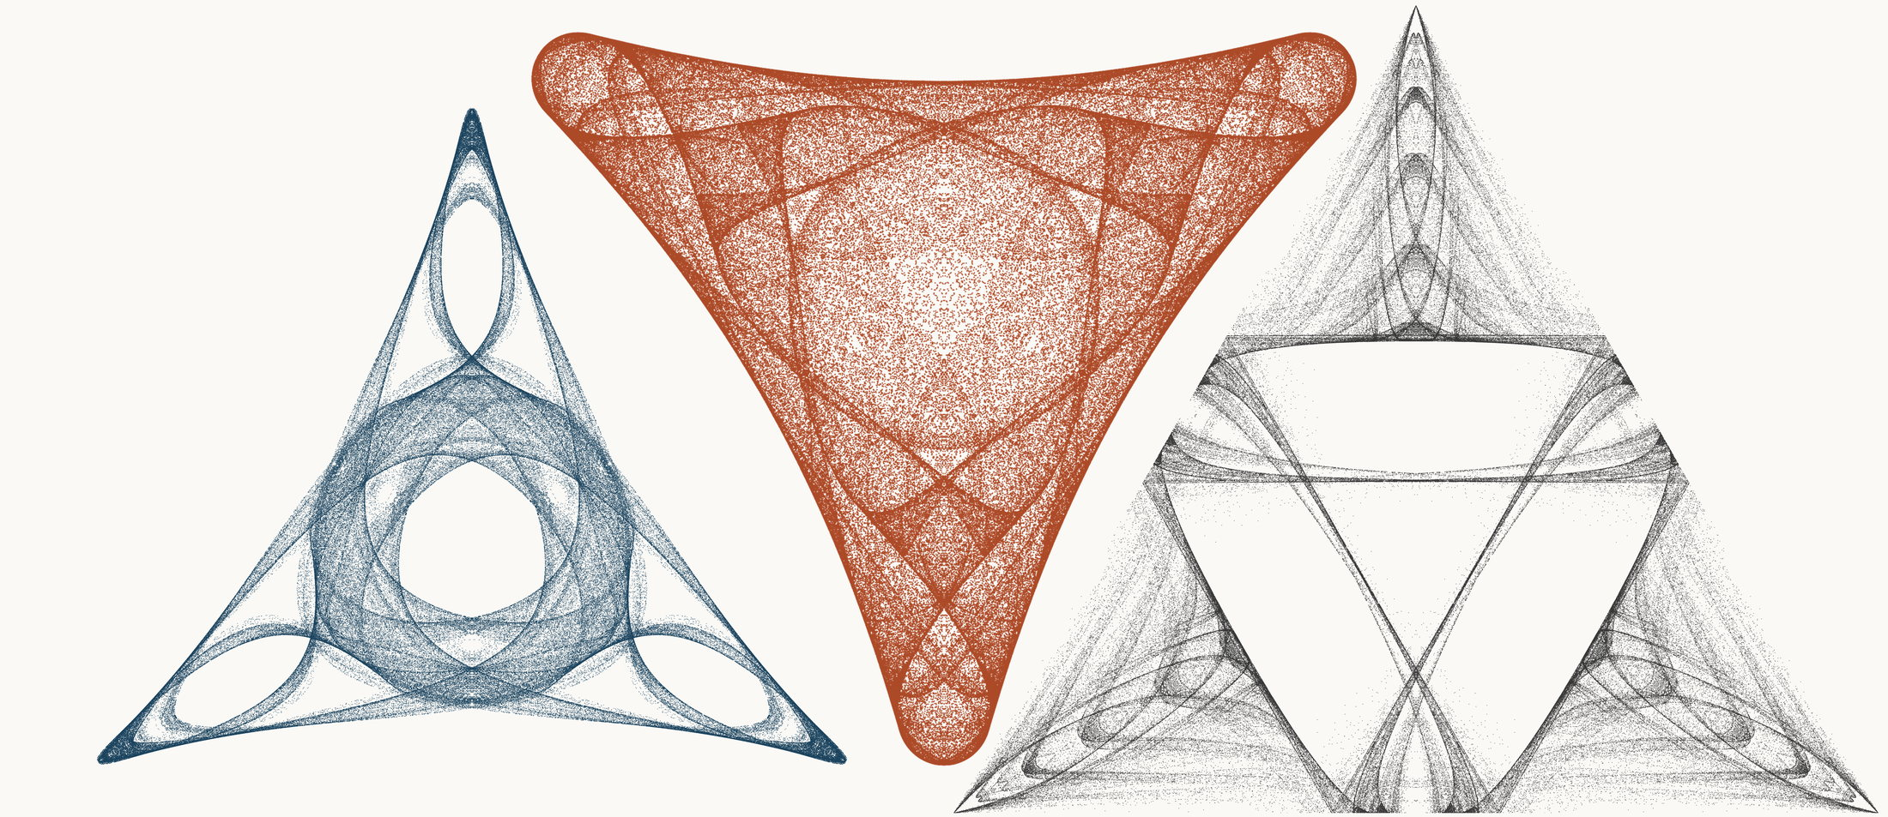
NEURAL INTERESTINGNESS 58 | RAW QUADTREE CODE BITS 58 | FORMER WUNDT GATE 58
X47009_M3  Definition X(47009); M3 pedal triangle  Neural score 58.157  Code bits 4,510 q/random 0.2185  Fitted taste 1.429 | X10603_M3  Definition X(10603); M3 pedal triangle  Code-bit rank 58 position 58  Quadtree code bits 989  q/random 0.06430 PNG/random 0.1682 | X58705_M1  Definition X(58705); M1 cevian triangle  Wundt position 58  Wundt gate 0.997425  q/random 0.5254 code bits 12,105
Each source plot uses 50,000 retained points after 4,000 discarded points and all six angle permutations. The center plot is visually oriented and enlarged only for presentation. Raw quadtree ranking is ascending by code bits.

Three Triangle Compressibility and Interestingness Atlas
Comparison position 59 of 120 Left and right upright Center visually inverted and maximized
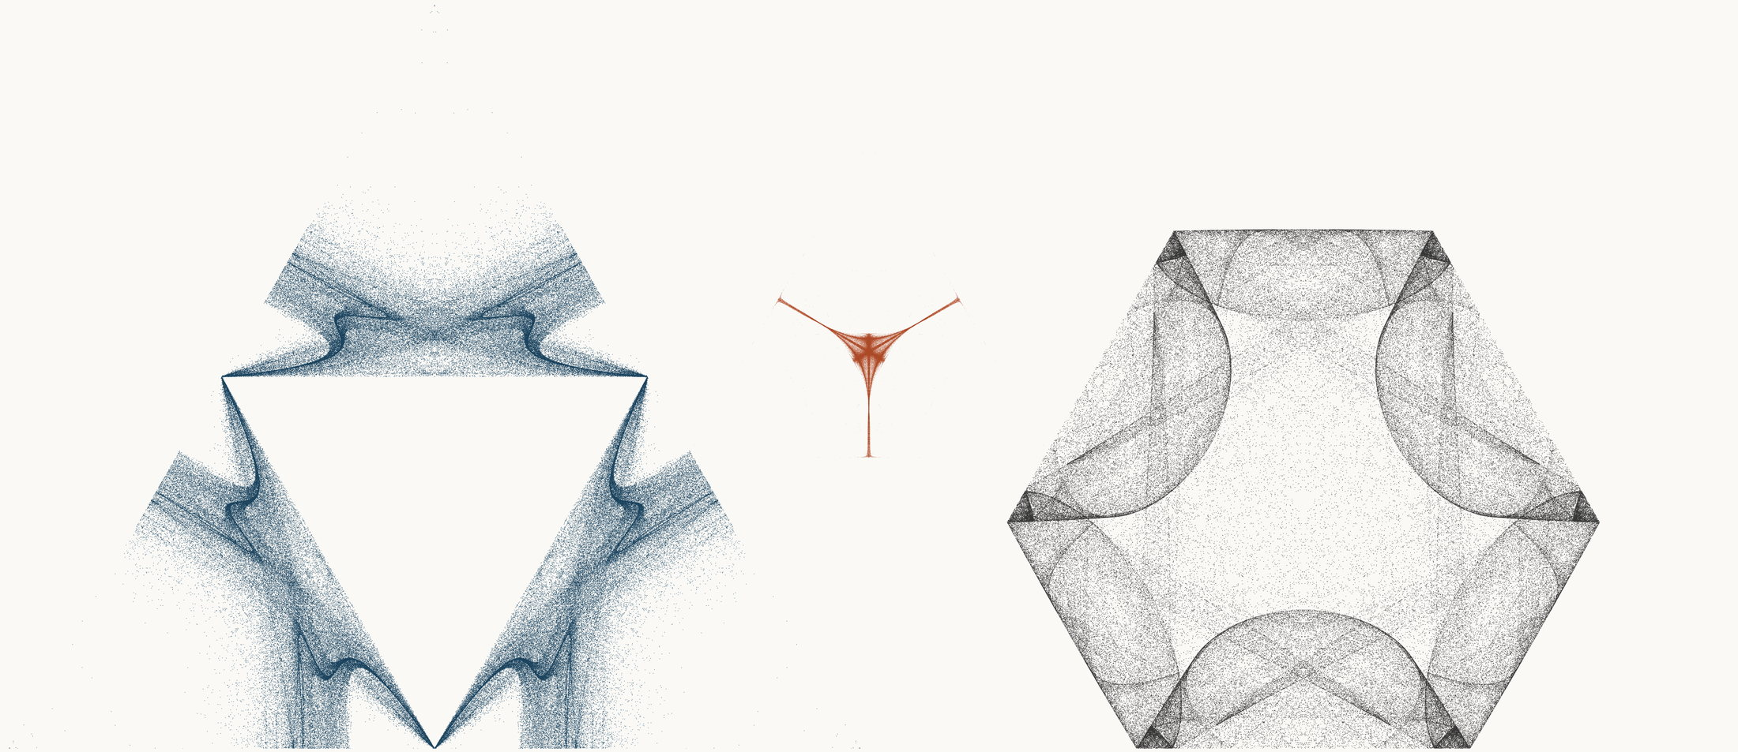
NEURAL INTERESTINGNESS 59 | RAW QUADTREE CODE BITS 59 | FORMER WUNDT GATE 59
X2749_M1  Definition X(2749); M1 cevian triangle  Neural score 58.091  Code bits 5,700 q/random 0.2668  Fitted taste 0.895 | X42640_M3  Definition X(42640); M3 pedal triangle  Code-bit rank 58 position 59  Quadtree code bits 989  q/random 0.14432 PNG/random 0.2614 | X54494_M3  Definition X(54494); M3 pedal triangle  Wundt position 59  Wundt gate 0.997403  q/random 0.4745 code bits 10,887
Each source plot uses 50,000 retained points after 4,000 discarded points and all six angle permutations. The center plot is visually oriented and enlarged only for presentation. Raw quadtree ranking is ascending by code bits.

Three Triangle Compressibility and Interestingness Atlas
Comparison position 60 of 120 Left and right upright Center visually inverted and maximized
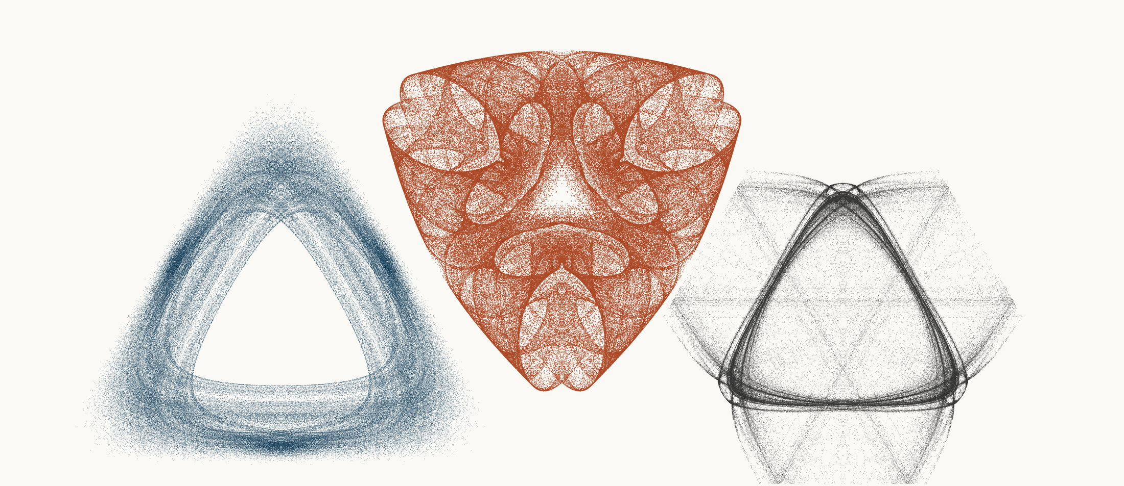
NEURAL INTERESTINGNESS 60 | RAW QUADTREE CODE BITS 60 | FORMER WUNDT GATE 60
X52699_M3  Definition X(52699); M3 pedal triangle  Neural score 58.088  Code bits 5,952 q/random 0.2616  Fitted taste 0.911 | X47852_M3  Definition X(47852); M3 pedal triangle  Code-bit rank 60 position 60  Quadtree code bits 996  q/random 0.06195 PNG/random 0.1668 | X26392_M3  Definition X(26392); M3 pedal triangle  Wundt position 60  Wundt gate 0.997385  q/random 0.4744 code bits 9,613
Each source plot uses 50,000 retained points after 4,000 discarded points and all six angle permutations. The center plot is visually oriented and enlarged only for presentation. Raw quadtree ranking is ascending by code bits.

Three Triangle Compressibility and Interestingness Atlas
Comparison position 61 of 120 Left and right upright Center visually inverted and maximized
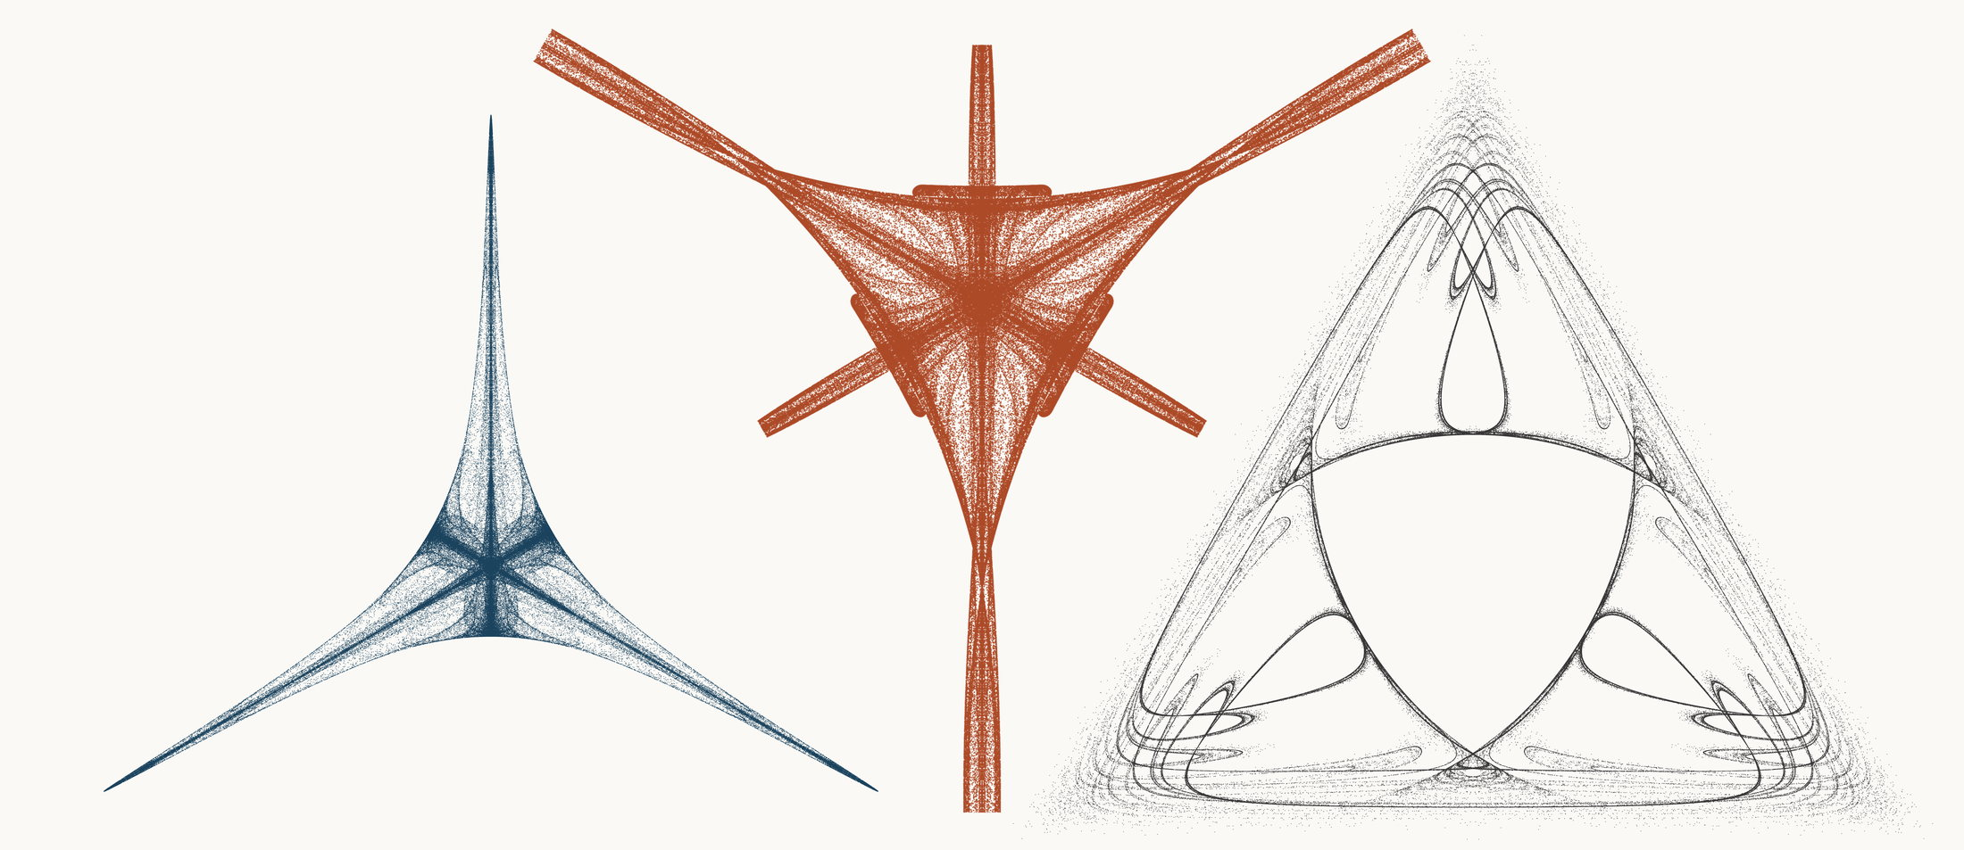
NEURAL INTERESTINGNESS 61 | RAW QUADTREE CODE BITS 61 | FORMER WUNDT GATE 61
X11047_M1  Definition X(11047); M1 cevian triangle  Neural score 58.068  Code bits 2,851 q/random 0.2296  Fitted taste -0.187 | X8056_M3  Definition X(8056); M3 pedal triangle  Code-bit rank 61 position 61  Quadtree code bits 1,010  q/random 0.09461 PNG/random 0.2176 | X36649_M3  Definition X(36649); M3 pedal triangle  Wundt position 61  Wundt gate 0.997347  q/random 0.5258 code bits 10,005
Each source plot uses 50,000 retained points after 4,000 discarded points and all six angle permutations. The center plot is visually oriented and enlarged only for presentation. Raw quadtree ranking is ascending by code bits.

Three Triangle Compressibility and Interestingness Atlas
Comparison position 62 of 120 Left and right upright Center visually inverted and maximized
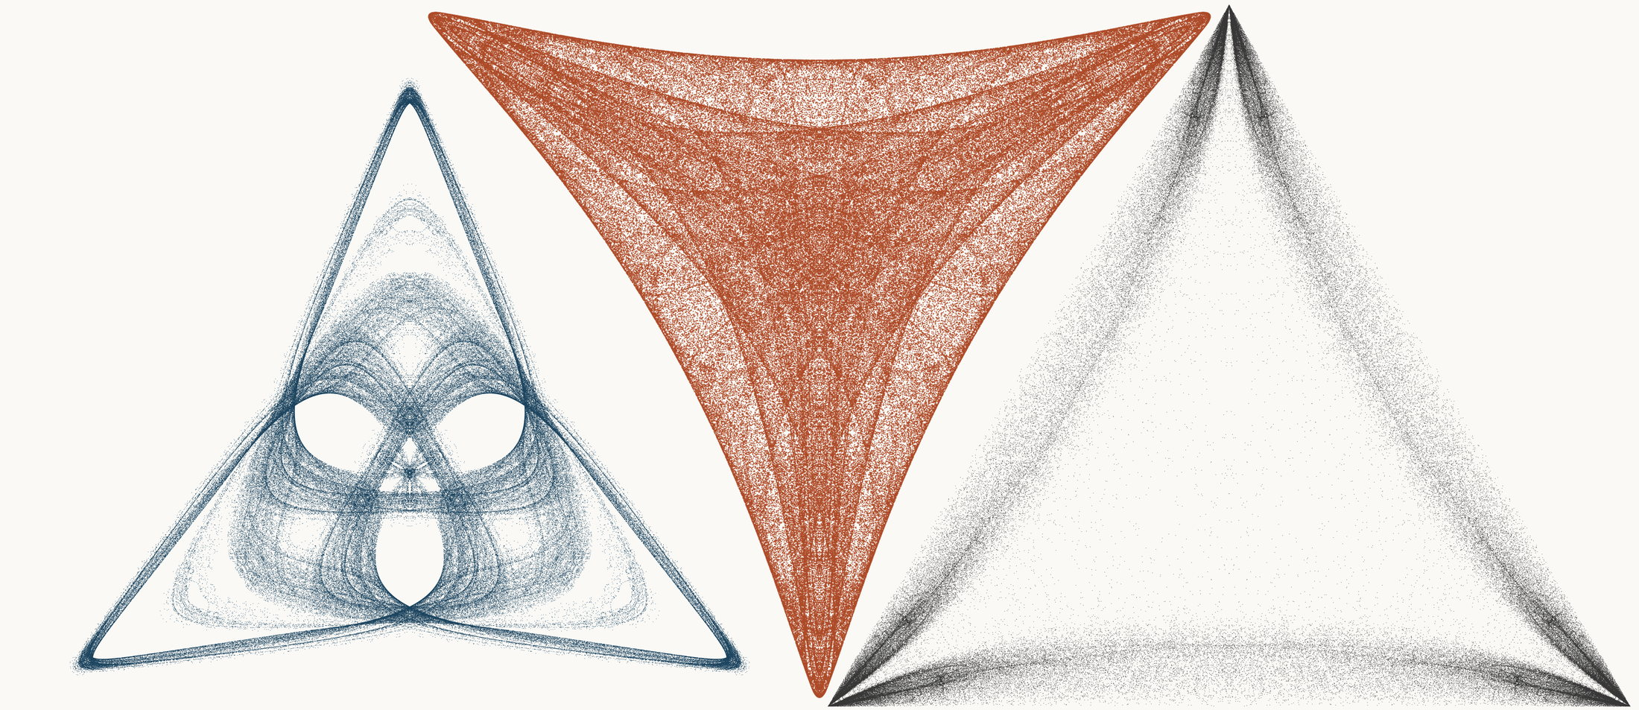
NEURAL INTERESTINGNESS 62 | RAW QUADTREE CODE BITS 62 | FORMER WUNDT GATE 62
X72712_M3  Definition X(72712); M3 pedal triangle  Neural score 58.042  Code bits 7,009 q/random 0.3189  Fitted taste 1.381 | X56360_M3  Definition X(56360); M3 pedal triangle  Code-bit rank 62 position 62  Quadtree code bits 1,017  q/random 0.05984 PNG/random 0.1730 | X60976_M1  Definition X(60976); M1 cevian triangle  Wundt position 62  Wundt gate 0.997268  q/random 0.5261 code bits 11,839
Each source plot uses 50,000 retained points after 4,000 discarded points and all six angle permutations. The center plot is visually oriented and enlarged only for presentation. Raw quadtree ranking is ascending by code bits.

Three Triangle Compressibility and Interestingness Atlas
Comparison position 63 of 120 Left and right upright Center visually inverted and maximized
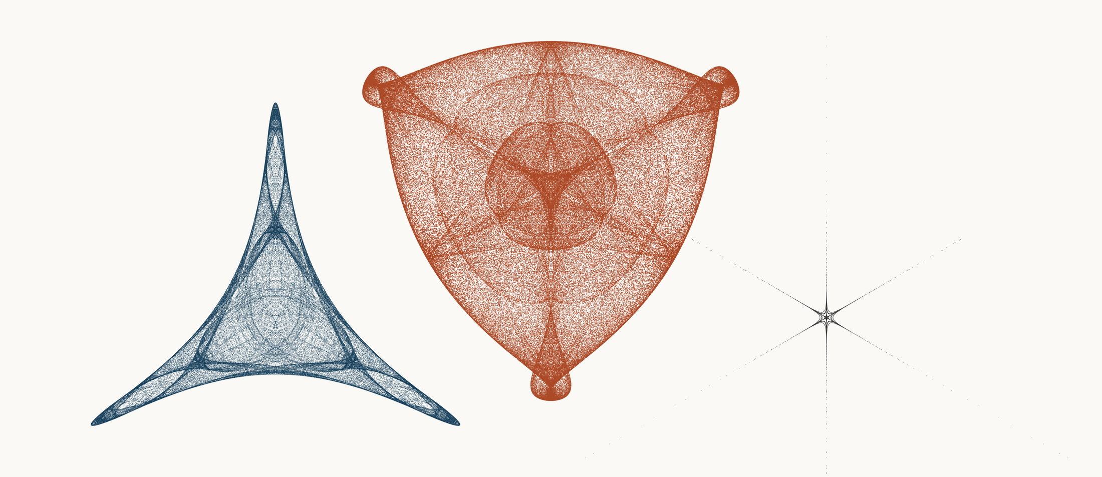
NEURAL INTERESTINGNESS 63 | RAW QUADTREE CODE BITS 63 | FORMER WUNDT GATE 63
X65687_M1  Definition X(65687); M1 cevian triangle  Neural score 57.930  Code bits 2,452 q/random 0.1423  Fitted taste 0.482 | X16414_M3  Definition X(16414); M3 pedal triangle  Code-bit rank 63 position 63  Quadtree code bits 1,024  q/random 0.05683 PNG/random 0.1966 | X22884_M1  Definition X(22884); M1 cevian triangle  Wundt position 63  Wundt gate 0.997145  q/random 0.4733 code bits 1,304
Each source plot uses 50,000 retained points after 4,000 discarded points and all six angle permutations. The center plot is visually oriented and enlarged only for presentation. Raw quadtree ranking is ascending by code bits.

Three Triangle Compressibility and Interestingness Atlas
Comparison position 64 of 120 Left and right upright Center visually inverted and maximized
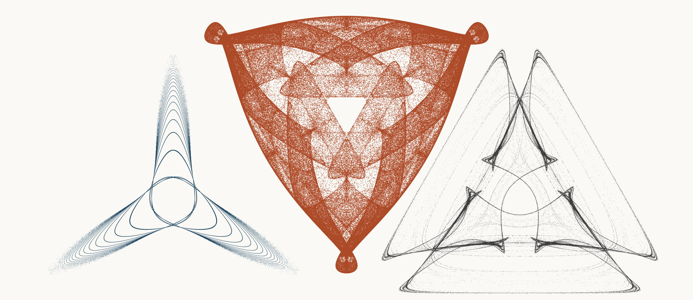
NEURAL INTERESTINGNESS 64 | RAW QUADTREE CODE BITS 64 | FORMER WUNDT GATE 64
X58401_M1  Definition X(58401); M1 cevian triangle  Neural score 57.882  Code bits 3,572 q/random 0.2989  Fitted taste 0.353 | X43129_M1  Definition X(43129); M1 cevian triangle  Code-bit rank 63 position 64  Quadtree code bits 1,024  q/random 0.07640 PNG/random 0.2007 | X6019_M3  Definition X(6019); M3 pedal triangle  Wundt position 64  Wundt gate 0.997136  q/random 0.5268 code bits 8,752
Each source plot uses 50,000 retained points after 4,000 discarded points and all six angle permutations. The center plot is visually oriented and enlarged only for presentation. Raw quadtree ranking is ascending by code bits.

Three Triangle Compressibility and Interestingness Atlas
Comparison position 65 of 120 Left and right upright Center visually inverted and maximized
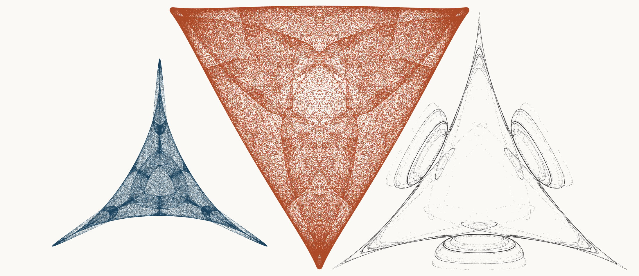
NEURAL INTERESTINGNESS 65 | RAW QUADTREE CODE BITS 65 | FORMER WUNDT GATE 65
X24764_M3  Definition X(24764); M3 pedal triangle  Neural score 57.874  Code bits 1,738 q/random 0.1058  Fitted taste 0.429 | X45383_M1  Definition X(45383); M1 cevian triangle  Code-bit rank 63 position 65  Quadtree code bits 1,024  q/random 0.06083 PNG/random 0.1869 | X20266_M3  Definition X(20266); M3 pedal triangle  Wundt position 65  Wundt gate 0.997117  q/random 0.4732 code bits 6,540
Each source plot uses 50,000 retained points after 4,000 discarded points and all six angle permutations. The center plot is visually oriented and enlarged only for presentation. Raw quadtree ranking is ascending by code bits.

Three Triangle Compressibility and Interestingness Atlas
Comparison position 66 of 120 Left and right upright Center visually inverted and maximized
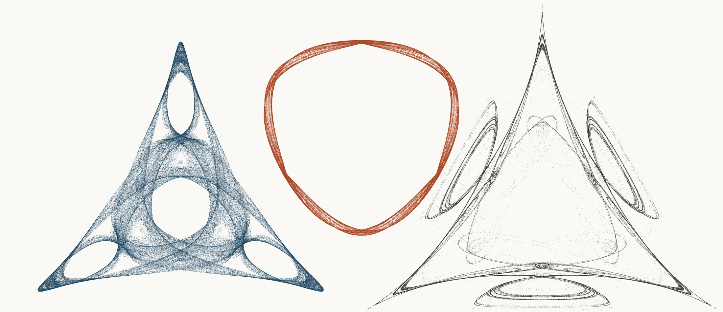
NEURAL INTERESTINGNESS 66 | RAW QUADTREE CODE BITS 66 | FORMER WUNDT GATE 66
X53825_M3  Definition X(53825); M3 pedal triangle  Neural score 57.859  Code bits 3,880 q/random 0.1852  Fitted taste 1.365 | X59662_M3  Definition X(59662); M3 pedal triangle  Code-bit rank 63 position 66  Quadtree code bits 1,024  q/random 0.11661 PNG/random 0.1955 | X72420_M3  Definition X(72420); M3 pedal triangle  Wundt position 66  Wundt gate 0.997053  q/random 0.4729 code bits 7,989
Each source plot uses 50,000 retained points after 4,000 discarded points and all six angle permutations. The center plot is visually oriented and enlarged only for presentation. Raw quadtree ranking is ascending by code bits.

Three Triangle Compressibility and Interestingness Atlas
Comparison position 67 of 120 Left and right upright Center visually inverted and maximized
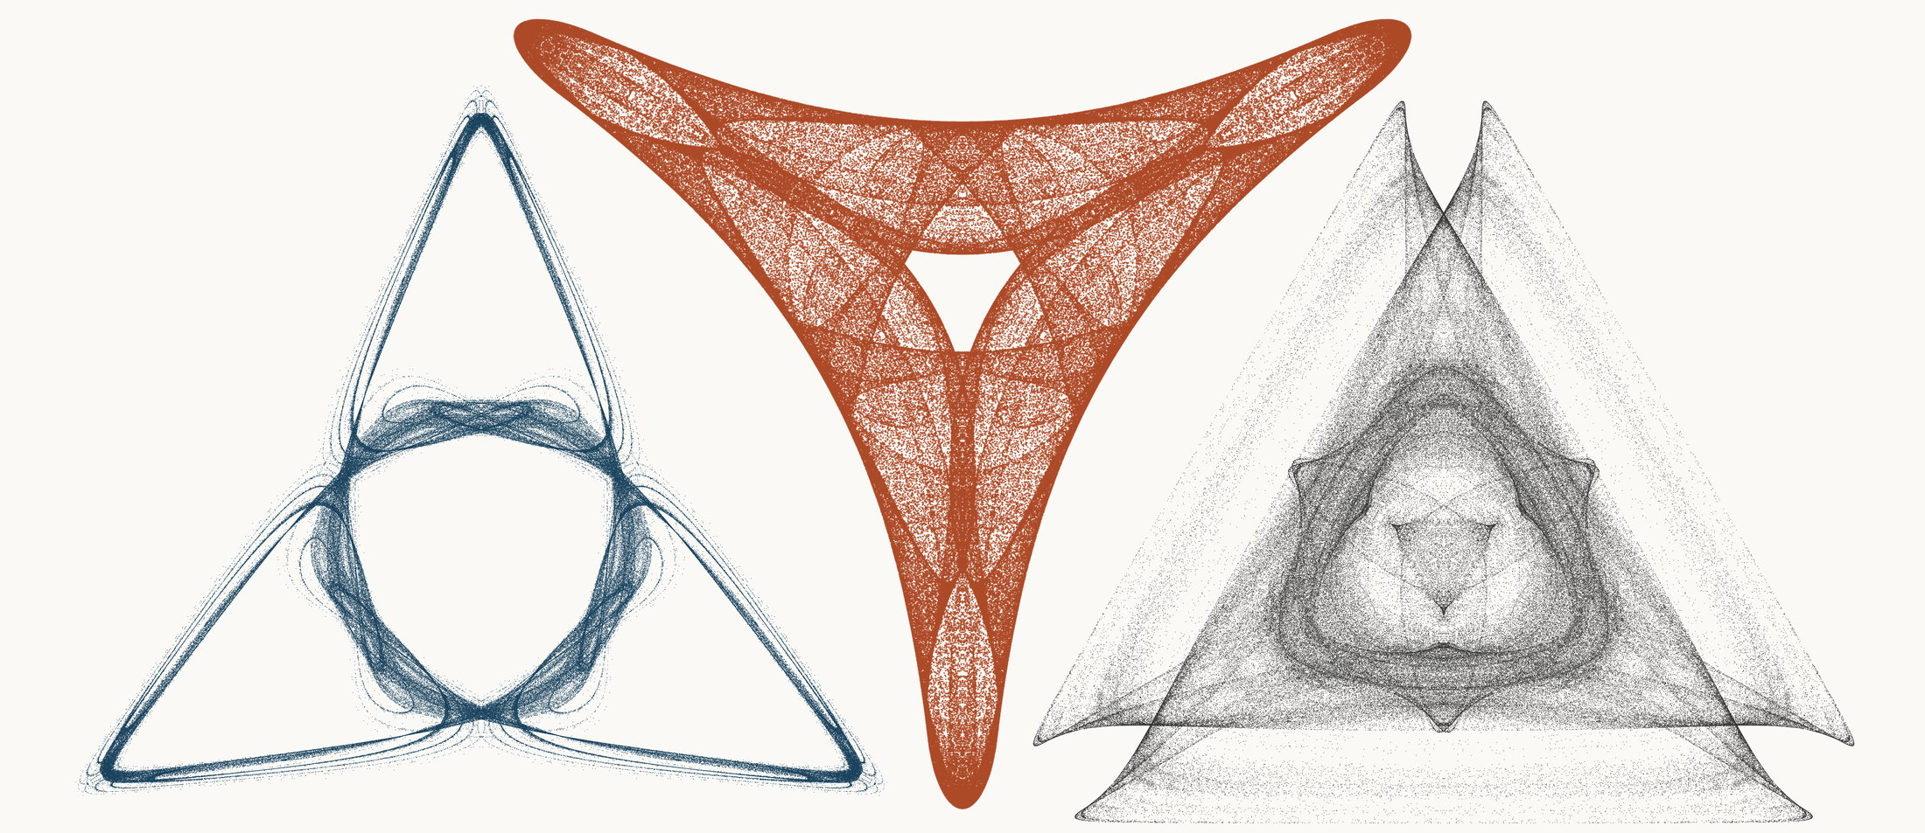
NEURAL INTERESTINGNESS 67 | RAW QUADTREE CODE BITS 67 | FORMER WUNDT GATE 67
X44312_M3  Definition X(44312); M3 pedal triangle  Neural score 57.858  Code bits 5,273 q/random 0.2941  Fitted taste 0.982 | X26731_M1  Definition X(26731); M1 cevian triangle  Code-bit rank 67 position 67  Quadtree code bits 1,038  q/random 0.08452 PNG/random 0.1981 | X59807_M3  Definition X(59807); M3 pedal triangle  Wundt position 67  Wundt gate 0.996921  q/random 0.5277 code bits 12,119
Each source plot uses 50,000 retained points after 4,000 discarded points and all six angle permutations. The center plot is visually oriented and enlarged only for presentation. Raw quadtree ranking is ascending by code bits.

Three Triangle Compressibility and Interestingness Atlas
Comparison position 68 of 120 Left and right upright Center visually inverted and maximized
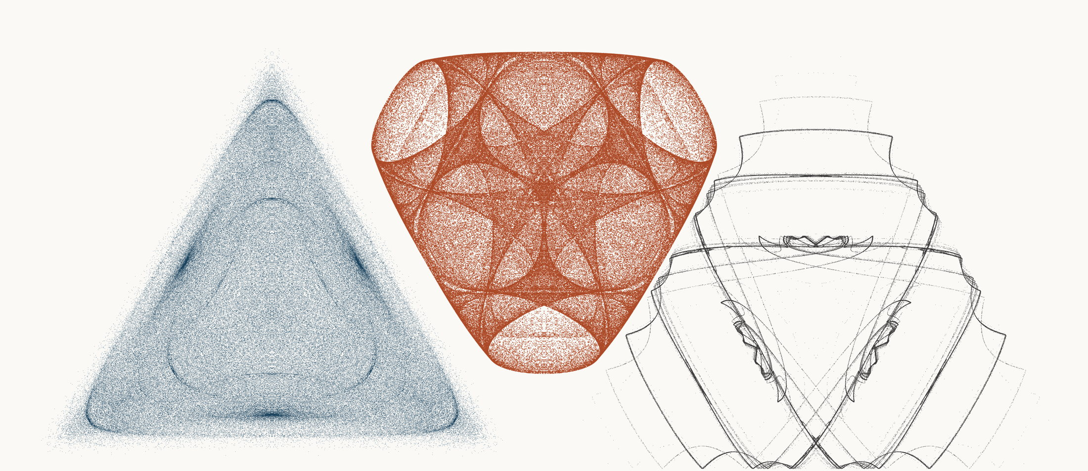
NEURAL INTERESTINGNESS 68 | RAW QUADTREE CODE BITS 68 | FORMER WUNDT GATE 68
X47474_M3  Definition X(47474); M3 pedal triangle  Neural score 57.857  Code bits 9,291 q/random 0.4092  Fitted taste 0.075 | X33694_M3  Definition X(33694); M3 pedal triangle  Code-bit rank 68 position 68  Quadtree code bits 1,045  q/random 0.06389 PNG/random 0.1865 | X17946_M1  Definition X(17946); M1 cevian triangle  Wundt position 68  Wundt gate 0.996916  q/random 0.4722 code bits 7,205
Each source plot uses 50,000 retained points after 4,000 discarded points and all six angle permutations. The center plot is visually oriented and enlarged only for presentation. Raw quadtree ranking is ascending by code bits.

Three Triangle Compressibility and Interestingness Atlas
Comparison position 69 of 120 Left and right upright Center visually inverted and maximized
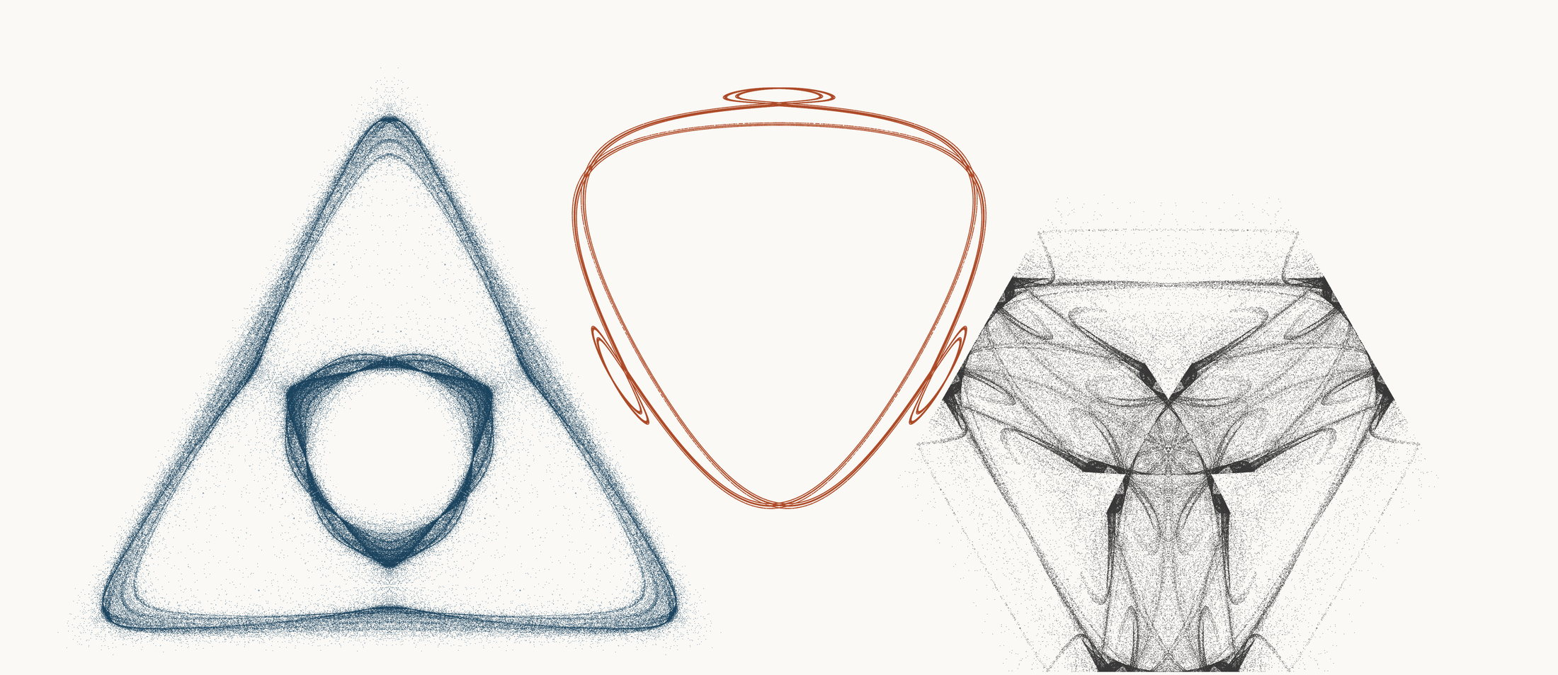
NEURAL INTERESTINGNESS 69 | RAW QUADTREE CODE BITS 69 | FORMER WUNDT GATE 69
X13274_M3  Definition X(13274); M3 pedal triangle  Neural score 57.832  Code bits 8,087 q/random 0.3942  Fitted taste 0.433 | X13311_M3  Definition X(13311); M3 pedal triangle  Code-bit rank 69 position 69  Quadtree code bits 1,052  q/random 0.19973 PNG/random 0.2308 | X60270_M1  Definition X(60270); M1 cevian triangle  Wundt position 69  Wundt gate 0.996888  q/random 0.4721 code bits 10,369
Each source plot uses 50,000 retained points after 4,000 discarded points and all six angle permutations. The center plot is visually oriented and enlarged only for presentation. Raw quadtree ranking is ascending by code bits.

Three Triangle Compressibility and Interestingness Atlas
Comparison position 70 of 120 Left and right upright Center visually inverted and maximized
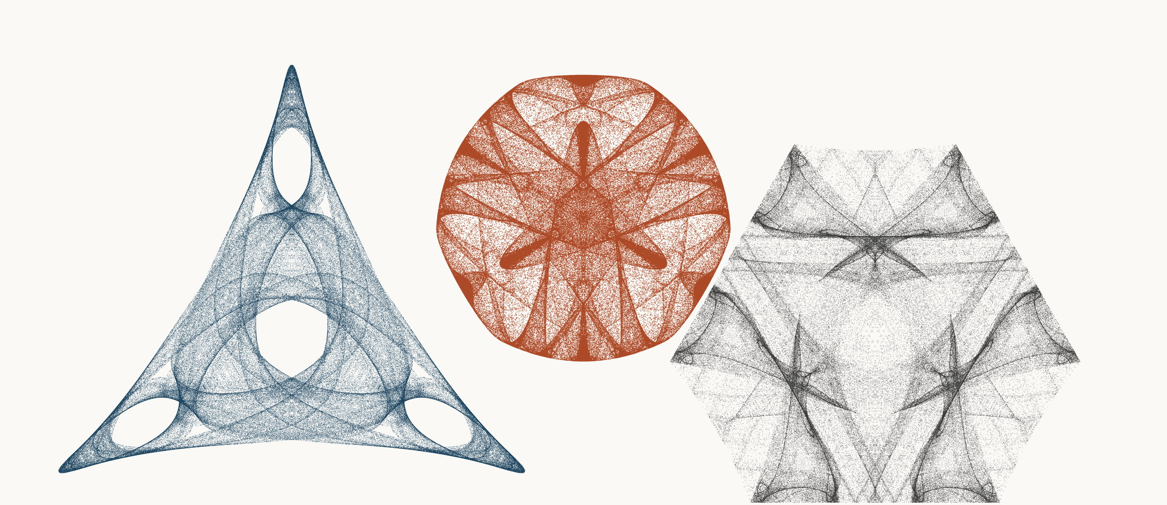
NEURAL INTERESTINGNESS 70 | RAW QUADTREE CODE BITS 70 | FORMER WUNDT GATE 70
X52119_M3  Definition X(52119); M3 pedal triangle  Neural score 57.693  Code bits 4,937 q/random 0.2255  Fitted taste 1.246 | X25273_M1  Definition X(25273); M1 cevian triangle  Code-bit rank 69 position 70  Quadtree code bits 1,052  q/random 0.07331 PNG/random 0.1959 | X64810_M3  Definition X(64810); M3 pedal triangle  Wundt position 70  Wundt gate 0.996867  q/random 0.5280 code bits 12,217
Each source plot uses 50,000 retained points after 4,000 discarded points and all six angle permutations. The center plot is visually oriented and enlarged only for presentation. Raw quadtree ranking is ascending by code bits.

Three Triangle Compressibility and Interestingness Atlas
Comparison position 71 of 120 Left and right upright Center visually inverted and maximized
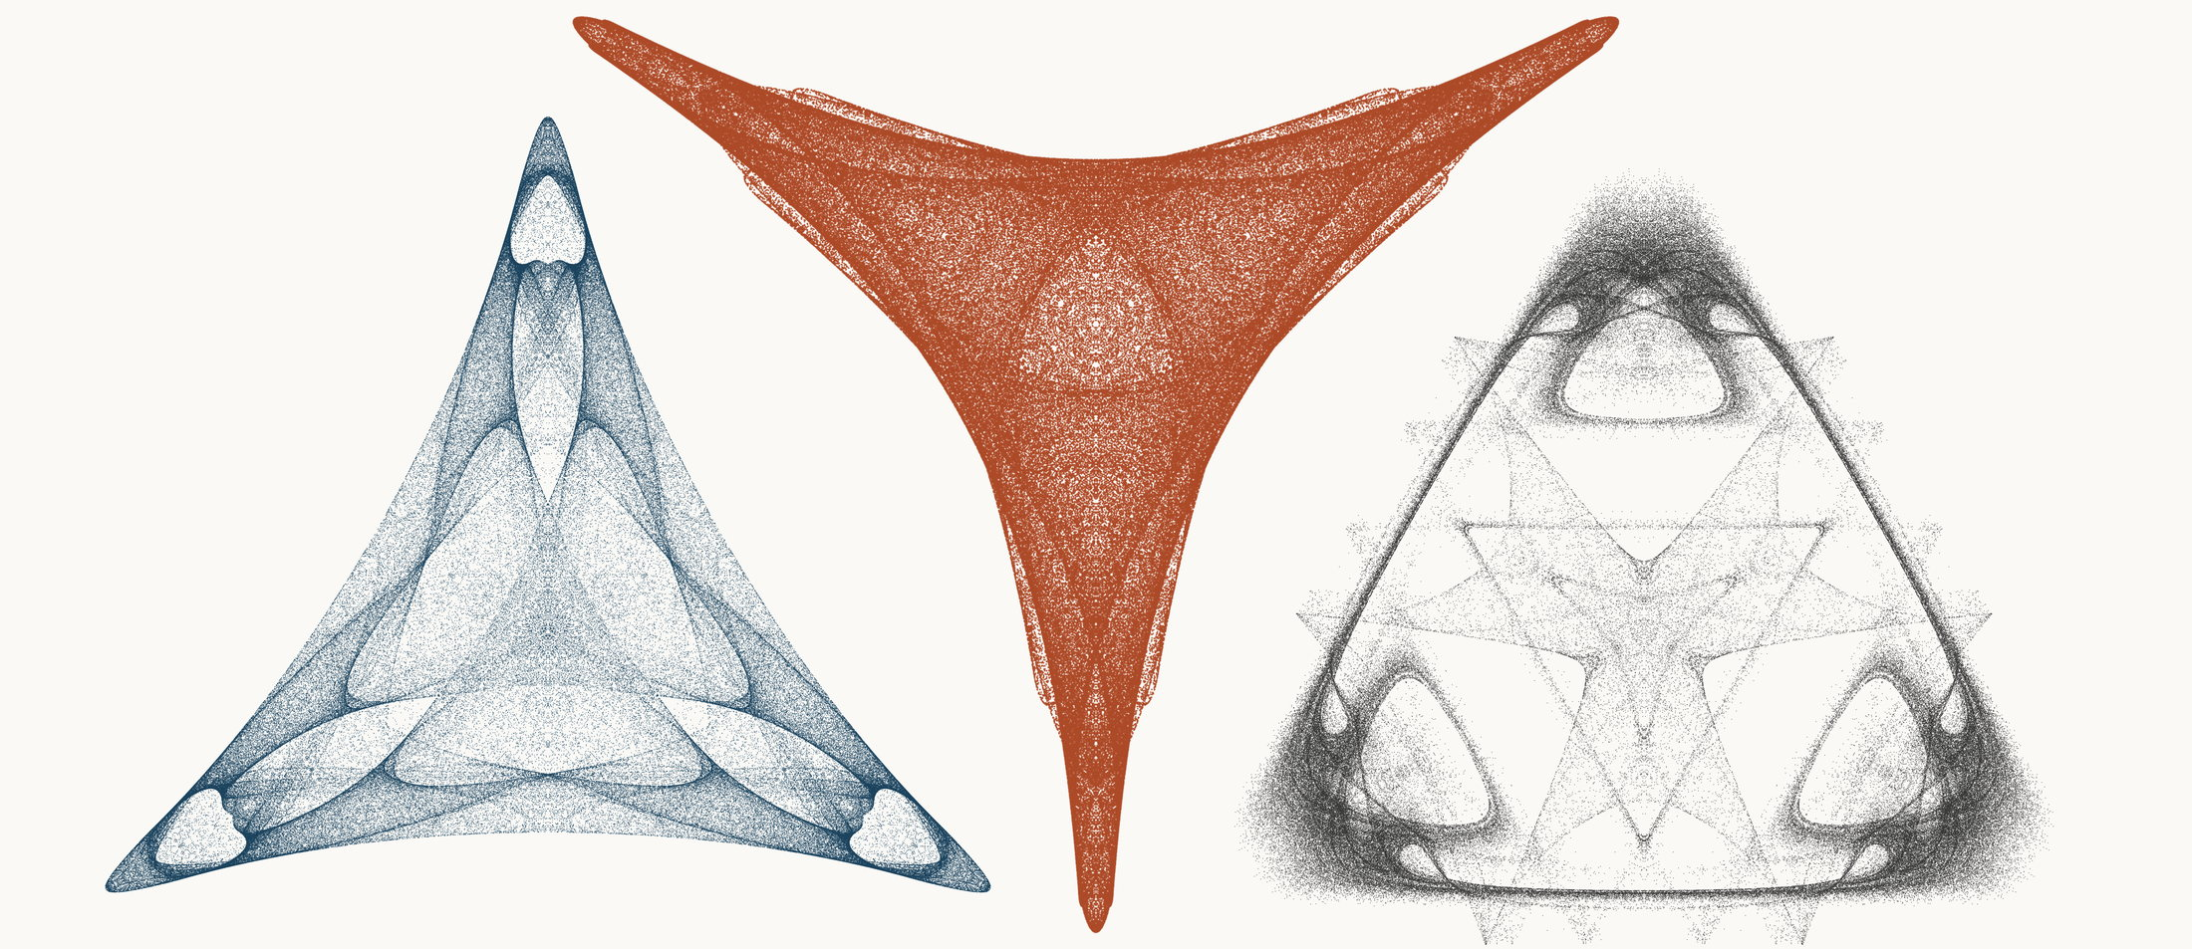
NEURAL INTERESTINGNESS 71 | RAW QUADTREE CODE BITS 71 | FORMER WUNDT GATE 71
X46458_M3  Definition X(46458); M3 pedal triangle  Neural score 57.668  Code bits 7,835 q/random 0.3503  Fitted taste 0.865 | X40694_M1  Definition X(40694); M1 cevian triangle  Code-bit rank 69 position 71  Quadtree code bits 1,052  q/random 0.08844 PNG/random 0.2188 | X15014_M3  Definition X(15014); M3 pedal triangle  Wundt position 71  Wundt gate 0.996865  q/random 0.4720 code bits 10,565
Each source plot uses 50,000 retained points after 4,000 discarded points and all six angle permutations. The center plot is visually oriented and enlarged only for presentation. Raw quadtree ranking is ascending by code bits.

Three Triangle Compressibility and Interestingness Atlas
Comparison position 72 of 120 Left and right upright Center visually inverted and maximized
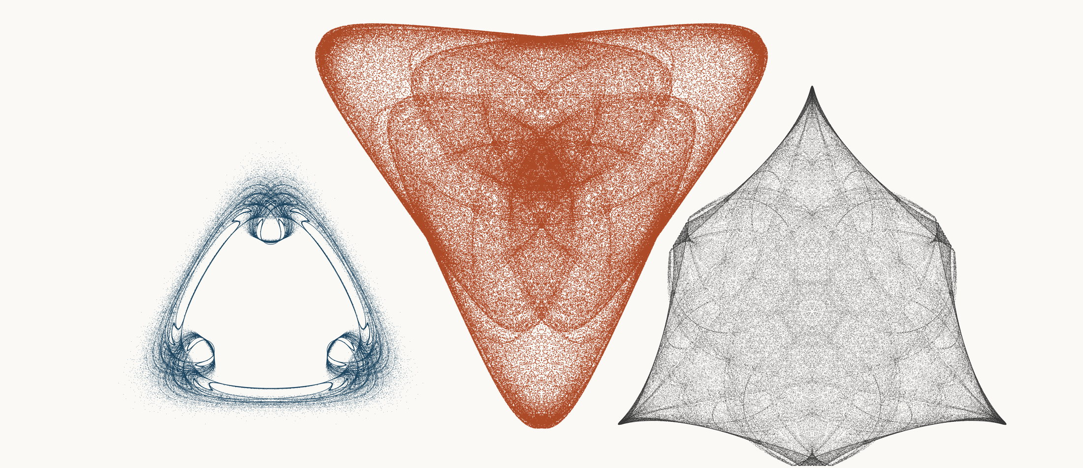
NEURAL INTERESTINGNESS 72 | RAW QUADTREE CODE BITS 72 | FORMER WUNDT GATE 72
X19728_M3  Definition X(19728); M3 pedal triangle  Neural score 57.636  Code bits 3,838 q/random 0.2502  Fitted taste 1.280 | X71310_M1  Definition X(71310); M1 cevian triangle  Code-bit rank 69 position 72  Quadtree code bits 1,052  q/random 0.06441 PNG/random 0.1641 | X39408_M3  Definition X(39408); M3 pedal triangle  Wundt position 72  Wundt gate 0.996849  q/random 0.4719 code bits 10,831
Each source plot uses 50,000 retained points after 4,000 discarded points and all six angle permutations. The center plot is visually oriented and enlarged only for presentation. Raw quadtree ranking is ascending by code bits.

Three Triangle Compressibility and Interestingness Atlas
Comparison position 73 of 120 Left and right upright Center visually inverted and maximized
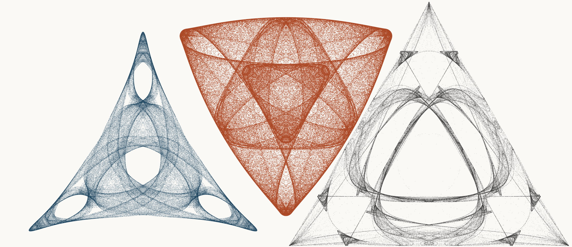
NEURAL INTERESTINGNESS 73 | RAW QUADTREE CODE BITS 73 | FORMER WUNDT GATE 73
X53838_M3  Definition X(53838); M3 pedal triangle  Neural score 57.633  Code bits 4,643 q/random 0.2103  Fitted taste 1.270 | X37173_M3  Definition X(37173); M3 pedal triangle  Code-bit rank 73 position 73  Quadtree code bits 1,059  q/random 0.06461 PNG/random 0.1995 | X50439_M1  Definition X(50439); M1 cevian triangle  Wundt position 73  Wundt gate 0.996781  q/random 0.4716 code bits 10,418
Each source plot uses 50,000 retained points after 4,000 discarded points and all six angle permutations. The center plot is visually oriented and enlarged only for presentation. Raw quadtree ranking is ascending by code bits.

Three Triangle Compressibility and Interestingness Atlas
Comparison position 74 of 120 Left and right upright Center visually inverted and maximized
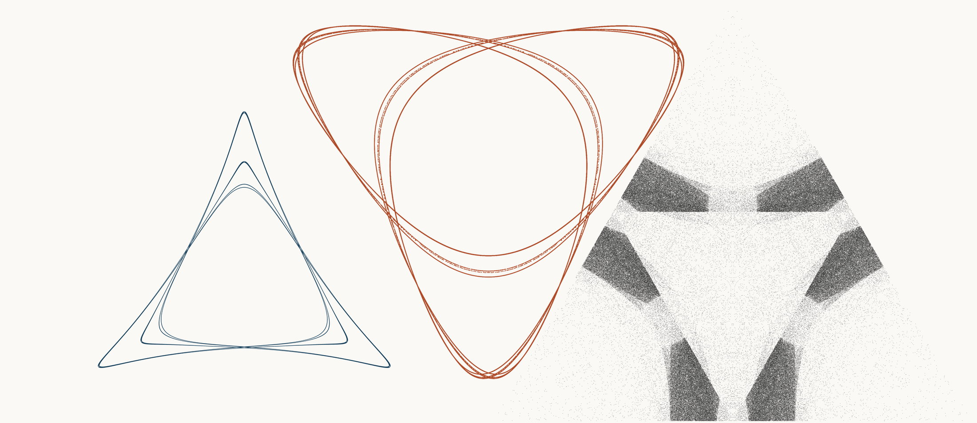
NEURAL INTERESTINGNESS 74 | RAW QUADTREE CODE BITS 74 | FORMER WUNDT GATE 74
X24472_M1  Definition X(24472); M1 cevian triangle  Neural score 57.610  Code bits 1,745 q/random 0.2754  Fitted taste 0.118 | X58596_M3  Definition X(58596); M3 pedal triangle  Code-bit rank 74 position 74  Quadtree code bits 1,066  q/random 0.20403 PNG/random 0.3138 | X54929_M1  Definition X(54929); M1 cevian triangle  Wundt position 74  Wundt gate 0.996745  q/random 0.5285 code bits 11,286
Each source plot uses 50,000 retained points after 4,000 discarded points and all six angle permutations. The center plot is visually oriented and enlarged only for presentation. Raw quadtree ranking is ascending by code bits.

Three Triangle Compressibility and Interestingness Atlas
Comparison position 75 of 120 Left and right upright Center visually inverted and maximized
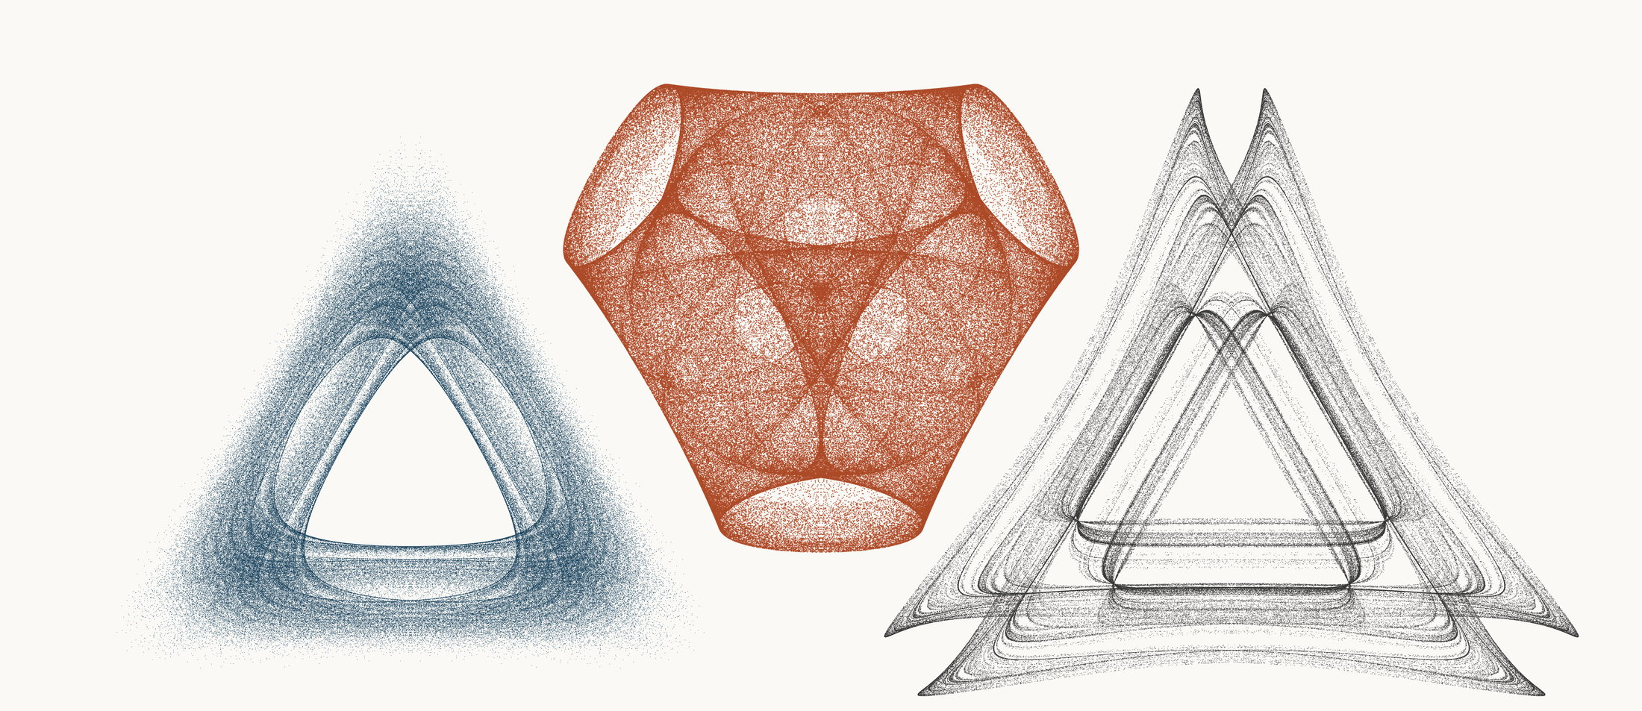
NEURAL INTERESTINGNESS 75 | RAW QUADTREE CODE BITS 75 | FORMER WUNDT GATE 75
X18700_M3  Definition X(18700); M3 pedal triangle  Neural score 57.431  Code bits 5,700 q/random 0.2540  Fitted taste 1.085 | X20976_M3  Definition X(20976); M3 pedal triangle  Code-bit rank 75 position 75  Quadtree code bits 1,080  q/random 0.06393 PNG/random 0.1861 | X65521_M1  Definition X(65521); M1 cevian triangle  Wundt position 75  Wundt gate 0.996663  q/random 0.4711 code bits 10,677
Each source plot uses 50,000 retained points after 4,000 discarded points and all six angle permutations. The center plot is visually oriented and enlarged only for presentation. Raw quadtree ranking is ascending by code bits.

Three Triangle Compressibility and Interestingness Atlas
Comparison position 76 of 120 Left and right upright Center visually inverted and maximized
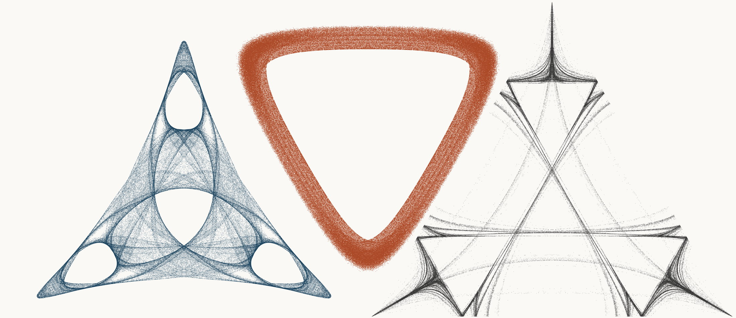
NEURAL INTERESTINGNESS 76 | RAW QUADTREE CODE BITS 76 | FORMER WUNDT GATE 76
X44320_M3  Definition X(44320); M3 pedal triangle  Neural score 57.290  Code bits 5,021 q/random 0.2352  Fitted taste 1.346 | X27881_M3  Definition X(27881); M3 pedal triangle  Code-bit rank 76 position 76  Quadtree code bits 1,087  q/random 0.07605 PNG/random 0.1296 | X5630_M1  Definition X(5630); M1 cevian triangle  Wundt position 76  Wundt gate 0.996609  q/random 0.4709 code bits 8,549
Each source plot uses 50,000 retained points after 4,000 discarded points and all six angle permutations. The center plot is visually oriented and enlarged only for presentation. Raw quadtree ranking is ascending by code bits.

Three Triangle Compressibility and Interestingness Atlas
Comparison position 77 of 120 Left and right upright Center visually inverted and maximized
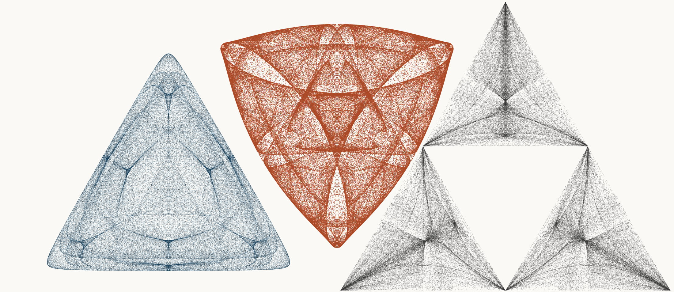
NEURAL INTERESTINGNESS 77 | RAW QUADTREE CODE BITS 77 | FORMER WUNDT GATE 77
X13827_M3  Definition X(13827); M3 pedal triangle  Neural score 57.288  Code bits 7,828 q/random 0.3411  Fitted taste 0.263 | X4188_M3  Definition X(4188); M3 pedal triangle  Code-bit rank 77 position 77  Quadtree code bits 1,094  q/random 0.06897 PNG/random 0.2033 | X915_M1  Definition X(915); M1 cevian triangle  Wundt position 77  Wundt gate 0.996561  q/random 0.5293 code bits 12,133
Each source plot uses 50,000 retained points after 4,000 discarded points and all six angle permutations. The center plot is visually oriented and enlarged only for presentation. Raw quadtree ranking is ascending by code bits.

Three Triangle Compressibility and Interestingness Atlas
Comparison position 78 of 120 Left and right upright Center visually inverted and maximized
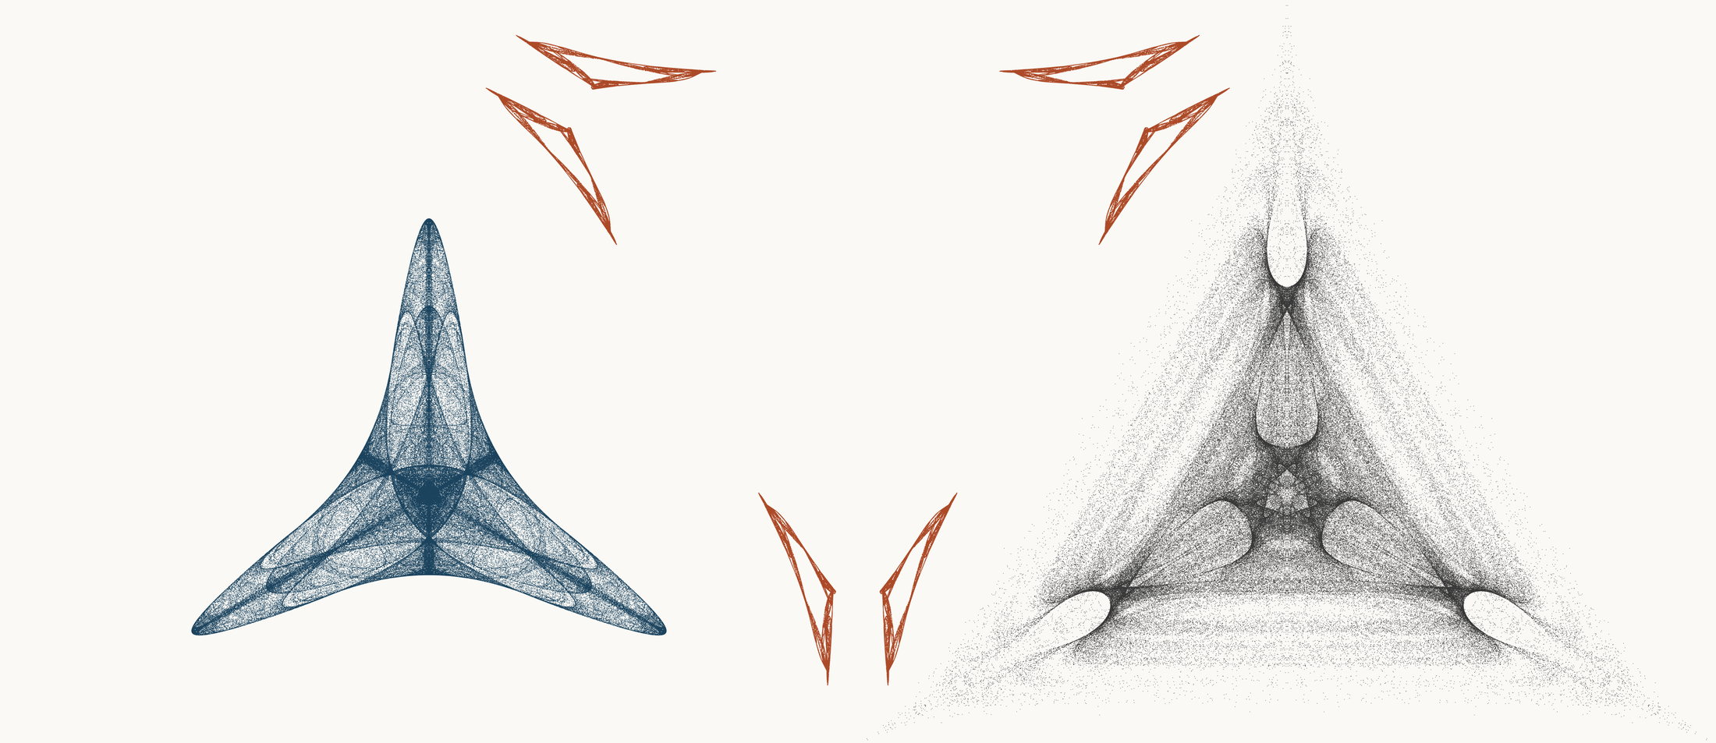
NEURAL INTERESTINGNESS 78 | RAW QUADTREE CODE BITS 78 | FORMER WUNDT GATE 78
X39908_M1  Definition X(39908); M1 cevian triangle  Neural score 57.273  Code bits 1,913 q/random 0.1152  Fitted taste 0.482 | X15187_M3  Definition X(15187); M3 pedal triangle  Code-bit rank 78 position 78  Quadtree code bits 1,101  q/random 0.16936 PNG/random 0.2213 | X16599_M1  Definition X(16599); M1 cevian triangle  Wundt position 78  Wundt gate 0.996536  q/random 0.4706 code bits 10,635
Each source plot uses 50,000 retained points after 4,000 discarded points and all six angle permutations. The center plot is visually oriented and enlarged only for presentation. Raw quadtree ranking is ascending by code bits.

Three Triangle Compressibility and Interestingness Atlas
Comparison position 79 of 120 Left and right upright Center visually inverted and maximized
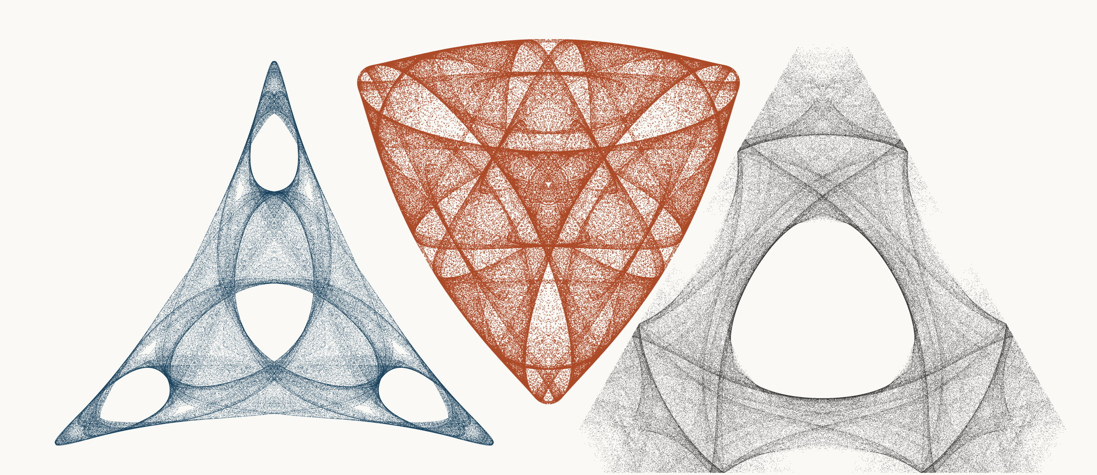
NEURAL INTERESTINGNESS 79 | RAW QUADTREE CODE BITS 79 | FORMER WUNDT GATE 79
X3120_M3  Definition X(3120); M3 pedal triangle  Neural score 57.273  Code bits 5,112 q/random 0.2344  Fitted taste 1.106 | X16400_M3  Definition X(16400); M3 pedal triangle  Code-bit rank 78 position 79  Quadtree code bits 1,101  q/random 0.07143 PNG/random 0.2161 | X7718_M3  Definition X(7718); M3 pedal triangle  Wundt position 79  Wundt gate 0.996505  q/random 0.4704 code bits 10,642
Each source plot uses 50,000 retained points after 4,000 discarded points and all six angle permutations. The center plot is visually oriented and enlarged only for presentation. Raw quadtree ranking is ascending by code bits.

Three Triangle Compressibility and Interestingness Atlas
Comparison position 80 of 120 Left and right upright Center visually inverted and maximized
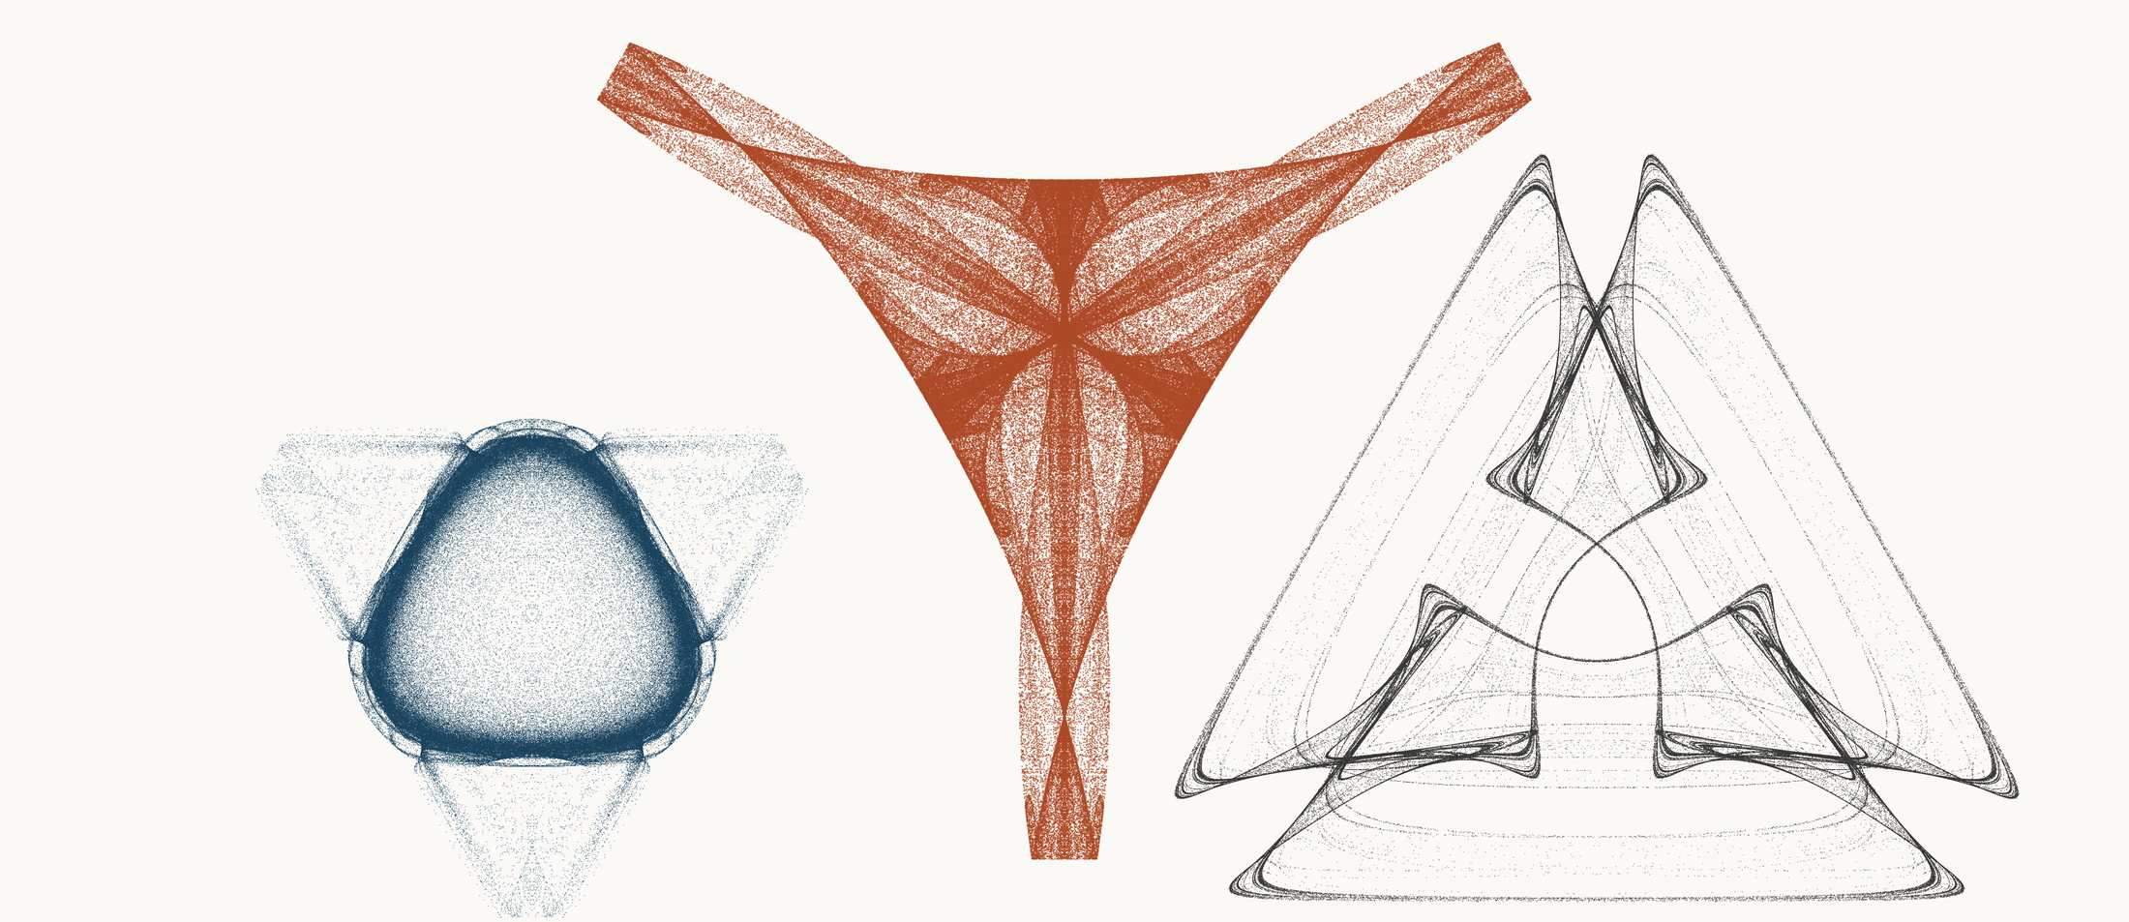
NEURAL INTERESTINGNESS 80 | RAW QUADTREE CODE BITS 80 | FORMER WUNDT GATE 80
X39946_M3  Definition X(39946); M3 pedal triangle  Neural score 57.196  Code bits 5,546 q/random 0.3116  Fitted taste 1.190 | X54535_M3  Definition X(54535); M3 pedal triangle  Code-bit rank 80 position 80  Quadtree code bits 1,108  q/random 0.07685 PNG/random 0.2097 | X3021_M3  Definition X(3021); M3 pedal triangle  Wundt position 80  Wundt gate 0.996502  q/random 0.5296 code bits 9,466
Each source plot uses 50,000 retained points after 4,000 discarded points and all six angle permutations. The center plot is visually oriented and enlarged only for presentation. Raw quadtree ranking is ascending by code bits.

Three Triangle Compressibility and Interestingness Atlas
Comparison position 81 of 120 Left and right upright Center visually inverted and maximized
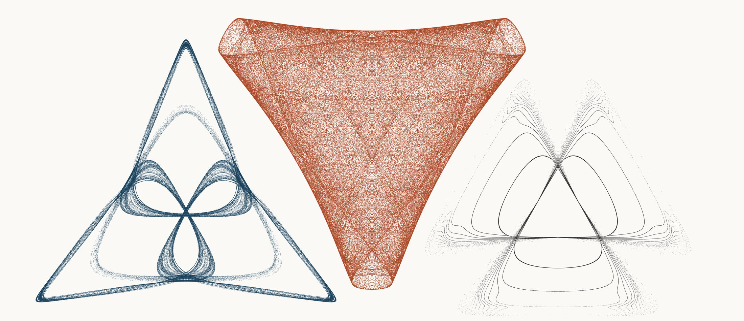
NEURAL INTERESTINGNESS 81 | RAW QUADTREE CODE BITS 81 | FORMER WUNDT GATE 81
X23941_M3  Definition X(23941); M3 pedal triangle  Neural score 57.164  Code bits 3,649 q/random 0.2094  Fitted taste 0.790 | X26655_M3  Definition X(26655); M3 pedal triangle  Code-bit rank 81 position 81  Quadtree code bits 1,115  q/random 0.05902 PNG/random 0.1883 | X58670_M3  Definition X(58670); M3 pedal triangle  Wundt position 81  Wundt gate 0.996443  q/random 0.4702 code bits 5,686
Each source plot uses 50,000 retained points after 4,000 discarded points and all six angle permutations. The center plot is visually oriented and enlarged only for presentation. Raw quadtree ranking is ascending by code bits.

Three Triangle Compressibility and Interestingness Atlas
Comparison position 82 of 120 Left and right upright Center visually inverted and maximized
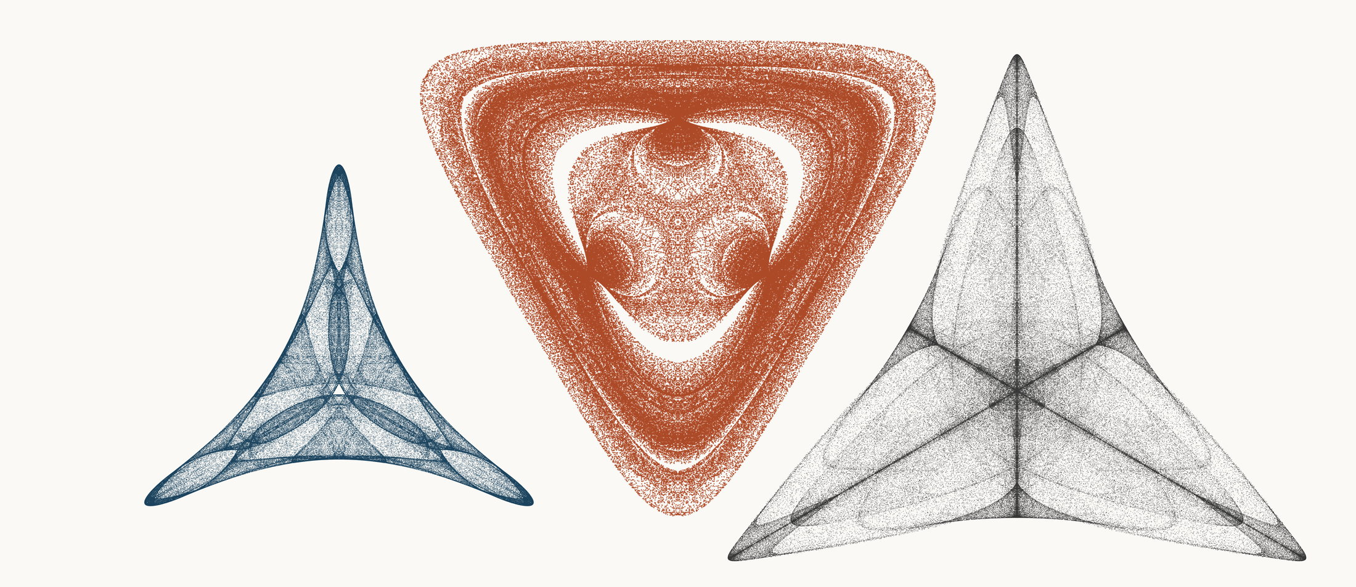
NEURAL INTERESTINGNESS 82 | RAW QUADTREE CODE BITS 82 | FORMER WUNDT GATE 82
X3924_M1  Definition X(3924); M1 cevian triangle  Neural score 57.060  Code bits 2,368 q/random 0.1419  Fitted taste 0.614 | X32245_M1  Definition X(32245); M1 cevian triangle  Code-bit rank 81 position 82  Quadtree code bits 1,115  q/random 0.07677 PNG/random 0.1746 | X16881_M3  Definition X(16881); M3 pedal triangle  Wundt position 82  Wundt gate 0.996340  q/random 0.4698 code bits 10,656
Each source plot uses 50,000 retained points after 4,000 discarded points and all six angle permutations. The center plot is visually oriented and enlarged only for presentation. Raw quadtree ranking is ascending by code bits.

Three Triangle Compressibility and Interestingness Atlas
Comparison position 83 of 120 Left and right upright Center visually inverted and maximized
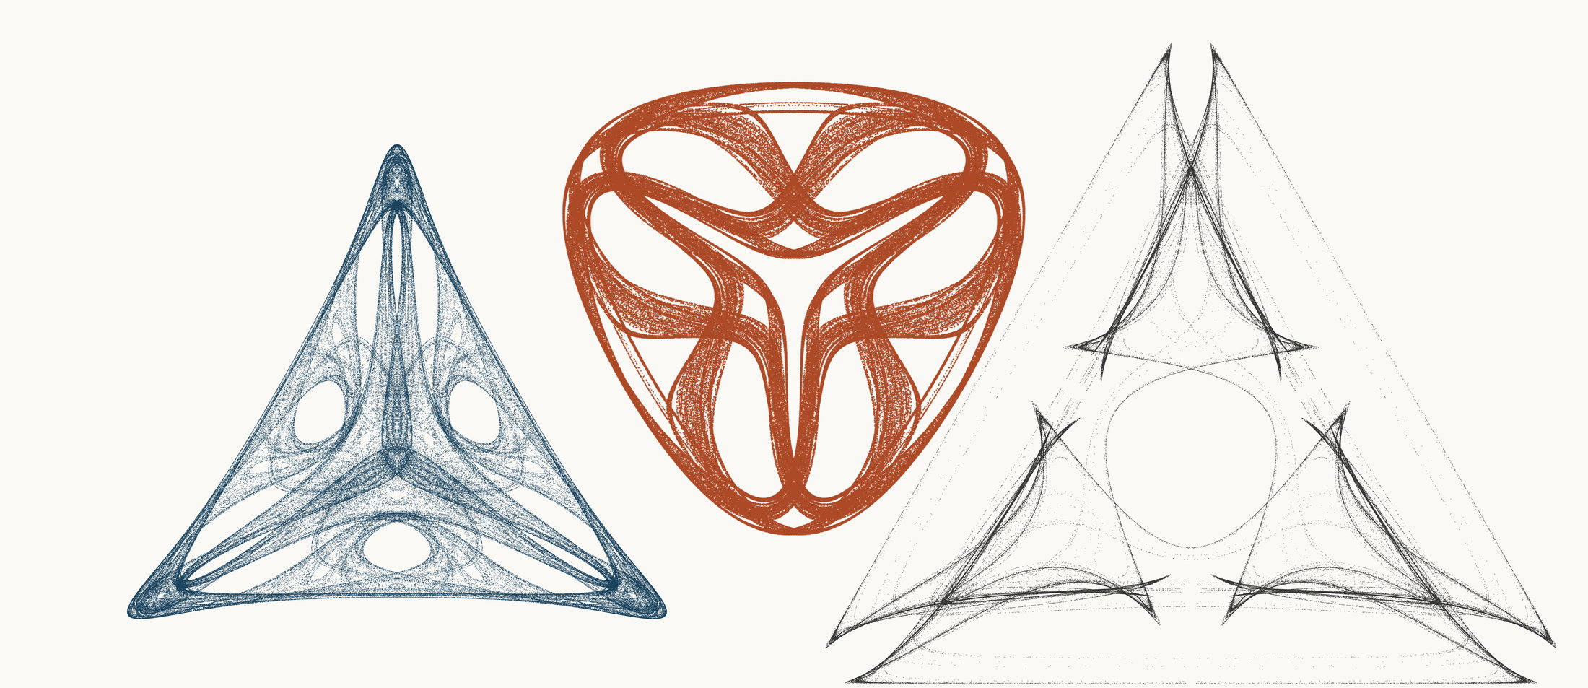
NEURAL INTERESTINGNESS 83 | RAW QUADTREE CODE BITS 83 | FORMER WUNDT GATE 83
X48714_M1  Definition X(48714); M1 cevian triangle  Neural score 56.994  Code bits 5,217 q/random 0.2484  Fitted taste 1.036 | X65825_M3  Definition X(65825); M3 pedal triangle  Code-bit rank 81 position 83  Quadtree code bits 1,115  q/random 0.11317 PNG/random 0.2355 | X51810_M3  Definition X(51810); M3 pedal triangle  Wundt position 83  Wundt gate 0.996287  q/random 0.4695 code bits 7,877
Each source plot uses 50,000 retained points after 4,000 discarded points and all six angle permutations. The center plot is visually oriented and enlarged only for presentation. Raw quadtree ranking is ascending by code bits.

Three Triangle Compressibility and Interestingness Atlas
Comparison position 84 of 120 Left and right upright Center visually inverted and maximized
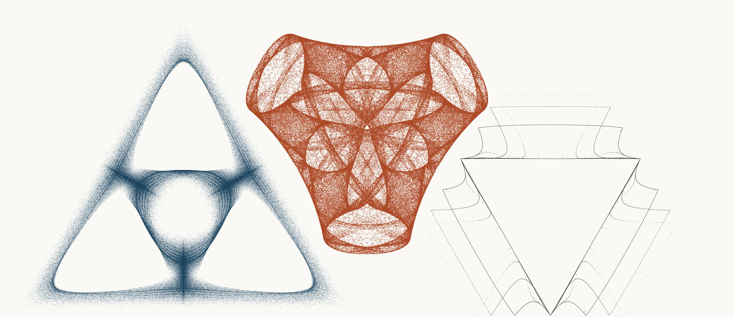
NEURAL INTERESTINGNESS 84 | RAW QUADTREE CODE BITS 84 | FORMER WUNDT GATE 84
X13183_M3  Definition X(13183); M3 pedal triangle  Neural score 56.949  Code bits 5,917 q/random 0.2823  Fitted taste 0.625 | X12774_M3  Definition X(12774); M3 pedal triangle  Code-bit rank 84 position 84  Quadtree code bits 1,122  q/random 0.07893 PNG/random 0.2022 | X43757_M1  Definition X(43757); M1 cevian triangle  Wundt position 84  Wundt gate 0.996225  q/random 0.4693 code bits 3,691
Each source plot uses 50,000 retained points after 4,000 discarded points and all six angle permutations. The center plot is visually oriented and enlarged only for presentation. Raw quadtree ranking is ascending by code bits.

Three Triangle Compressibility and Interestingness Atlas
Comparison position 85 of 120 Left and right upright Center visually inverted and maximized
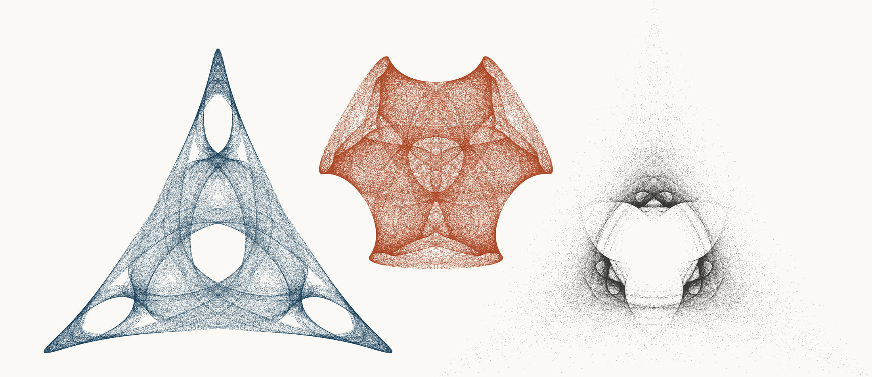
NEURAL INTERESTINGNESS 85 | RAW QUADTREE CODE BITS 85 | FORMER WUNDT GATE 85
X53559_M3  Definition X(53559); M3 pedal triangle  Neural score 56.894  Code bits 4,839 q/random 0.2230  Fitted taste 1.157 | X23558_M3  Definition X(23558); M3 pedal triangle  Code-bit rank 84 position 85  Quadtree code bits 1,122  q/random 0.06309 PNG/random 0.1663 | X71424_M3  Definition X(71424); M3 pedal triangle  Wundt position 85  Wundt gate 0.996184  q/random 0.5309 code bits 10,229
Each source plot uses 50,000 retained points after 4,000 discarded points and all six angle permutations. The center plot is visually oriented and enlarged only for presentation. Raw quadtree ranking is ascending by code bits.

Three Triangle Compressibility and Interestingness Atlas
Comparison position 86 of 120 Left and right upright Center visually inverted and maximized
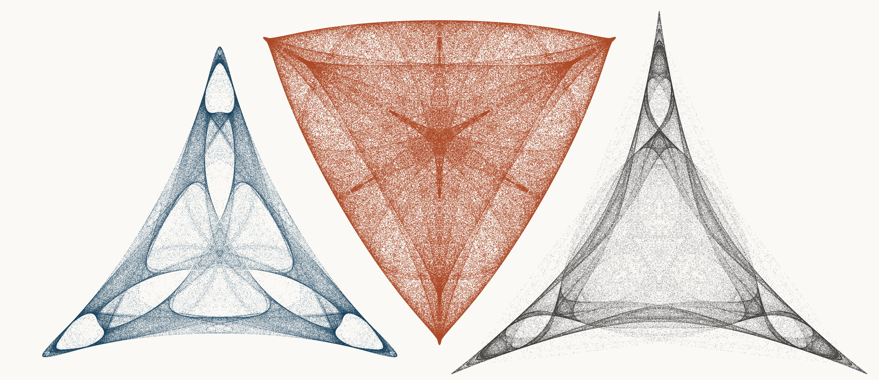
NEURAL INTERESTINGNESS 86 | RAW QUADTREE CODE BITS 86 | FORMER WUNDT GATE 86
X21725_M3  Definition X(21725); M3 pedal triangle  Neural score 56.744  Code bits 7,058 q/random 0.3297  Fitted taste 1.086 | X25484_M3  Definition X(25484); M3 pedal triangle  Code-bit rank 84 position 86  Quadtree code bits 1,122  q/random 0.06185 PNG/random 0.2036 | X8573_M1  Definition X(8573); M1 cevian triangle  Wundt position 86  Wundt gate 0.996128  q/random 0.4689 code bits 10,341
Each source plot uses 50,000 retained points after 4,000 discarded points and all six angle permutations. The center plot is visually oriented and enlarged only for presentation. Raw quadtree ranking is ascending by code bits.

Three Triangle Compressibility and Interestingness Atlas
Comparison position 87 of 120 Left and right upright Center visually inverted and maximized
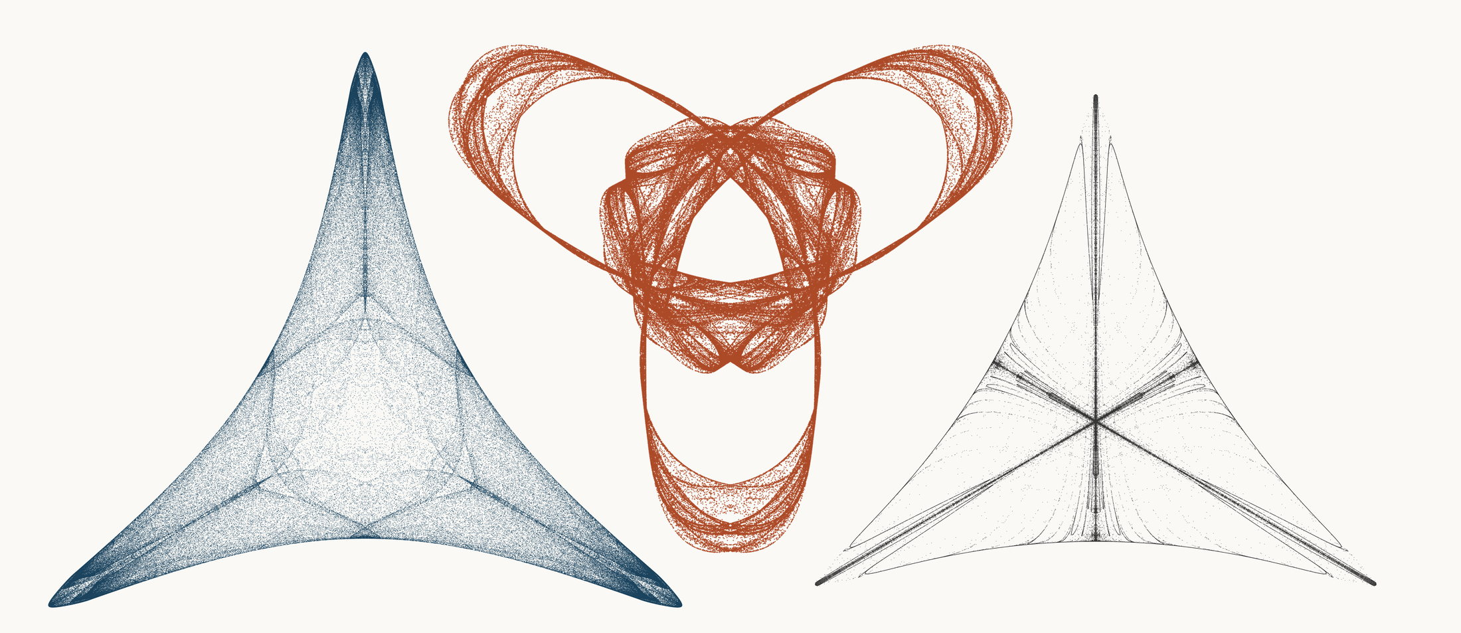
NEURAL INTERESTINGNESS 87 | RAW QUADTREE CODE BITS 87 | FORMER WUNDT GATE 87
X40958_M1  Definition X(40958); M1 cevian triangle  Neural score 56.738  Code bits 7,730 q/random 0.3575  Fitted taste 0.460 | X64598_M3  Definition X(64598); M3 pedal triangle  Code-bit rank 84 position 87  Quadtree code bits 1,122  q/random 0.10760 PNG/random 0.2394 | X65122_M3  Definition X(65122); M3 pedal triangle  Wundt position 87  Wundt gate 0.996071  q/random 0.4687 code bits 5,707
Each source plot uses 50,000 retained points after 4,000 discarded points and all six angle permutations. The center plot is visually oriented and enlarged only for presentation. Raw quadtree ranking is ascending by code bits.

Three Triangle Compressibility and Interestingness Atlas
Comparison position 88 of 120 Left and right upright Center visually inverted and maximized
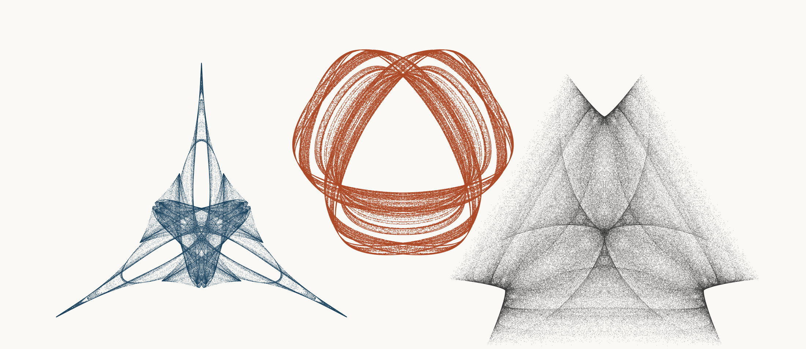
NEURAL INTERESTINGNESS 88 | RAW QUADTREE CODE BITS 88 | FORMER WUNDT GATE 88
X65608_M3  Definition X(65608); M3 pedal triangle  Neural score 56.694  Code bits 2,963 q/random 0.1957  Fitted taste 0.895 | X66787_M3  Definition X(66787); M3 pedal triangle  Code-bit rank 84 position 88  Quadtree code bits 1,122  q/random 0.09615 PNG/random 0.1622 | X8519_M3  Definition X(8519); M3 pedal triangle  Wundt position 88  Wundt gate 0.996007  q/random 0.4684 code bits 10,691
Each source plot uses 50,000 retained points after 4,000 discarded points and all six angle permutations. The center plot is visually oriented and enlarged only for presentation. Raw quadtree ranking is ascending by code bits.

Three Triangle Compressibility and Interestingness Atlas
Comparison position 89 of 120 Left and right upright Center visually inverted and maximized
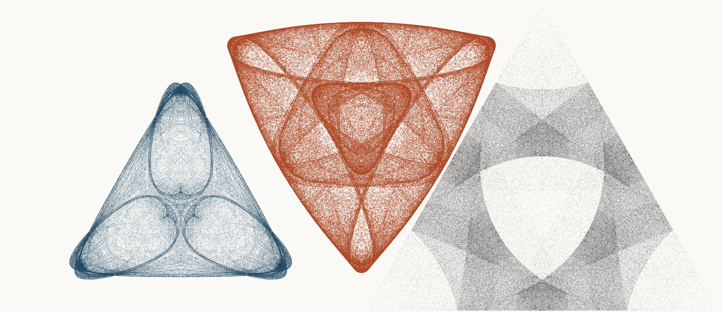
NEURAL INTERESTINGNESS 89 | RAW QUADTREE CODE BITS 89 | FORMER WUNDT GATE 89
X19384_M3  Definition X(19384); M3 pedal triangle  Neural score 56.673  Code bits 6,344 q/random 0.2839  Fitted taste 0.834 | X35951_M3  Definition X(35951); M3 pedal triangle  Code-bit rank 89 position 89  Quadtree code bits 1,129  q/random 0.06877 PNG/random 0.1988 | X14554_M3  Definition X(14554); M3 pedal triangle  Wundt position 89  Wundt gate 0.995941  q/random 0.5319 code bits 11,923
Each source plot uses 50,000 retained points after 4,000 discarded points and all six angle permutations. The center plot is visually oriented and enlarged only for presentation. Raw quadtree ranking is ascending by code bits.

Three Triangle Compressibility and Interestingness Atlas
Comparison position 90 of 120 Left and right upright Center visually inverted and maximized
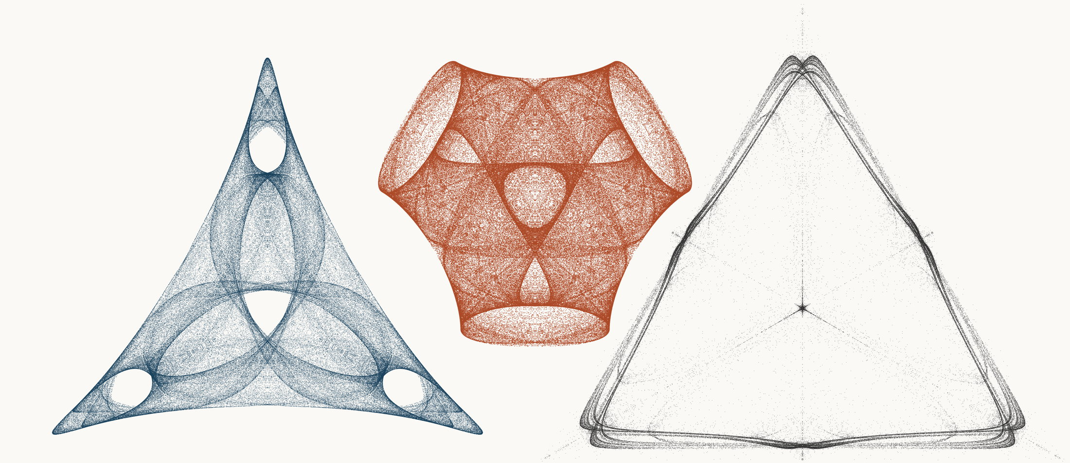
NEURAL INTERESTINGNESS 90 | RAW QUADTREE CODE BITS 90 | FORMER WUNDT GATE 90
X23823_M3  Definition X(23823); M3 pedal triangle  Neural score 56.612  Code bits 5,938 q/random 0.2648  Fitted taste 1.063 | X23648_M3  Definition X(23648); M3 pedal triangle  Code-bit rank 90 position 90  Quadtree code bits 1,157  q/random 0.06829 PNG/random 0.1854 | X32199_M3  Definition X(32199); M3 pedal triangle  Wundt position 90  Wundt gate 0.995810  q/random 0.5324 code bits 8,983
Each source plot uses 50,000 retained points after 4,000 discarded points and all six angle permutations. The center plot is visually oriented and enlarged only for presentation. Raw quadtree ranking is ascending by code bits.

Three Triangle Compressibility and Interestingness Atlas
Comparison position 91 of 120 Left and right upright Center visually inverted and maximized
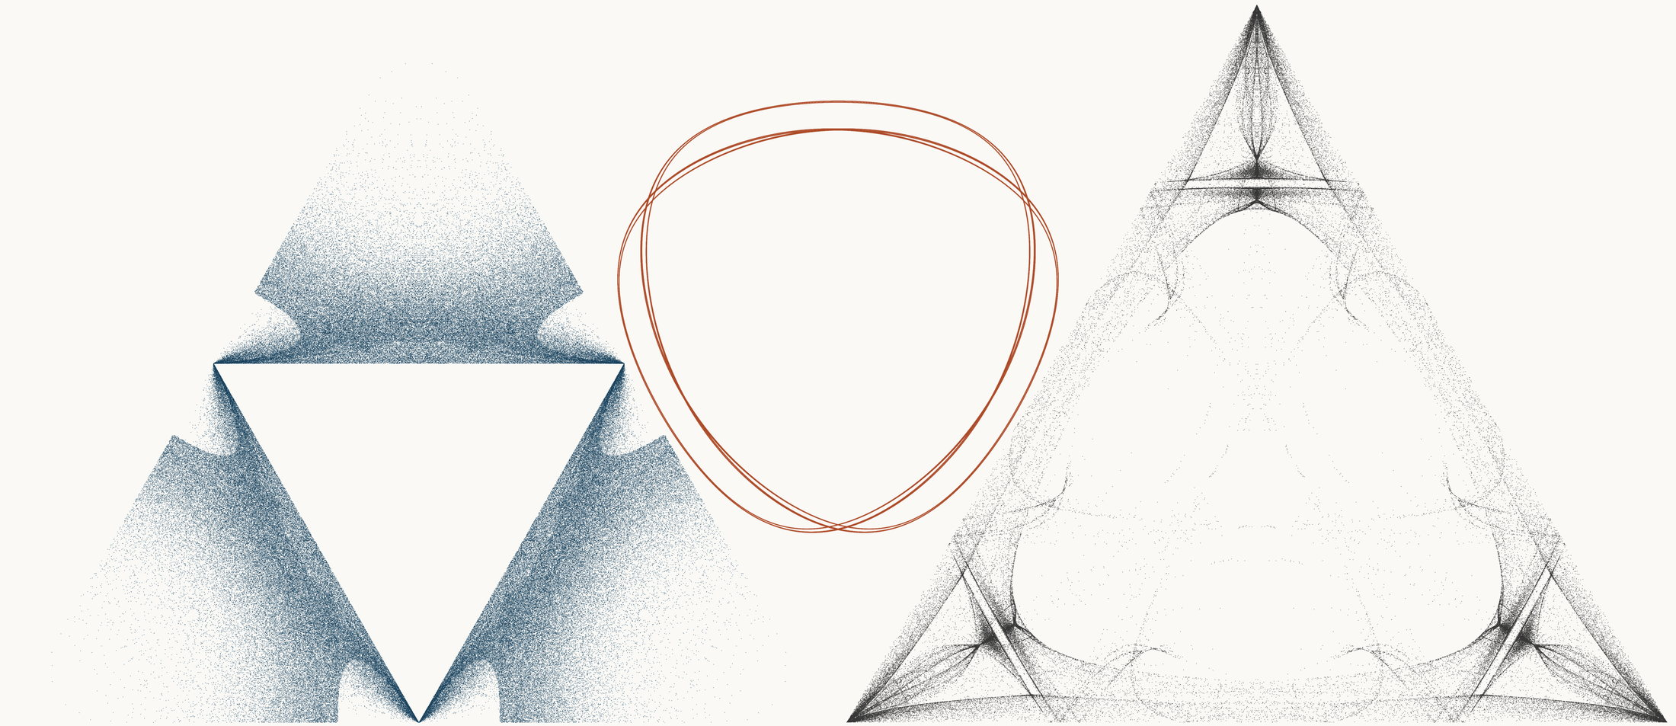
NEURAL INTERESTINGNESS 91 | RAW QUADTREE CODE BITS 91 | FORMER WUNDT GATE 91
X11652_M1  Definition X(11652); M1 cevian triangle  Neural score 56.590  Code bits 7,737 q/random 0.3397  Fitted taste 1.214 | X1391_M1  Definition X(1391); M1 cevian triangle  Code-bit rank 91 position 91  Quadtree code bits 1,164  q/random 0.23380 PNG/random 0.2965 | X56449_M1  Definition X(56449); M1 cevian triangle  Wundt position 91  Wundt gate 0.995779  q/random 0.5325 code bits 10,845
Each source plot uses 50,000 retained points after 4,000 discarded points and all six angle permutations. The center plot is visually oriented and enlarged only for presentation. Raw quadtree ranking is ascending by code bits.

Three Triangle Compressibility and Interestingness Atlas
Comparison position 92 of 120 Left and right upright Center visually inverted and maximized
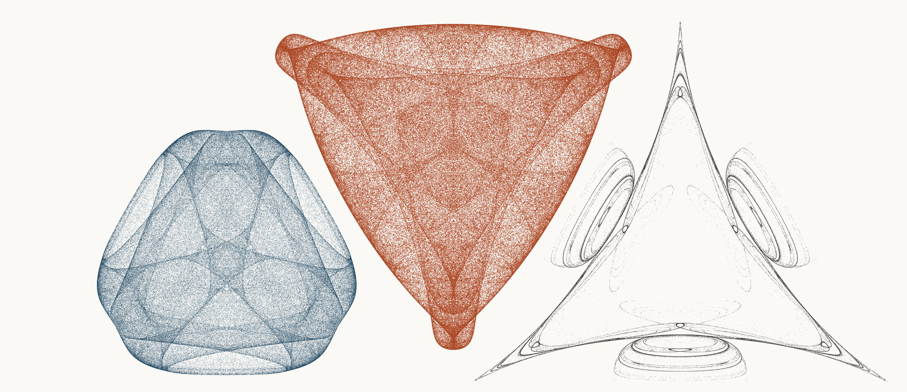
NEURAL INTERESTINGNESS 92 | RAW QUADTREE CODE BITS 92 | FORMER WUNDT GATE 92
X1569_M3  Definition X(1569); M3 pedal triangle  Neural score 56.585  Code bits 6,883 q/random 0.2982  Fitted taste 0.187 | X33280_M3  Definition X(33280); M3 pedal triangle  Code-bit rank 91 position 92  Quadtree code bits 1,164  q/random 0.06162 PNG/random 0.1992 | X18634_M3  Definition X(18634); M3 pedal triangle  Wundt position 92  Wundt gate 0.995744  q/random 0.4674 code bits 6,722
Each source plot uses 50,000 retained points after 4,000 discarded points and all six angle permutations. The center plot is visually oriented and enlarged only for presentation. Raw quadtree ranking is ascending by code bits.

Three Triangle Compressibility and Interestingness Atlas
Comparison position 93 of 120 Left and right upright Center visually inverted and maximized
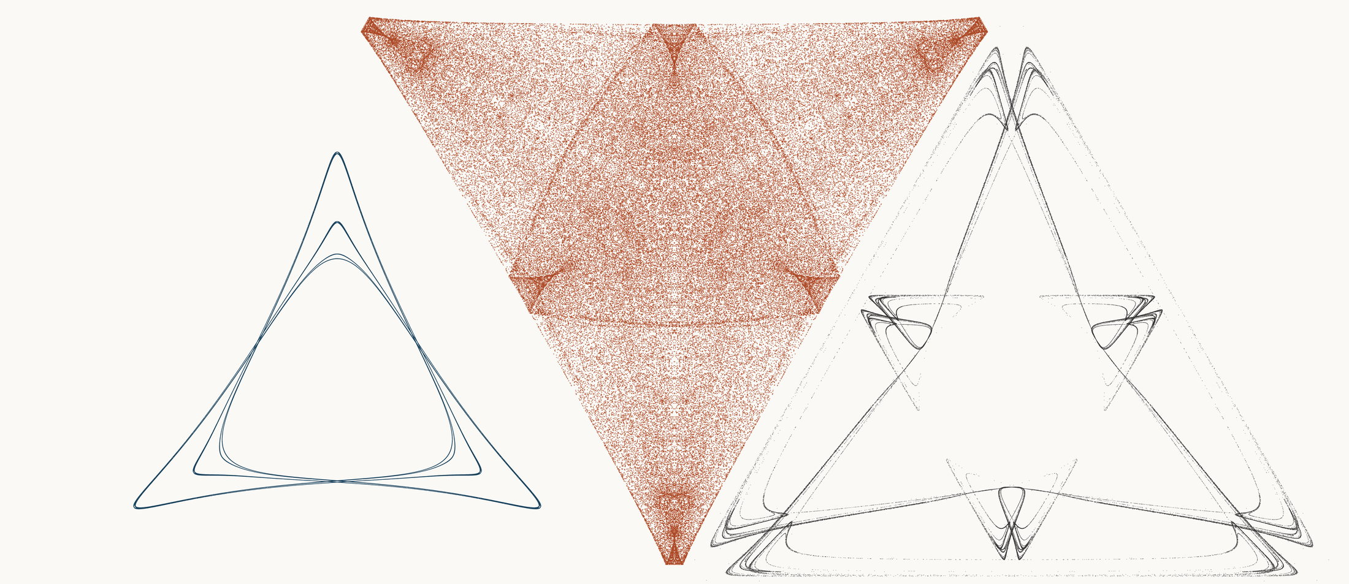
NEURAL INTERESTINGNESS 93 | RAW QUADTREE CODE BITS 93 | FORMER WUNDT GATE 93
X12736_M1  Definition X(12736); M1 cevian triangle  Neural score 56.582  Code bits 1,766 q/random 0.2754  Fitted taste 0.026 | X56587_M3  Definition X(56587); M3 pedal triangle  Code-bit rank 91 position 93  Quadtree code bits 1,164  q/random 0.05946 PNG/random 0.1975 | X63770_M3  Definition X(63770); M3 pedal triangle  Wundt position 93  Wundt gate 0.995484  q/random 0.4664 code bits 6,561
Each source plot uses 50,000 retained points after 4,000 discarded points and all six angle permutations. The center plot is visually oriented and enlarged only for presentation. Raw quadtree ranking is ascending by code bits.

Three Triangle Compressibility and Interestingness Atlas
Comparison position 94 of 120 Left and right upright Center visually inverted and maximized
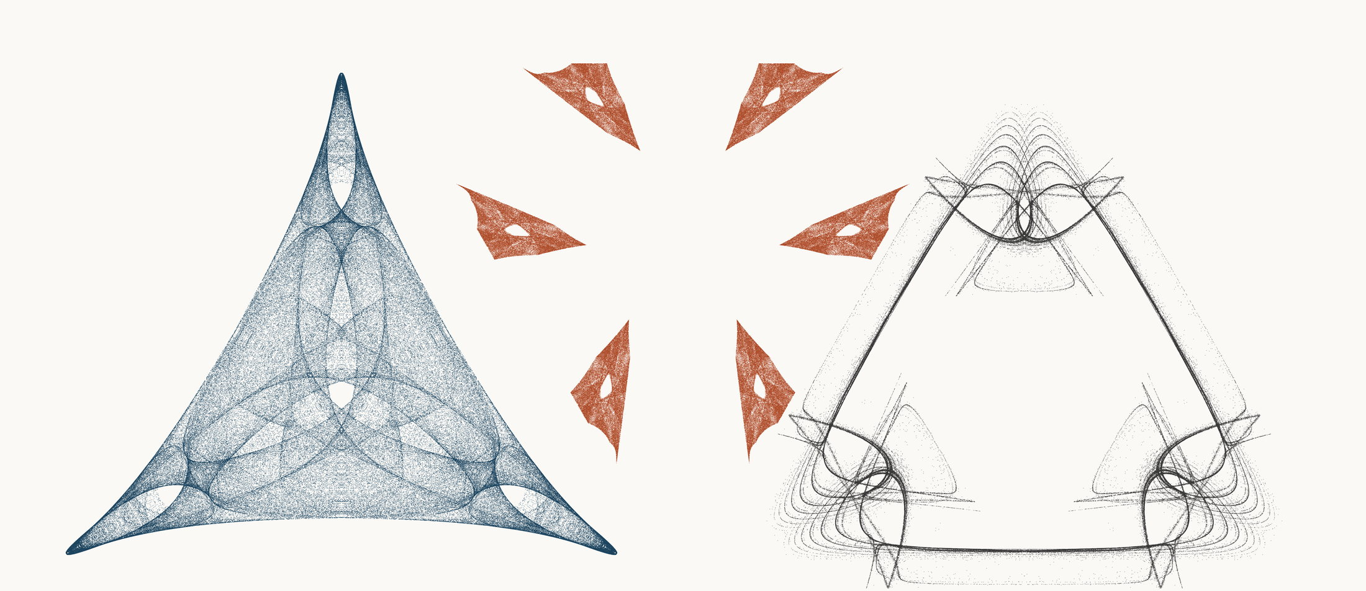
NEURAL INTERESTINGNESS 94 | RAW QUADTREE CODE BITS 94 | FORMER WUNDT GATE 94
X38961_M3  Definition X(38961); M3 pedal triangle  Neural score 56.463  Code bits 6,134 q/random 0.2697  Fitted taste 0.976 | X22237_M1  Definition X(22237); M1 cevian triangle  Code-bit rank 94 position 94  Quadtree code bits 1,171  q/random 0.07710 PNG/random 0.2406 | X8765_M3  Definition X(8765); M3 pedal triangle  Wundt position 94  Wundt gate 0.995483  q/random 0.4664 code bits 8,066
Each source plot uses 50,000 retained points after 4,000 discarded points and all six angle permutations. The center plot is visually oriented and enlarged only for presentation. Raw quadtree ranking is ascending by code bits.

Three Triangle Compressibility and Interestingness Atlas
Comparison position 95 of 120 Left and right upright Center visually inverted and maximized
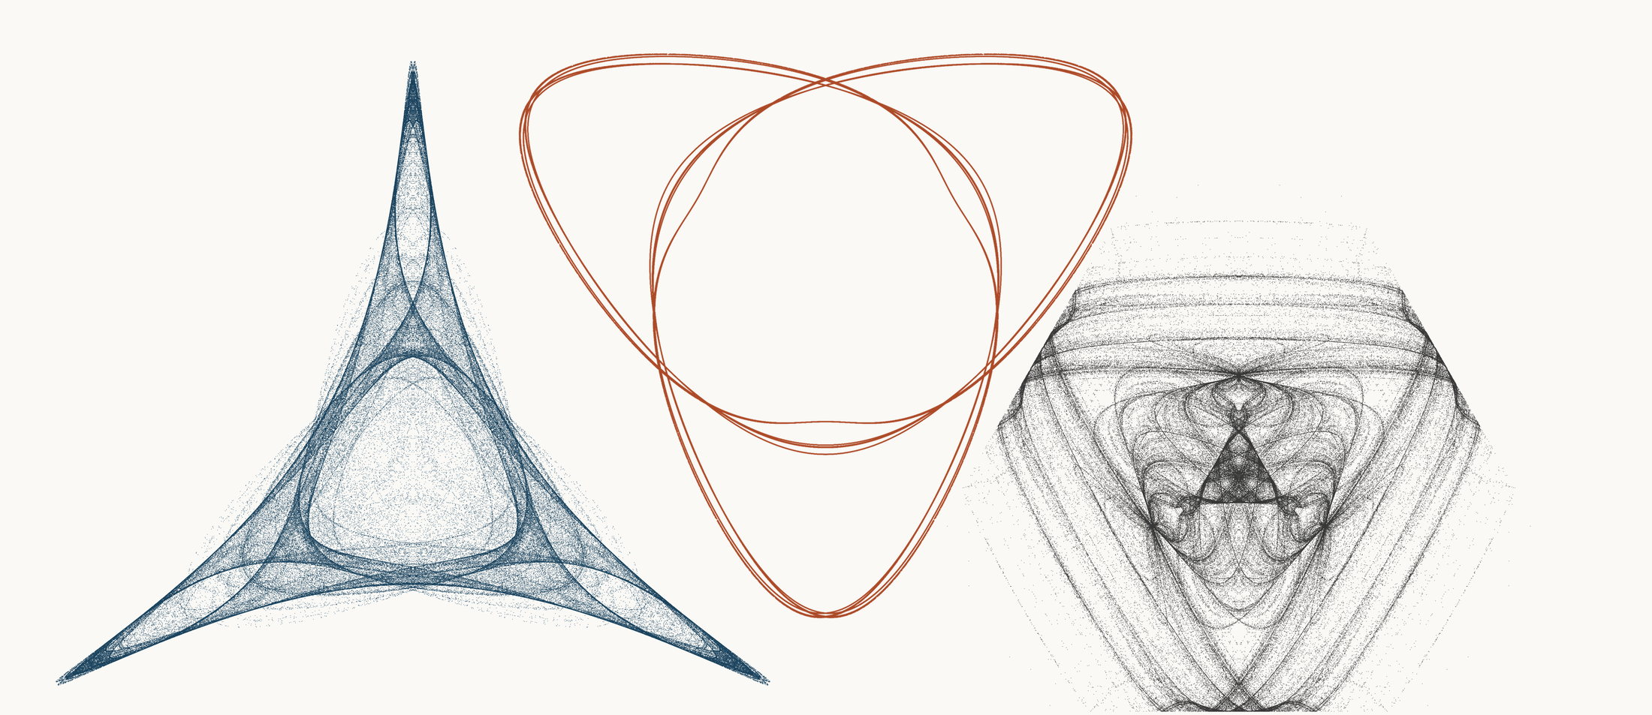
NEURAL INTERESTINGNESS 95 | RAW QUADTREE CODE BITS 95 | FORMER WUNDT GATE 95
X3554_M1  Definition X(3554); M1 cevian triangle  Neural score 56.447  Code bits 6,281 q/random 0.3131  Fitted taste 0.849 | X58594_M3  Definition X(58594); M3 pedal triangle  Code-bit rank 94 position 95  Quadtree code bits 1,171  q/random 0.21830 PNG/random 0.3165 | X51920_M1  Definition X(51920); M1 cevian triangle  Wundt position 95  Wundt gate 0.995380  q/random 0.4660 code bits 10,369
Each source plot uses 50,000 retained points after 4,000 discarded points and all six angle permutations. The center plot is visually oriented and enlarged only for presentation. Raw quadtree ranking is ascending by code bits.

Three Triangle Compressibility and Interestingness Atlas
Comparison position 96 of 120 Left and right upright Center visually inverted and maximized
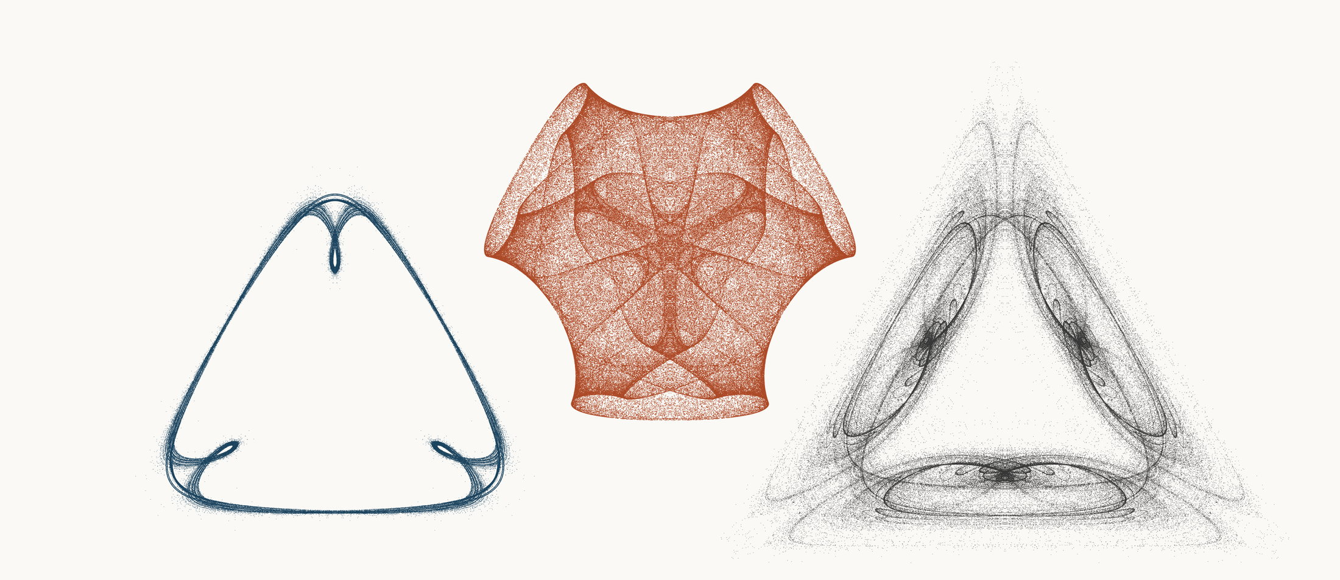
NEURAL INTERESTINGNESS 96 | RAW QUADTREE CODE BITS 96 | FORMER WUNDT GATE 96
X61567_M3  Definition X(61567); M3 pedal triangle  Neural score 56.387  Code bits 1,822 q/random 0.1887  Fitted taste 0.011 | X71281_M3  Definition X(71281); M3 pedal triangle  Code-bit rank 94 position 96  Quadtree code bits 1,171  q/random 0.06737 PNG/random 0.1691 | X24930_M3  Definition X(24930); M3 pedal triangle  Wundt position 96  Wundt gate 0.995323  q/random 0.4658 code bits 10,348
Each source plot uses 50,000 retained points after 4,000 discarded points and all six angle permutations. The center plot is visually oriented and enlarged only for presentation. Raw quadtree ranking is ascending by code bits.

Three Triangle Compressibility and Interestingness Atlas
Comparison position 97 of 120 Left and right upright Center visually inverted and maximized
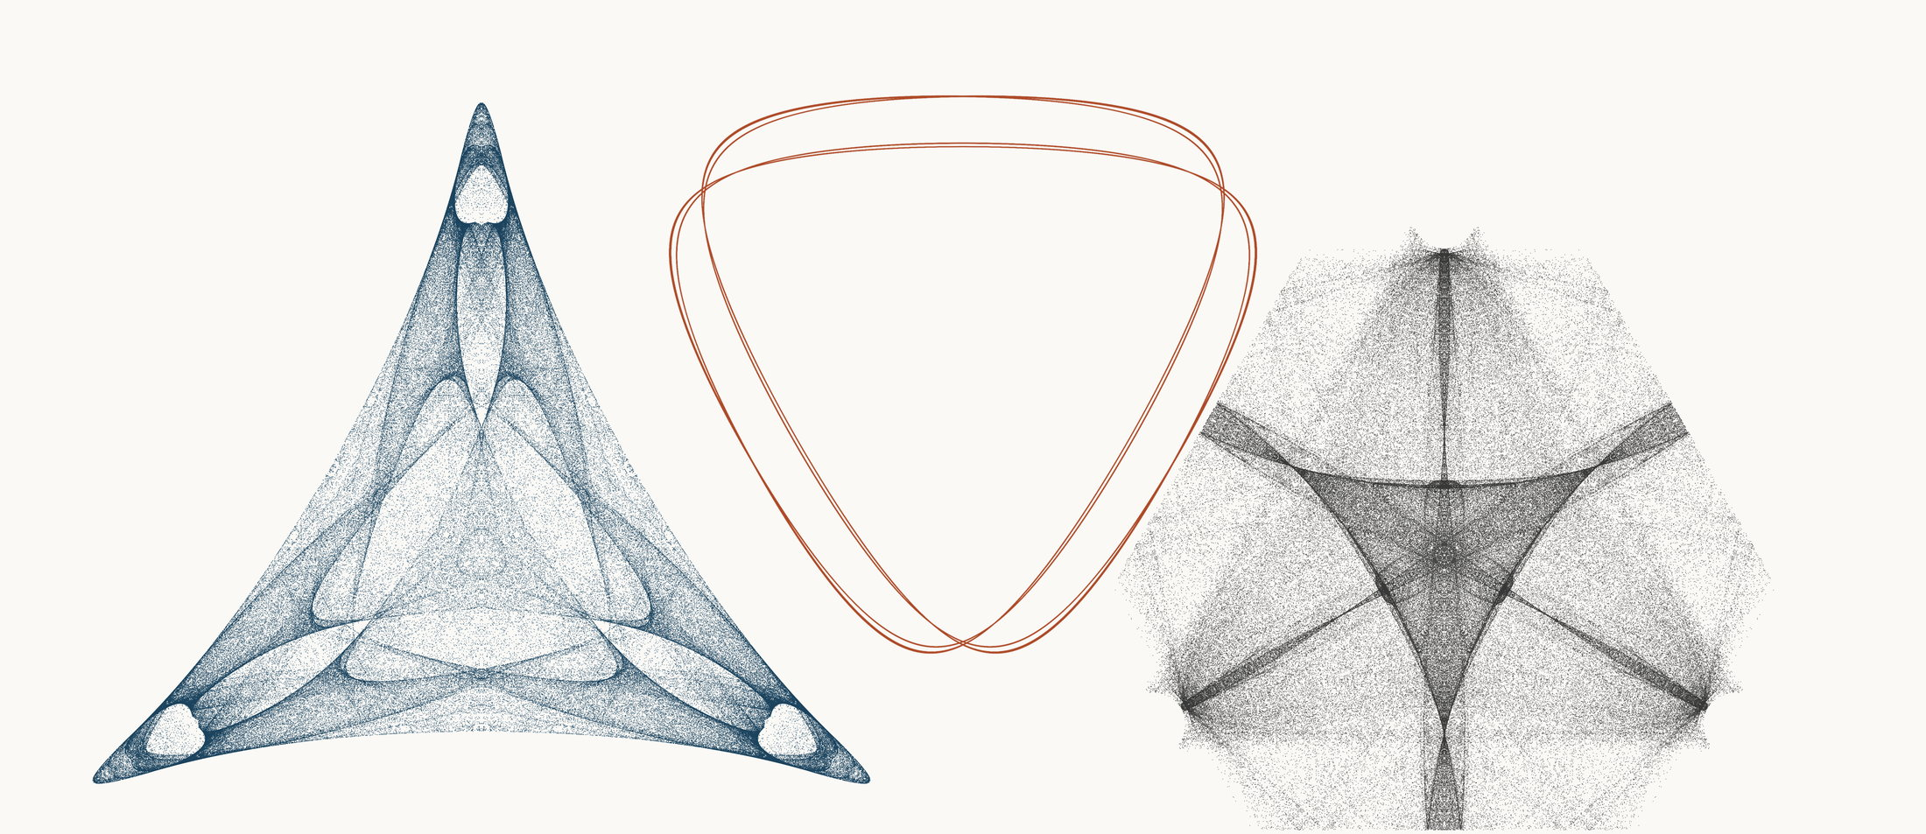
NEURAL INTERESTINGNESS 97 | RAW QUADTREE CODE BITS 97 | FORMER WUNDT GATE 97
X16592_M3  Definition X(16592); M3 pedal triangle  Neural score 56.351  Code bits 7,814 q/random 0.3512  Fitted taste 0.854 | X10086_M3  Definition X(10086); M3 pedal triangle  Code-bit rank 97 position 97  Quadtree code bits 1,178  q/random 0.24277 PNG/random 0.2249 | X65074_M3  Definition X(65074); M3 pedal triangle  Wundt position 97  Wundt gate 0.995321  q/random 0.5342 code bits 12,357
Each source plot uses 50,000 retained points after 4,000 discarded points and all six angle permutations. The center plot is visually oriented and enlarged only for presentation. Raw quadtree ranking is ascending by code bits.

Three Triangle Compressibility and Interestingness Atlas
Comparison position 98 of 120 Left and right upright Center visually inverted and maximized
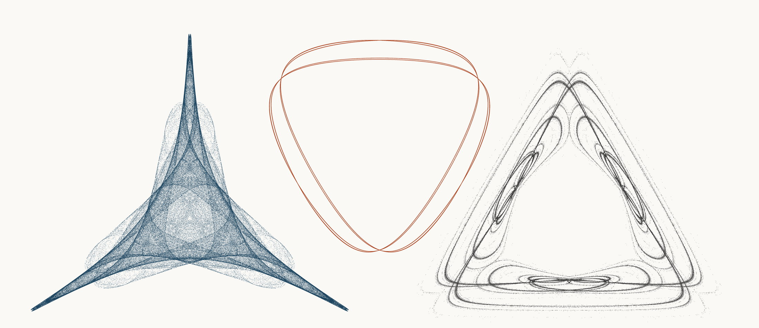
NEURAL INTERESTINGNESS 98 | RAW QUADTREE CODE BITS 98 | FORMER WUNDT GATE 98
X69204_M1  Definition X(69204); M1 cevian triangle  Neural score 56.222  Code bits 4,377 q/random 0.2163  Fitted taste 0.821 | X10088_M3  Definition X(10088); M3 pedal triangle  Code-bit rank 98 position 98  Quadtree code bits 1,185  q/random 0.25684 PNG/random 0.2474 | X13221_M3  Definition X(13221); M3 pedal triangle  Wundt position 98  Wundt gate 0.995286  q/random 0.4657 code bits 7,646
Each source plot uses 50,000 retained points after 4,000 discarded points and all six angle permutations. The center plot is visually oriented and enlarged only for presentation. Raw quadtree ranking is ascending by code bits.

Three Triangle Compressibility and Interestingness Atlas
Comparison position 99 of 120 Left and right upright Center visually inverted and maximized
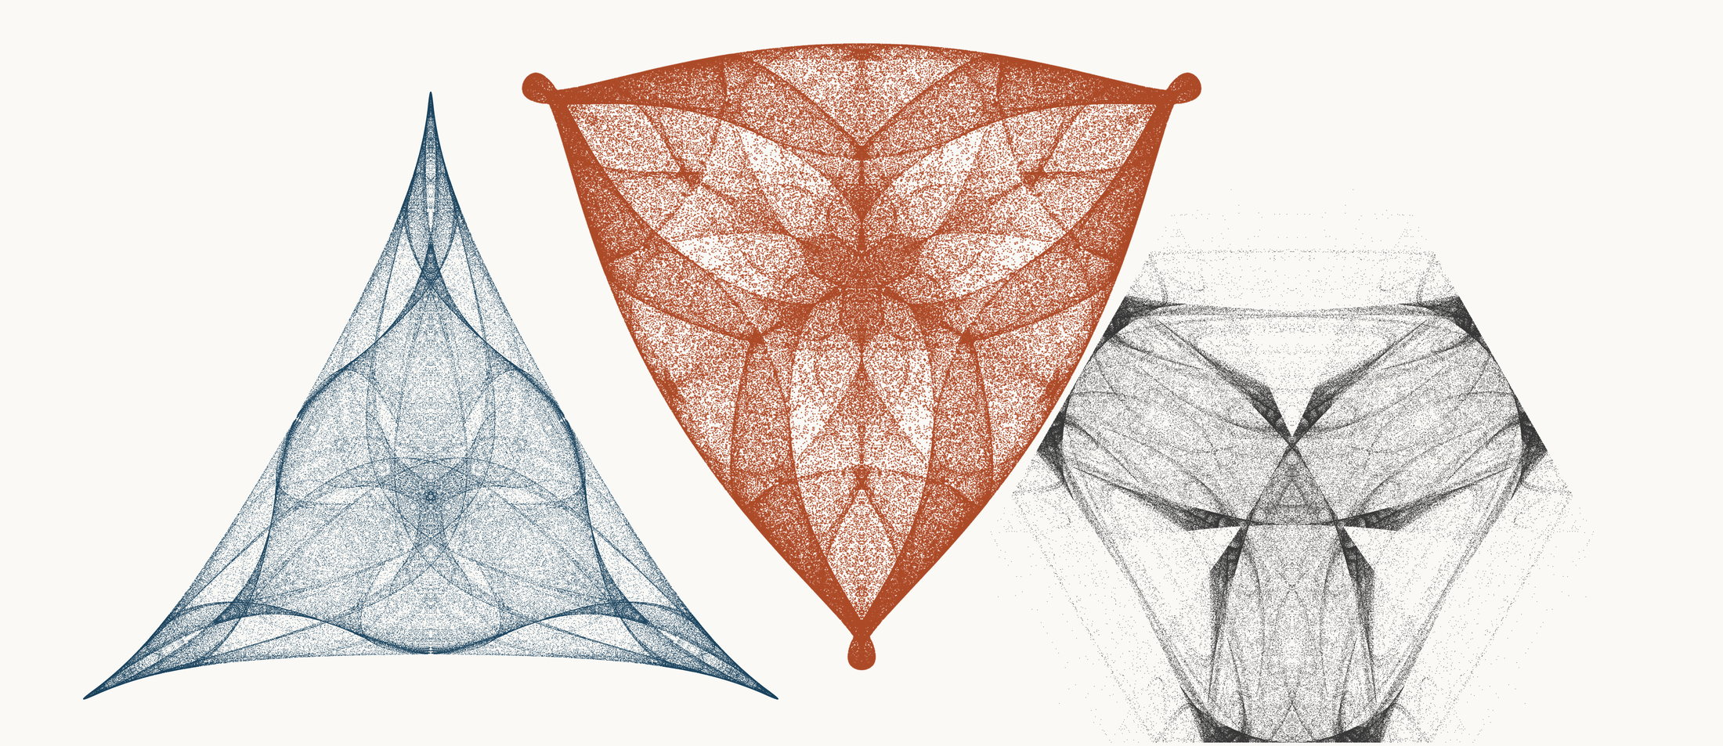
NEURAL INTERESTINGNESS 99 | RAW QUADTREE CODE BITS 99 | FORMER WUNDT GATE 99
X71532_M3  Definition X(71532); M3 pedal triangle  Neural score 56.193  Code bits 7,387 q/random 0.3316  Fitted taste 1.016 | X18407_M3  Definition X(18407); M3 pedal triangle  Code-bit rank 98 position 99  Quadtree code bits 1,185  q/random 0.07409 PNG/random 0.2164 | X11608_M1  Definition X(11608); M1 cevian triangle  Wundt position 99  Wundt gate 0.995239  q/random 0.4655 code bits 10,439
Each source plot uses 50,000 retained points after 4,000 discarded points and all six angle permutations. The center plot is visually oriented and enlarged only for presentation. Raw quadtree ranking is ascending by code bits.

Three Triangle Compressibility and Interestingness Atlas
Comparison position 100 of 120 Left and right upright Center visually inverted and maximized
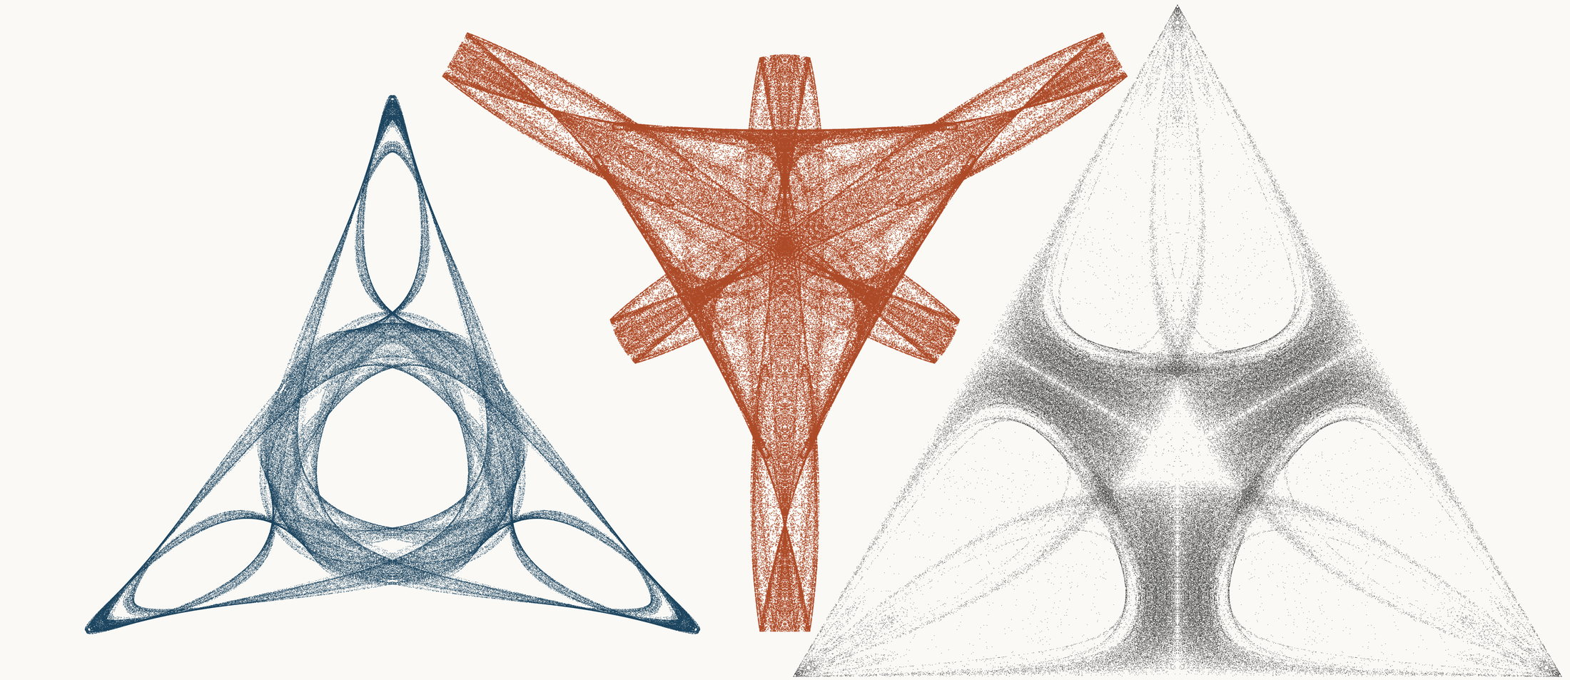
NEURAL INTERESTINGNESS 100 | RAW QUADTREE CODE BITS 100 | FORMER WUNDT GATE 100
X16727_M3  Definition X(16727); M3 pedal triangle  Neural score 56.183  Code bits 3,271 q/random 0.1722  Fitted taste 1.315 | X45202_M3  Definition X(45202); M3 pedal triangle  Code-bit rank 98 position 100  Quadtree code bits 1,185  q/random 0.07565 PNG/random 0.2100 | X54390_M3  Definition X(54390); M3 pedal triangle  Wundt position 100  Wundt gate 0.995230  q/random 0.4655 code bits 10,523
Each source plot uses 50,000 retained points after 4,000 discarded points and all six angle permutations. The center plot is visually oriented and enlarged only for presentation. Raw quadtree ranking is ascending by code bits.

Three Triangle Compressibility and Interestingness Atlas
Comparison position 101 of 120 Left and right upright Center visually inverted and maximized
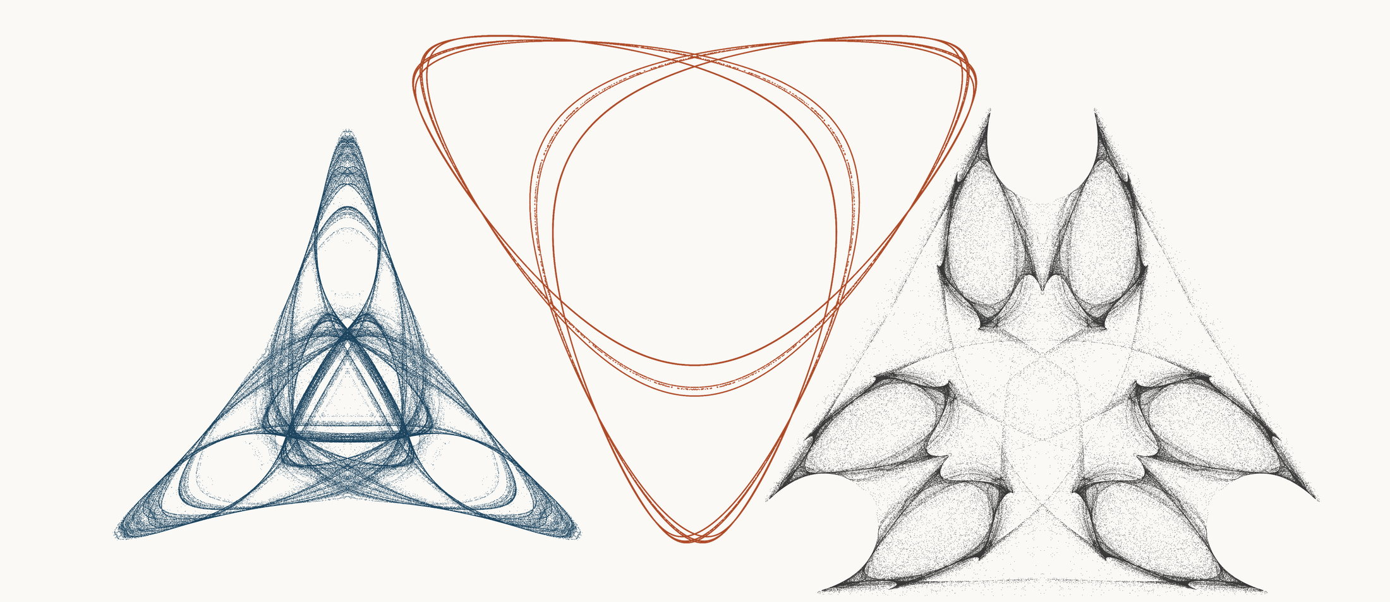
NEURAL INTERESTINGNESS 101 | RAW QUADTREE CODE BITS 101 | FORMER WUNDT GATE 101
X66000_M3  Definition X(66000); M3 pedal triangle  Neural score 56.071  Code bits 3,600 q/random 0.2027  Fitted taste 0.829 | X58602_M3  Definition X(58602); M3 pedal triangle  Code-bit rank 98 position 101  Quadtree code bits 1,185  q/random 0.22685 PNG/random 0.2849 | X41558_M3  Definition X(41558); M3 pedal triangle  Wundt position 101  Wundt gate 0.995128  q/random 0.5349 code bits 11,482
Each source plot uses 50,000 retained points after 4,000 discarded points and all six angle permutations. The center plot is visually oriented and enlarged only for presentation. Raw quadtree ranking is ascending by code bits.

Three Triangle Compressibility and Interestingness Atlas
Comparison position 102 of 120 Left and right upright Center visually inverted and maximized
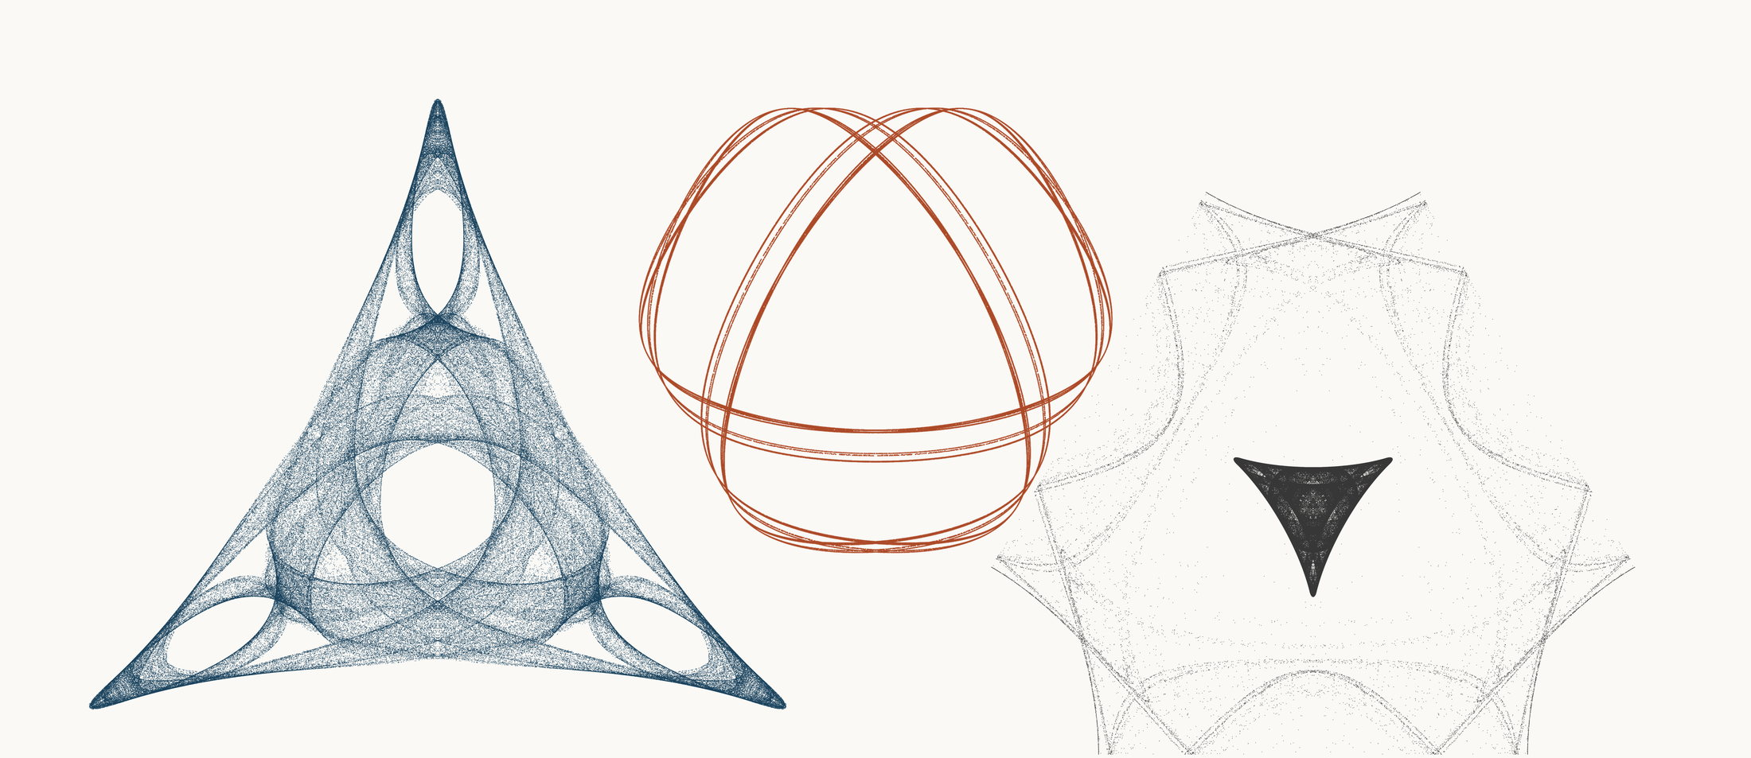
NEURAL INTERESTINGNESS 102 | RAW QUADTREE CODE BITS 102 | FORMER WUNDT GATE 102
X4403_M3  Definition X(4403); M3 pedal triangle  Neural score 56.003  Code bits 4,580 q/random 0.2116  Fitted taste 1.217 | X12080_M3  Definition X(12080); M3 pedal triangle  Code-bit rank 102 position 102  Quadtree code bits 1,192  q/random 0.17989 PNG/random 0.2653 | X56362_M1  Definition X(56362); M1 cevian triangle  Wundt position 102  Wundt gate 0.995066  q/random 0.5351 code bits 8,801
Each source plot uses 50,000 retained points after 4,000 discarded points and all six angle permutations. The center plot is visually oriented and enlarged only for presentation. Raw quadtree ranking is ascending by code bits.

Three Triangle Compressibility and Interestingness Atlas
Comparison position 103 of 120 Left and right upright Center visually inverted and maximized
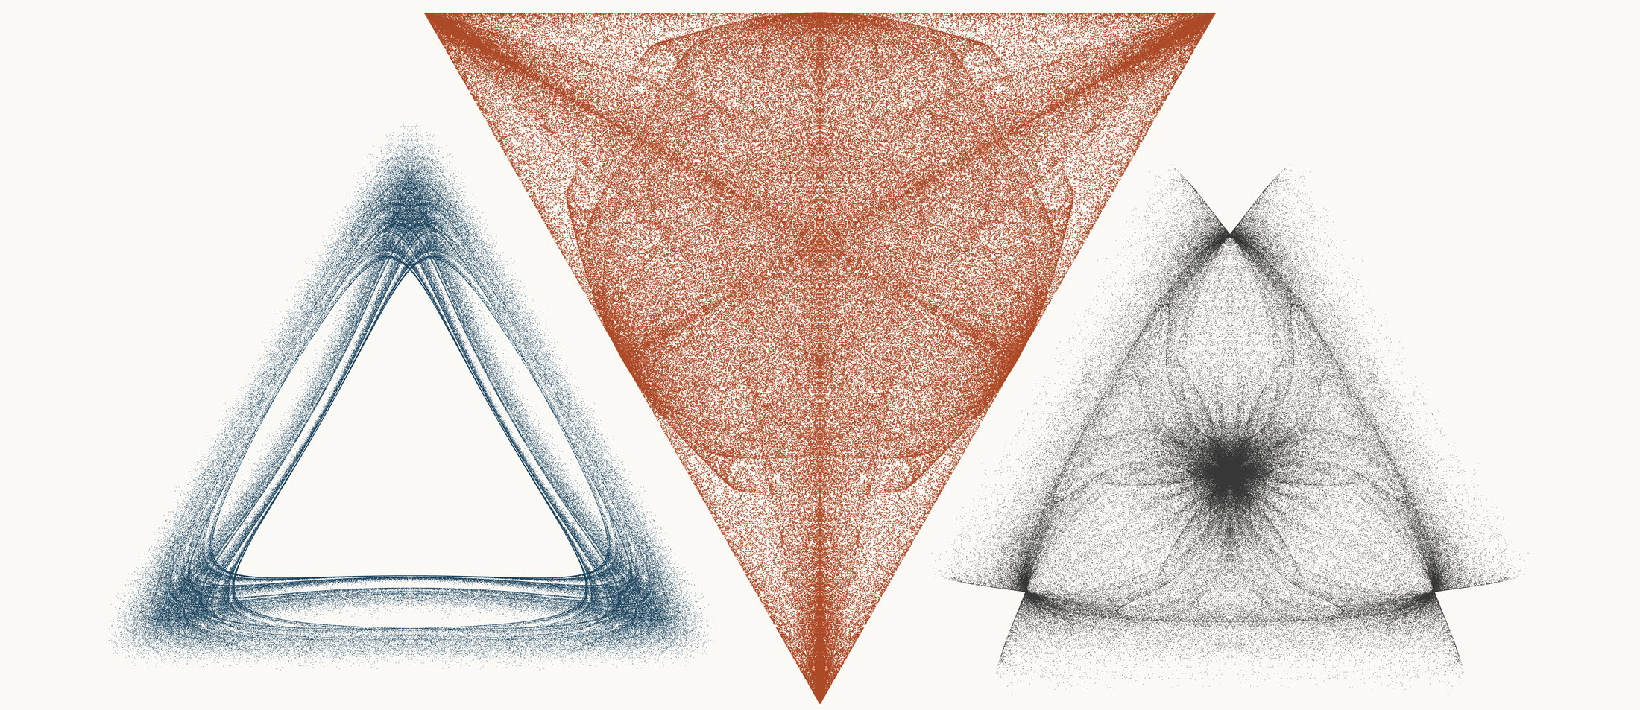
NEURAL INTERESTINGNESS 103 | RAW QUADTREE CODE BITS 103 | FORMER WUNDT GATE 103
X69533_M3  Definition X(69533); M3 pedal triangle  Neural score 55.975  Code bits 6,421 q/random 0.3007  Fitted taste 0.576 | X55558_M3  Definition X(55558); M3 pedal triangle  Code-bit rank 102 position 103  Quadtree code bits 1,192  q/random 0.06135 PNG/random 0.2041 | X38608_M3  Definition X(38608); M3 pedal triangle  Wundt position 103  Wundt gate 0.995026  q/random 0.4647 code bits 10,565
Each source plot uses 50,000 retained points after 4,000 discarded points and all six angle permutations. The center plot is visually oriented and enlarged only for presentation. Raw quadtree ranking is ascending by code bits.

Three Triangle Compressibility and Interestingness Atlas
Comparison position 104 of 120 Left and right upright Center visually inverted and maximized
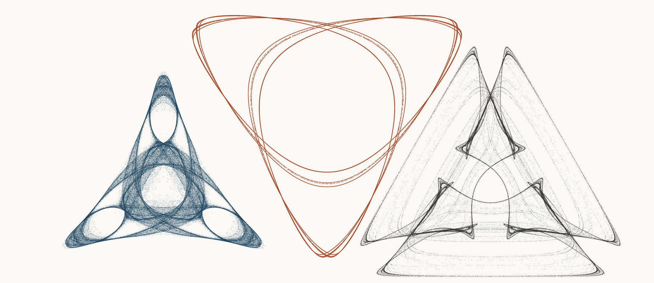
NEURAL INTERESTINGNESS 104 | RAW QUADTREE CODE BITS 104 | FORMER WUNDT GATE 104
X49210_M3  Definition X(49210); M3 pedal triangle  Neural score 55.812  Code bits 2,816 q/random 0.1638  Fitted taste 0.782 | X58597_M3  Definition X(58597); M3 pedal triangle  Code-bit rank 104 position 104  Quadtree code bits 1,199  q/random 0.22953 PNG/random 0.2760 | X5579_M3  Definition X(5579); M3 pedal triangle  Wundt position 104  Wundt gate 0.995009  q/random 0.5353 code bits 8,913
Each source plot uses 50,000 retained points after 4,000 discarded points and all six angle permutations. The center plot is visually oriented and enlarged only for presentation. Raw quadtree ranking is ascending by code bits.

Three Triangle Compressibility and Interestingness Atlas
Comparison position 105 of 120 Left and right upright Center visually inverted and maximized
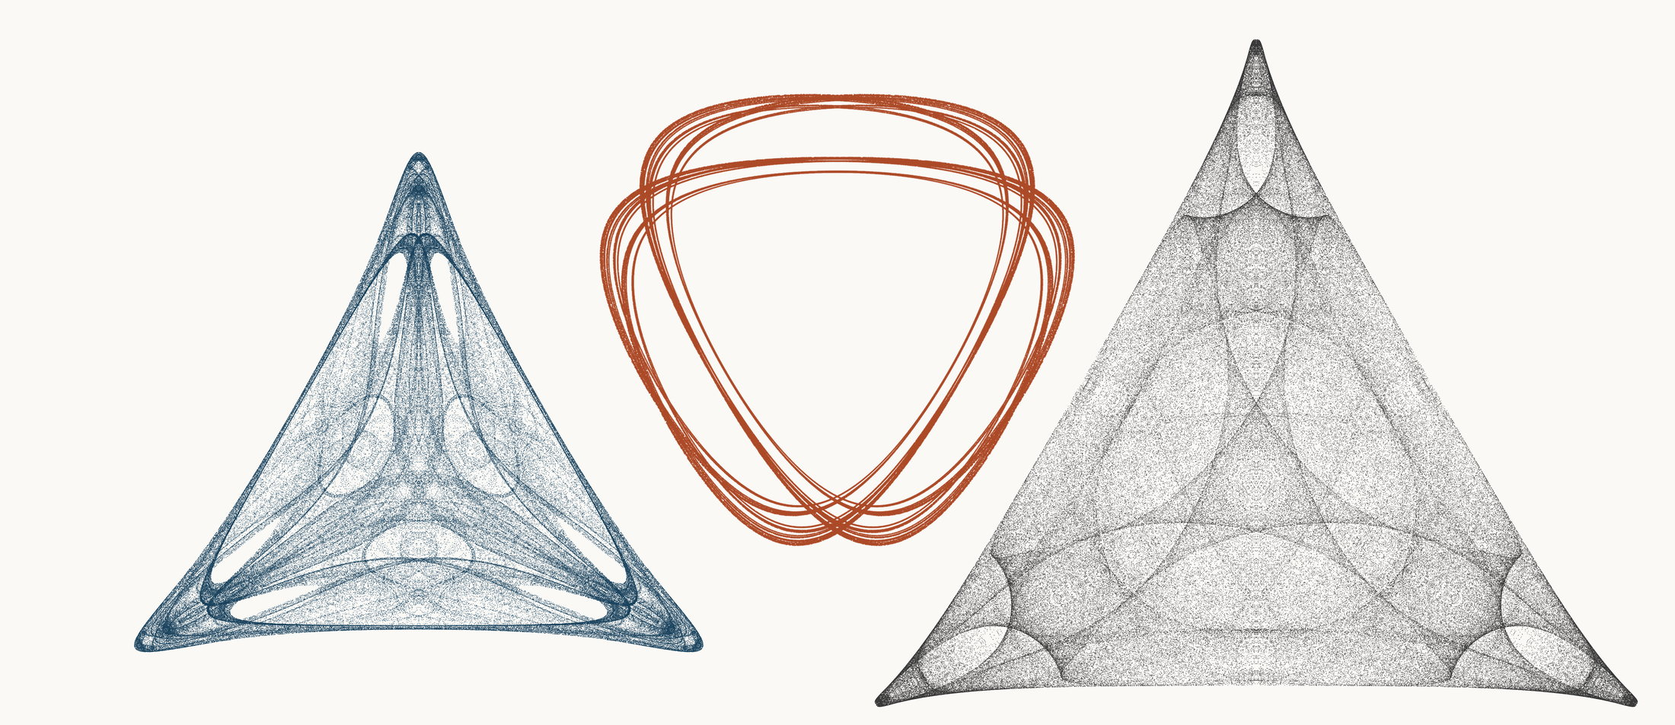
NEURAL INTERESTINGNESS 105 | RAW QUADTREE CODE BITS 105 | FORMER WUNDT GATE 105
X49266_M1  Definition X(49266); M1 cevian triangle  Neural score 55.748  Code bits 5,868 q/random 0.2730  Fitted taste 0.921 | X10352_M3  Definition X(10352); M3 pedal triangle  Code-bit rank 105 position 105  Quadtree code bits 1,206  q/random 0.15482 PNG/random 0.1970 | X32584_M3  Definition X(32584); M3 pedal triangle  Wundt position 105  Wundt gate 0.994980  q/random 0.5354 code bits 12,063
Each source plot uses 50,000 retained points after 4,000 discarded points and all six angle permutations. The center plot is visually oriented and enlarged only for presentation. Raw quadtree ranking is ascending by code bits.

Three Triangle Compressibility and Interestingness Atlas
Comparison position 106 of 120 Left and right upright Center visually inverted and maximized
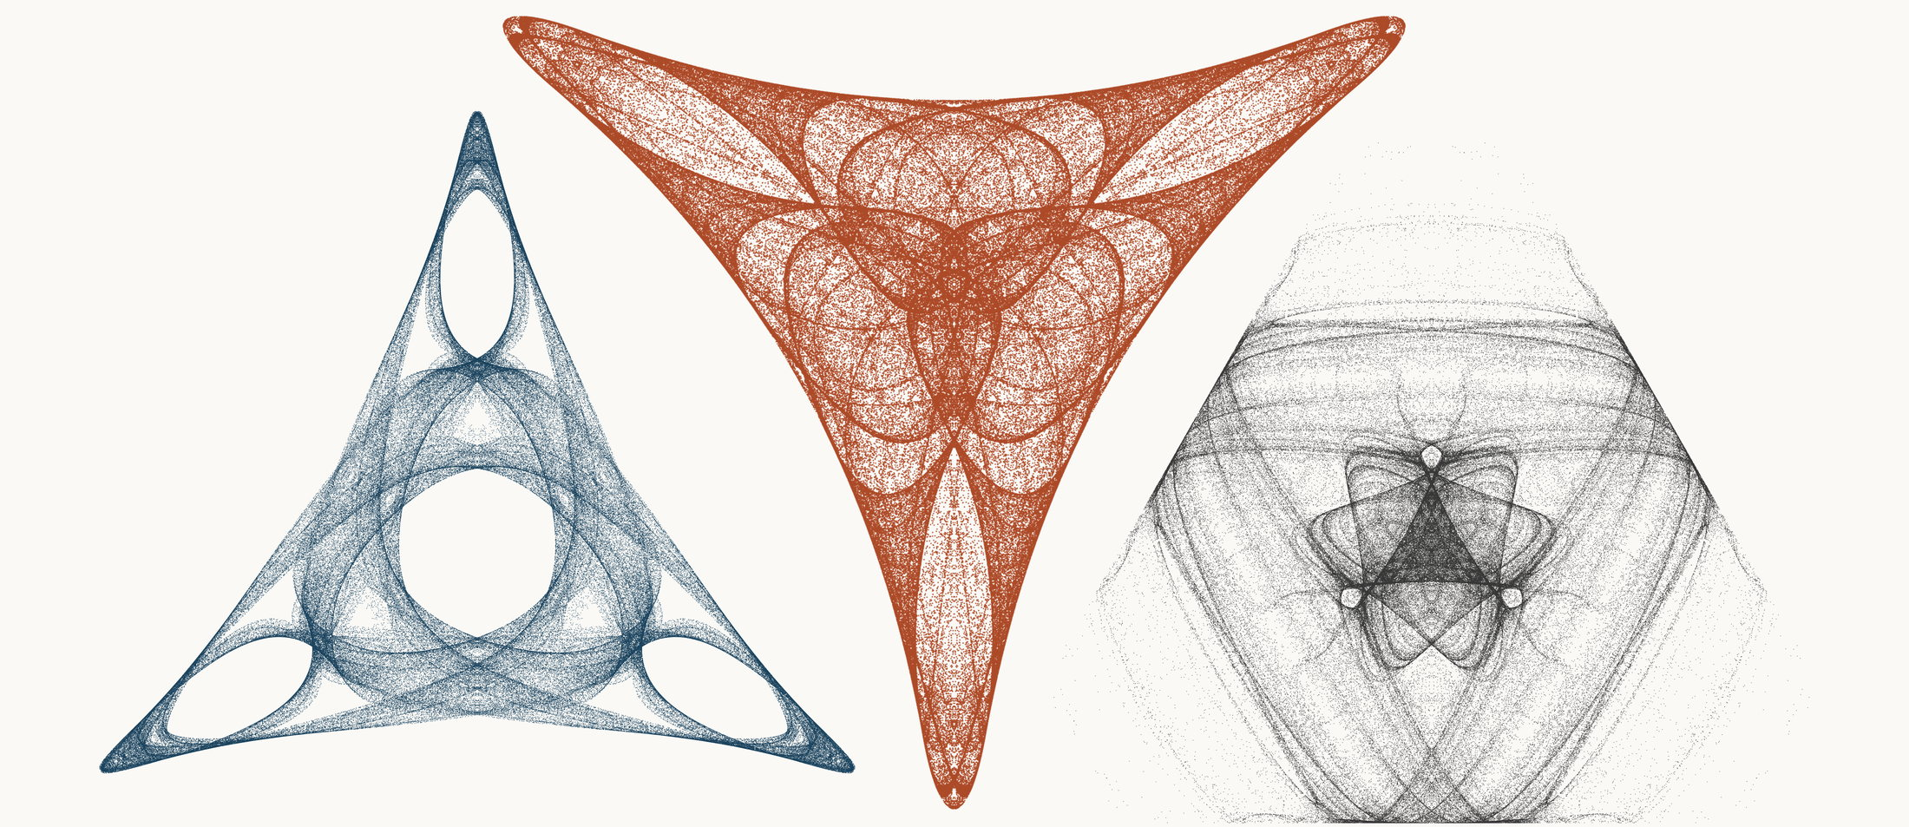
NEURAL INTERESTINGNESS 106 | RAW QUADTREE CODE BITS 106 | FORMER WUNDT GATE 106
X15611_M3  Definition X(15611); M3 pedal triangle  Neural score 55.725  Code bits 3,600 q/random 0.1737  Fitted taste 1.306 | X11647_M3  Definition X(11647); M3 pedal triangle  Code-bit rank 105 position 106  Quadtree code bits 1,206  q/random 0.08596 PNG/random 0.2225 | X18793_M1  Definition X(18793); M1 cevian triangle  Wundt position 106  Wundt gate 0.994863  q/random 0.5358 code bits 12,196
Each source plot uses 50,000 retained points after 4,000 discarded points and all six angle permutations. The center plot is visually oriented and enlarged only for presentation. Raw quadtree ranking is ascending by code bits.

Three Triangle Compressibility and Interestingness Atlas
Comparison position 107 of 120 Left and right upright Center visually inverted and maximized
NEURAL INTERESTINGNESS 107 | RAW QUADTREE CODE BITS 107 | FORMER WUNDT GATE 107
X32187_M3  Definition X(32187); M3 pedal triangle  Neural score 55.713  Code bits 1,402 q/random 0.0980  Fitted taste 0.313 | X27621_M3  Definition X(27621); M3 pedal triangle  Code-bit rank 105 position 107  Quadtree code bits 1,206  q/random 0.23401 PNG/random 0.2030 | X13310_M3  Definition X(13310); M3 pedal triangle  Wundt position 107  Wundt gate 0.994810  q/random 0.4640 code bits 10,551
Each source plot uses 50,000 retained points after 4,000 discarded points and all six angle permutations. The center plot is visually oriented and enlarged only for presentation. Raw quadtree ranking is ascending by code bits.

Three Triangle Compressibility and Interestingness Atlas
Comparison position 108 of 120 Left and right upright Center visually inverted and maximized
NEURAL INTERESTINGNESS 108 | RAW QUADTREE CODE BITS 108 | FORMER WUNDT GATE 108
X5729_M1  Definition X(5729); M1 cevian triangle  Neural score 55.684  Code bits 3,222 q/random 0.1616  Fitted taste 0.713 | X60304_M1  Definition X(60304); M1 cevian triangle  Code-bit rank 105 position 108  Quadtree code bits 1,206  q/random 0.07956 PNG/random 0.2433 | X40537_M1  Definition X(40537); M1 cevian triangle  Wundt position 108  Wundt gate 0.994613  q/random 0.4633 code bits 10,607
Each source plot uses 50,000 retained points after 4,000 discarded points and all six angle permutations. The center plot is visually oriented and enlarged only for presentation. Raw quadtree ranking is ascending by code bits.

Three Triangle Compressibility and Interestingness Atlas
Comparison position 109 of 120 Left and right upright Center visually inverted and maximized
NEURAL INTERESTINGNESS 109 | RAW QUADTREE CODE BITS 109 | FORMER WUNDT GATE 109
X53823_M3  Definition X(53823); M3 pedal triangle  Neural score 55.605  Code bits 5,350 q/random 0.2437  Fitted taste 1.219 | X61519_M1  Definition X(61519); M1 cevian triangle  Code-bit rank 105 position 109  Quadtree code bits 1,206  q/random 0.09343 PNG/random 0.2102 | X70742_M3  Definition X(70742); M3 pedal triangle  Wundt position 109  Wundt gate 0.994588  q/random 0.4632 code bits 10,404
Each source plot uses 50,000 retained points after 4,000 discarded points and all six angle permutations. The center plot is visually oriented and enlarged only for presentation. Raw quadtree ranking is ascending by code bits.

Three Triangle Compressibility and Interestingness Atlas
Comparison position 110 of 120 Left and right upright Center visually inverted and maximized
NEURAL INTERESTINGNESS 110 | RAW QUADTREE CODE BITS 110 | FORMER WUNDT GATE 110
X47014_M3  Definition X(47014); M3 pedal triangle  Neural score 55.582  Code bits 3,887 q/random 0.1773  Fitted taste 1.266 | X10087_M3  Definition X(10087); M3 pedal triangle  Code-bit rank 110 position 110  Quadtree code bits 1,213  q/random 0.24128 PNG/random 0.2180 | X11641_M3  Definition X(11641); M3 pedal triangle  Wundt position 110  Wundt gate 0.994458  q/random 0.4628 code bits 10,663
Each source plot uses 50,000 retained points after 4,000 discarded points and all six angle permutations. The center plot is visually oriented and enlarged only for presentation. Raw quadtree ranking is ascending by code bits.

Three Triangle Compressibility and Interestingness Atlas
Comparison position 111 of 120 Left and right upright Center visually inverted and maximized
NEURAL INTERESTINGNESS 111 | RAW QUADTREE CODE BITS 111 | FORMER WUNDT GATE 111
X35799_M3  Definition X(35799); M3 pedal triangle  Neural score 55.579  Code bits 5,924 q/random 0.3784  Fitted taste 0.189 | X58595_M3  Definition X(58595); M3 pedal triangle  Code-bit rank 110 position 111  Quadtree code bits 1,213  q/random 0.22914 PNG/random 0.3004 | X66459_M3  Definition X(66459); M3 pedal triangle  Wundt position 111  Wundt gate 0.994330  q/random 0.5376 code bits 8,899
Each source plot uses 50,000 retained points after 4,000 discarded points and all six angle permutations. The center plot is visually oriented and enlarged only for presentation. Raw quadtree ranking is ascending by code bits.

Three Triangle Compressibility and Interestingness Atlas
Comparison position 112 of 120 Left and right upright Center visually inverted and maximized
NEURAL INTERESTINGNESS 112 | RAW QUADTREE CODE BITS 112 | FORMER WUNDT GATE 112
X57592_M3  Definition X(57592); M3 pedal triangle  Neural score 55.566  Code bits 3,985 q/random 0.2133  Fitted taste 0.656 | X59816_M3  Definition X(59816); M3 pedal triangle  Code-bit rank 110 position 112  Quadtree code bits 1,213  q/random 0.07740 PNG/random 0.2203 | X1156_M1  Definition X(1156); M1 cevian triangle  Wundt position 112  Wundt gate 0.994228  q/random 0.4620 code bits 3,663
Each source plot uses 50,000 retained points after 4,000 discarded points and all six angle permutations. The center plot is visually oriented and enlarged only for presentation. Raw quadtree ranking is ascending by code bits.

Three Triangle Compressibility and Interestingness Atlas
Comparison position 113 of 120 Left and right upright Center visually inverted and maximized
NEURAL INTERESTINGNESS 113 | RAW QUADTREE CODE BITS 113 | FORMER WUNDT GATE 113
X61403_M3  Definition X(61403); M3 pedal triangle  Neural score 55.515  Code bits 7,723 q/random 0.3473  Fitted taste 0.919 | X43981_M3  Definition X(43981); M3 pedal triangle  Code-bit rank 113 position 113  Quadtree code bits 1,220  q/random 0.07181 PNG/random 0.1978 | X2954_M1  Definition X(2954); M1 cevian triangle  Wundt position 113  Wundt gate 0.994144  q/random 0.5383 code bits 11,671
Each source plot uses 50,000 retained points after 4,000 discarded points and all six angle permutations. The center plot is visually oriented and enlarged only for presentation. Raw quadtree ranking is ascending by code bits.

Three Triangle Compressibility and Interestingness Atlas
Comparison position 114 of 120 Left and right upright Center visually inverted and maximized
NEURAL INTERESTINGNESS 114 | RAW QUADTREE CODE BITS 114 | FORMER WUNDT GATE 114
X39310_M3  Definition X(39310); M3 pedal triangle  Neural score 55.462  Code bits 5,343 q/random 0.3465  Fitted taste 0.805 | X63348_M3  Definition X(63348); M3 pedal triangle  Code-bit rank 113 position 114  Quadtree code bits 1,220  q/random 0.21117 PNG/random 0.3242 | X47545_M3  Definition X(47545); M3 pedal triangle  Wundt position 114  Wundt gate 0.994091  q/random 0.4616 code bits 9,417
Each source plot uses 50,000 retained points after 4,000 discarded points and all six angle permutations. The center plot is visually oriented and enlarged only for presentation. Raw quadtree ranking is ascending by code bits.

Three Triangle Compressibility and Interestingness Atlas
Comparison position 115 of 120 Left and right upright Center visually inverted and maximized
NEURAL INTERESTINGNESS 115 | RAW QUADTREE CODE BITS 115 | FORMER WUNDT GATE 115
X15527_M3  Definition X(15527); M3 pedal triangle  Neural score 55.433  Code bits 7,086 q/random 0.3187  Fitted taste 1.026 | X71850_M3  Definition X(71850); M3 pedal triangle  Code-bit rank 113 position 115  Quadtree code bits 1,220  q/random 0.09581 PNG/random 0.1921 | X2455_M3  Definition X(2455); M3 pedal triangle  Wundt position 115  Wundt gate 0.994015  q/random 0.4613 code bits 10,145
Each source plot uses 50,000 retained points after 4,000 discarded points and all six angle permutations. The center plot is visually oriented and enlarged only for presentation. Raw quadtree ranking is ascending by code bits.

Three Triangle Compressibility and Interestingness Atlas
Comparison position 116 of 120 Left and right upright Center visually inverted and maximized
NEURAL INTERESTINGNESS 116 | RAW QUADTREE CODE BITS 116 | FORMER WUNDT GATE 116
X55059_M3  Definition X(55059); M3 pedal triangle  Neural score 55.399  Code bits 3,467 q/random 0.1789  Fitted taste 1.305 | X23418_M3  Definition X(23418); M3 pedal triangle  Code-bit rank 116 position 116  Quadtree code bits 1,227  q/random 0.06591 PNG/random 0.1773 | X2942_M1  Definition X(2942); M1 cevian triangle  Wundt position 116  Wundt gate 0.993679  q/random 0.5398 code bits 11,930
Each source plot uses 50,000 retained points after 4,000 discarded points and all six angle permutations. The center plot is visually oriented and enlarged only for presentation. Raw quadtree ranking is ascending by code bits.

Three Triangle Compressibility and Interestingness Atlas
Comparison position 117 of 120 Left and right upright Center visually inverted and maximized
NEURAL INTERESTINGNESS 117 | RAW QUADTREE CODE BITS 117 | FORMER WUNDT GATE 117
X42614_M1  Definition X(42614); M1 cevian triangle  Neural score 55.379  Code bits 4,888 q/random 0.2589  Fitted taste 0.843 | X58589_M3  Definition X(58589); M3 pedal triangle  Code-bit rank 116 position 117  Quadtree code bits 1,227  q/random 0.22124 PNG/random 0.3091 | X65633_M3  Definition X(65633); M3 pedal triangle  Wundt position 117  Wundt gate 0.993674  q/random 0.4602 code bits 5,875
Each source plot uses 50,000 retained points after 4,000 discarded points and all six angle permutations. The center plot is visually oriented and enlarged only for presentation. Raw quadtree ranking is ascending by code bits.

Three Triangle Compressibility and Interestingness Atlas
Comparison position 118 of 120 Left and right upright Center visually inverted and maximized
NEURAL INTERESTINGNESS 118 | RAW QUADTREE CODE BITS 118 | FORMER WUNDT GATE 118
X10988_M1  Definition X(10988); M1 cevian triangle  Neural score 55.352  Code bits 5,665 q/random 0.2731  Fitted taste 0.708 | X17199_M3  Definition X(17199); M3 pedal triangle  Code-bit rank 118 position 118  Quadtree code bits 1,234  q/random 0.13415 PNG/random 0.1484 | X34578_M1  Definition X(34578); M1 cevian triangle  Wundt position 118  Wundt gate 0.993578  q/random 0.4599 code bits 10,327
Each source plot uses 50,000 retained points after 4,000 discarded points and all six angle permutations. The center plot is visually oriented and enlarged only for presentation. Raw quadtree ranking is ascending by code bits.

Three Triangle Compressibility and Interestingness Atlas
Comparison position 119 of 120 Left and right upright Center visually inverted and maximized
NEURAL INTERESTINGNESS 119 | RAW QUADTREE CODE BITS 119 | FORMER WUNDT GATE 119
X43680_M3  Definition X(43680); M3 pedal triangle  Neural score 55.350  Code bits 4,181 q/random 0.1899  Fitted taste 1.423 | X324_M3  Definition X(324); M3 pedal triangle  Code-bit rank 118 position 119  Quadtree code bits 1,234  q/random 0.07622 PNG/random 0.1926 | X61553_M3  Definition X(61553); M3 pedal triangle  Wundt position 119  Wundt gate 0.993330  q/random 0.4592 code bits 9,172
Each source plot uses 50,000 retained points after 4,000 discarded points and all six angle permutations. The center plot is visually oriented and enlarged only for presentation. Raw quadtree ranking is ascending by code bits.

Three Triangle Compressibility and Interestingness Atlas
Comparison position 120 of 120 Left and right upright Center visually inverted and maximized
NEURAL INTERESTINGNESS 120 | RAW QUADTREE CODE BITS 120 | FORMER WUNDT GATE 120
X2768_M1  Definition X(2768); M1 cevian triangle  Neural score 55.316  Code bits 6,134 q/random 0.2902  Fitted taste 1.187 | X60623_M3  Definition X(60623); M3 pedal triangle  Code-bit rank 118 position 120  Quadtree code bits 1,234  q/random 0.07300 PNG/random 0.1939 | X54489_M1  Definition X(54489); M1 cevian triangle  Wundt position 120  Wundt gate 0.993313  q/random 0.4591 code bits 10,495
Each source plot uses 50,000 retained points after 4,000 discarded points and all six angle permutations. The center plot is visually oriented and enlarged only for presentation. Raw quadtree ranking is ascending by code bits.

